### **Question to be answered during the research:**

### Ultimate question to be answered: How do the newly proposed alternatives to enhanced access in healthcare and fintech solutions impact financial inclusion in healthcare, and how do they compare to traditional solutions in terms of accessibility, affordability, and effectiveness?

1. Which people are suffering the most in the USA in terms of financial barriers in healthcare and why?
   1. Which social factors do you believe have the most significant influence on healthcare access, considering aspects such as age, racism, gender, geographical location, education, and financial stability?
   2. Do these vulnerable patients have insurance, but also high copayments / high deductibles? Or are these vulnerable patients unable to get insurance, and fully exposed to the catastrophic financial consequences of a health issue?
2. What are the limitations and challenges associated with current insurance plans and reimbursement approaches, and how can innovative alternatives address these shortcomings?
3. In what ways can innovative alternatives address the identified shortcomings in insurance services, thereby enhancing financial inclusion and healthcare access in these regions?

### --------------------------------------------------------------------------------------------------------------------

## The highest barriers in the US healthcare system

### 1. The Fee-For-Service System

#### Health Coverage Around the World

The Organisation for Economic Co-operation and Development (OECD) includes 38 member countries. Most of them have achieved 100% coverage, with their populations served through the benefits of universal healthcare.

* Germany:

Germany boasts universal coverage without a single-payer system. Residents are mandated to maintain health coverage, typically through nonprofit "sickness funds" funded by both employees and employers. Private health insurance is available, but only around 10% of residents opt for it.

* Singapore:

Singapore achieves universal coverage with a government-run insurance system called MediShield. Individuals contribute 4% to 10.5% of their income to a MediSave account, covering large medical expenses after a deductible. Routine medical care can be paid from MediSave accounts, subject to specific expenses.

* Japan:

Japan adopts a universal coverage model without a single-payer system. The Statutory Health Insurance System (SHIS) features numerous competing health insurance plans. Residents enroll and pay premiums for SHIS coverage, with an option for private, supplemental health insurance.

* United Kingdom:

The United Kingdom combines universal coverage with a single-payer system, qualifying as a form of socialized medicine. The U.K. National Health Service (NHS) is funded through tax revenue. Residents can purchase private health insurance for elective procedures or expedited access to care, while tax-funded services remain the backbone of the healthcare system.

[<https://www.nytimes.com/interactive/2019/08/14/magazine/universal-health-care-racism.html>]

[https://www.verywellhealth.com/difference-between-universal-coverage-and-single-payer-system-1738546]

##### USA Healthcare System General Performance Ranking

More than ten years after the passage of the Affordable Care Act (ACA), healthcare reform continues to be a primary concern for the American public. The number of uninsured Americans is still considerable, and both the affordability of healthcare at both systemic and individual levels isdiminishing. The pervasive impact of racism and prejudice on health disparities is becoming increasingly apparent. The COVID-19 pandemic, which added immense pressure to an already strained healthcare system, has further accentuated these shortcomings.

In response to this context, the National Academy of Medicine initiated the Vital Directions for Health and Health Care: Priorities for 2021 project, building on a 2016 initiative of the same name. The objective of the project was to offer expert guidance on various focus areas within US health policy.

Access to care, care process, administrative efficiency, equity, and health care outcomes — drawn from Commonwealth Fund international surveys conducted in each country and administrative data from the Organisation for Economic Co-operation and Development and the World Health Organization.

Assessment of health care system performance in Australia, Canada, France, Germany, the Netherlands, New Zealand, Norway, Sweden, Switzerland, the United Kingdom, and the United States, based on indicators available across five domains:

* Access to care
* Care process
* Administrative efficiency
* Equity
* Health care outcomes.

Most of the data were drawn from surveys examining how members of the public and primary care physicians experience health care in their respective countries. These Commonwealth Fund surveys were conducted by SSRS in collaboration with partner organizations in the 10 other countries. Additional data were drawn from the Organisation for Economic Co-operation and Development (OECD) and the World Health Organization (WHO).

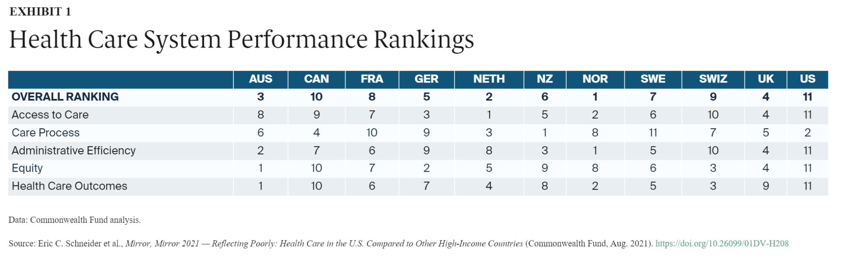

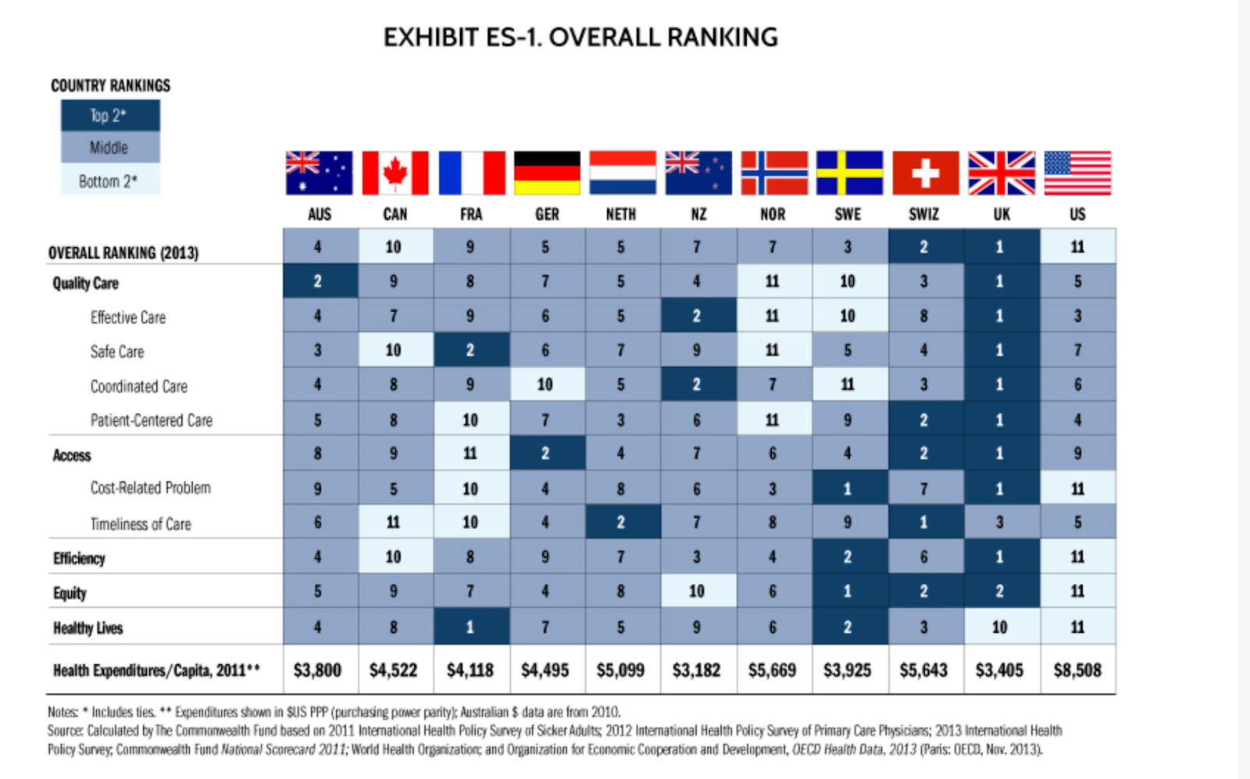

[https://www.commonwealthfund.org/press-release/2014/us-health-system-ranks-last-among-eleven-countries-measures-access-equity?redirect_source=/publications/press-releases/2014/jun/us-health-system-ranks-last]

The top-performing countries overall are Norway, the Netherlands, and Australia. The United States ranks last overall, despite spending far more of its gross domestic product on health care. The U.S. ranks last on access to care, administrative efficiency, equity, and health care outcomes, but second on measures of care process.

The next three countries in the ranking — the U.K., Germany, and New Zealand — perform very similarly to one another. The U.S. ranks #11 — last. Exhibit 2 shows the extent to which the U.S. is an outlier: its performance falls well below the average of the other countries and far below the two countries ranked directly above it, Switzerland and Canada. In fact, the U.S. is such an outlier that the ranking criterion has been calculated on the average performance based on the other 10 countries, excluding the U.S.

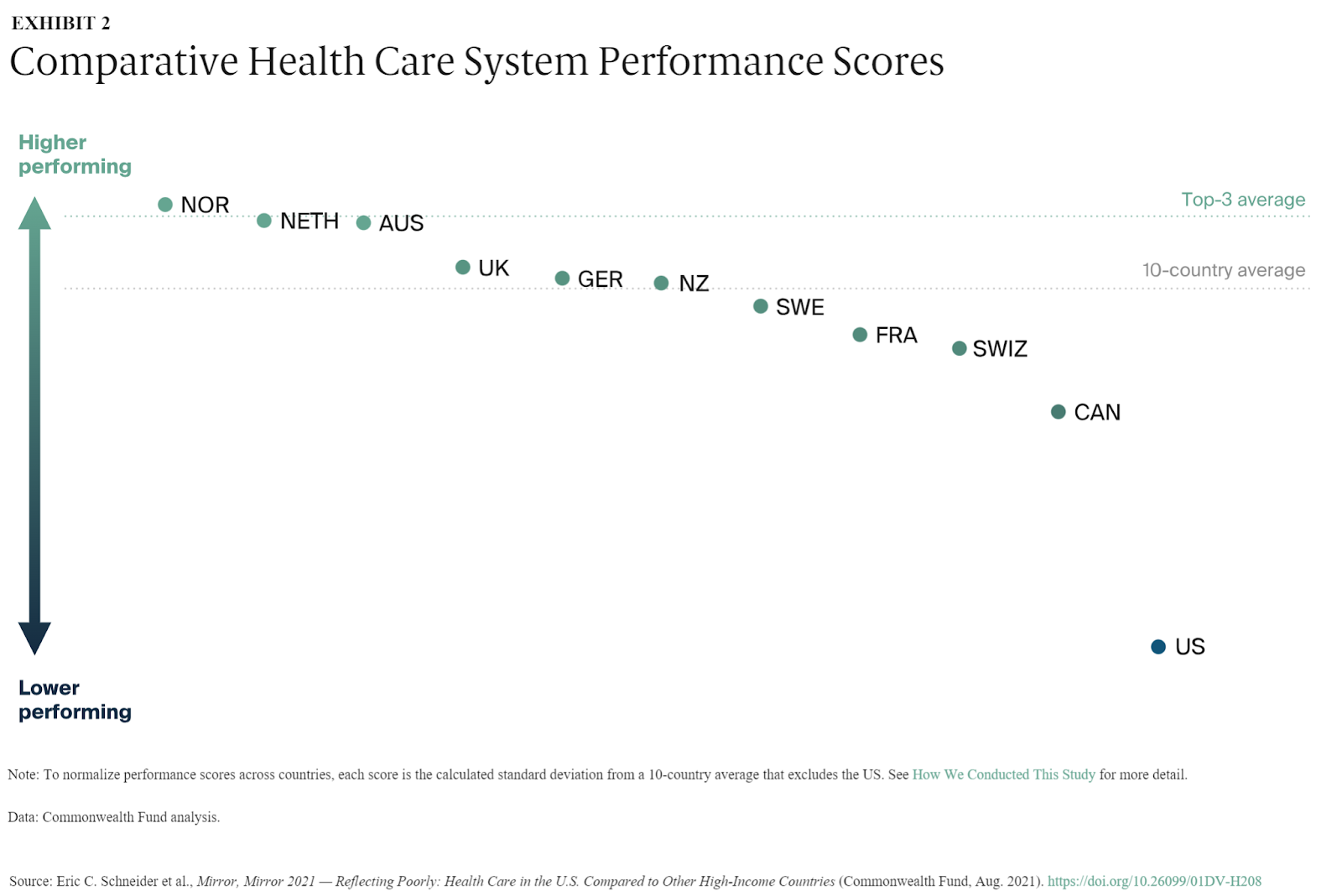

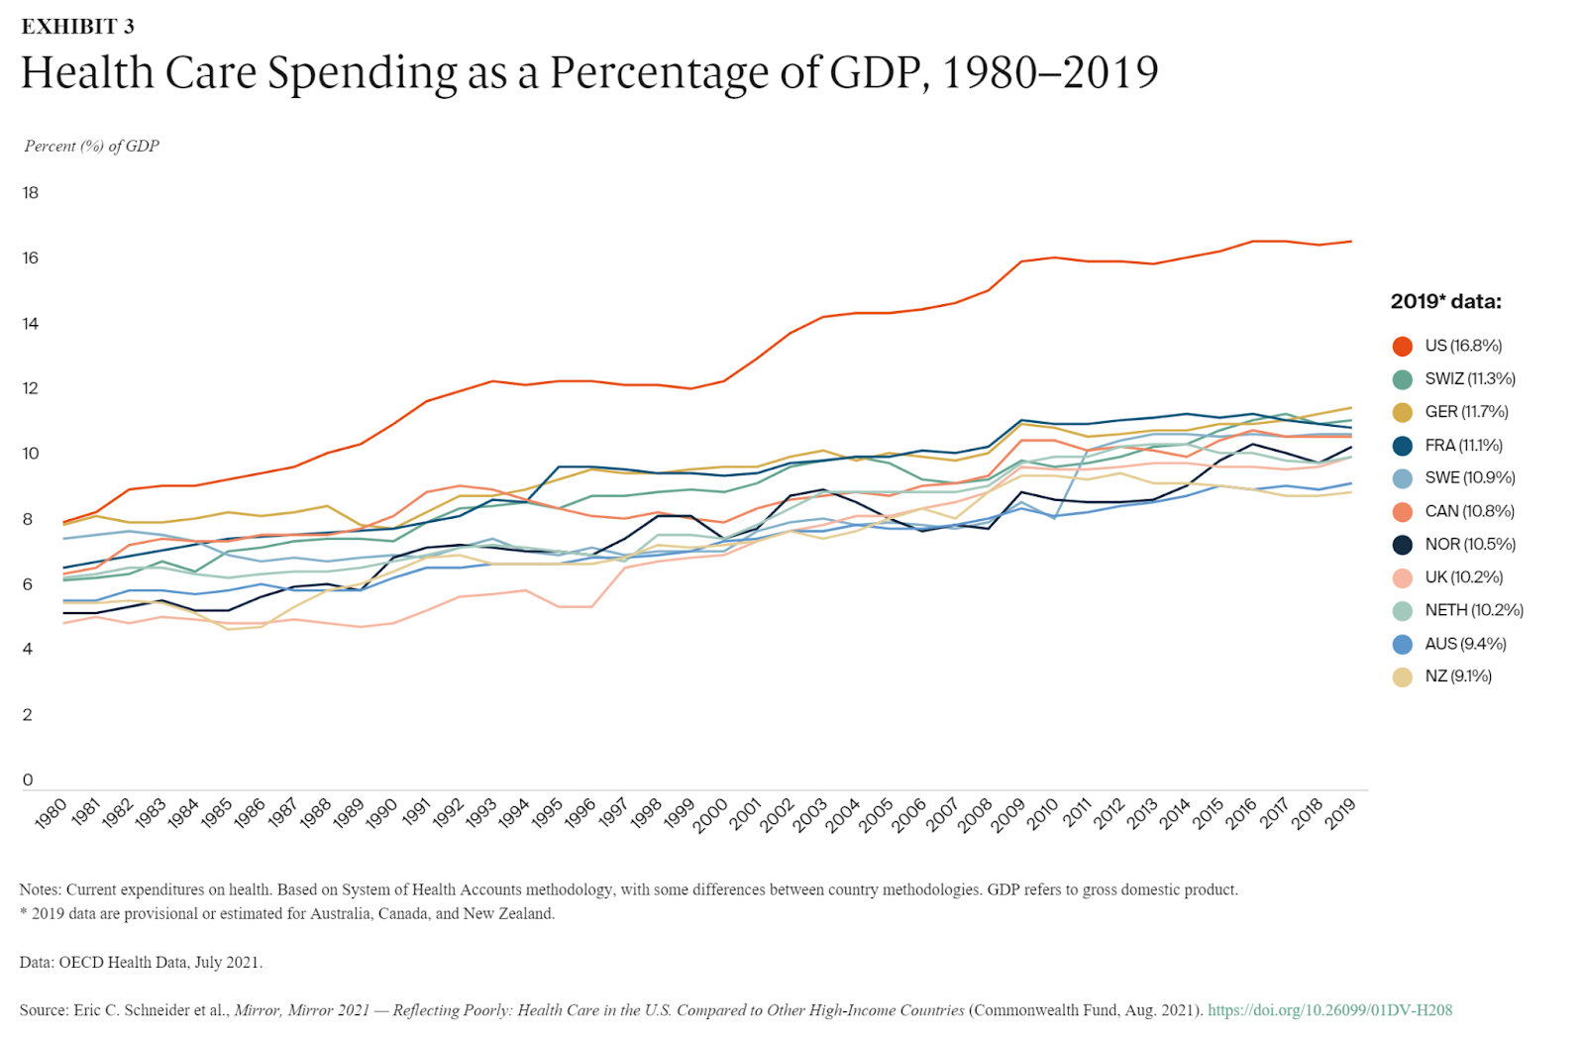

Exhibit 3 shows that while spending as a share of gross domestic product (GDP) has increased in all countries, spending growth in the U.S. — by far the worst performer overall — has greatly exceeded growth in the other 10 nations. In 1980, high-income countries spent between 5 percent and 8 percent of GDP on health care. But as U.S. spending accelerated over the decades, the U.S. was spending a substantially larger share of its GDP on health care by 2019 than every other high-income country.

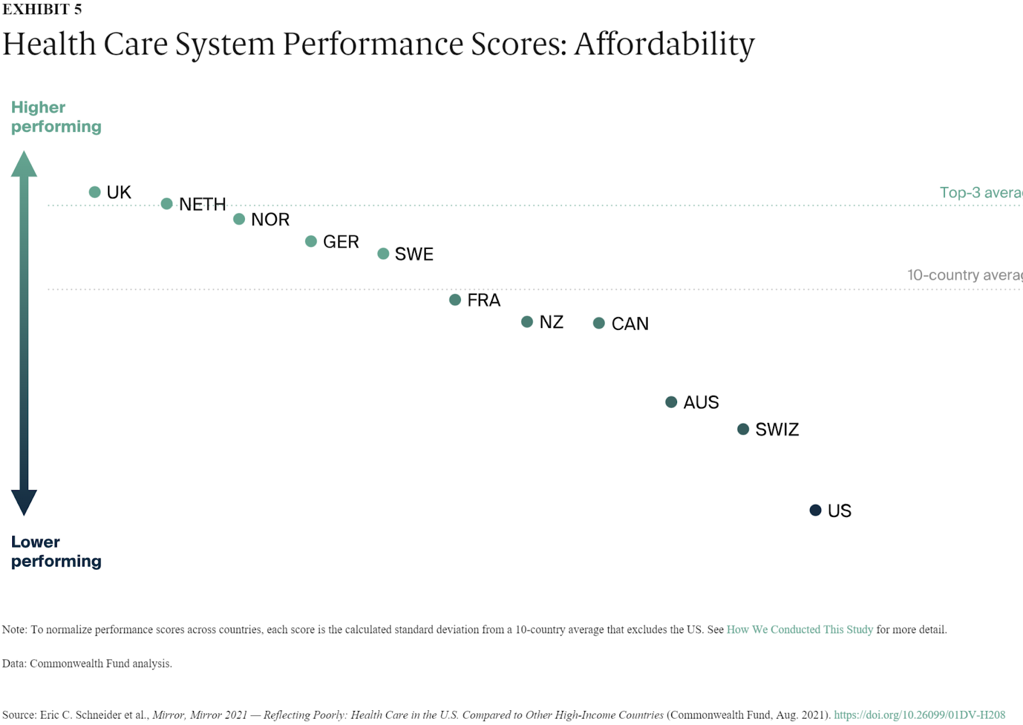

*Access to care* includes measures of health care’s *affordability* and *timeliness.* The Netherlands performs best on this performance domain among the 11 countries, ranking at or near the top in both subdomains. Norway and Germany also performed well on access to care (Exhibit 1), but all three are outranked on affordability by the U.K. (Exhibit 5).

Overall, the U.S. is #11 — last — on access to care (Exhibit 1). The U.S. has the poorest performance on the affordability subdomain, scoring much lower than even the next-lowest country, Switzerland (Exhibit 5). Compared to residents of the U.S., residents of the Netherlands, the U.K., Norway, and Germany are much less likely to report that their insurance denied payment of a claim or paid less than expected. Residents of these countries are also less likely to report difficulty in paying medical bills.

People in the countries performing the best on the timeliness subdomain are more likely to be able to get same-day care and after-hours care. The U.S. ranked #9 on timeliness.

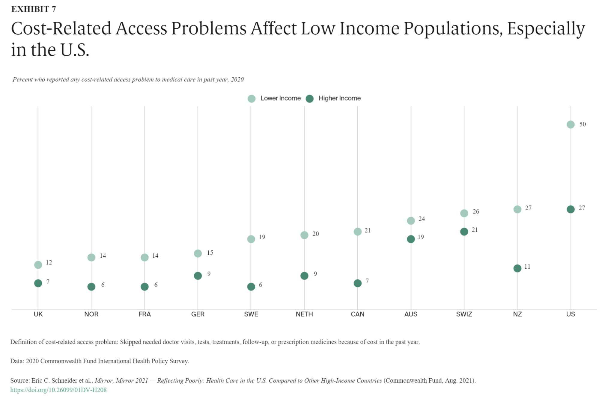

The U.S. consistently demonstrated the largest disparities between income groups, except for those measures related to preventive services and safety of care. U.S. disparities are especially large when looking at financial barriers to accessing medical and dental care, medical bill burdens, difficulty obtaining after-hours care, and use of web portals to facilitate patient engagement. Compared to the other countries, the United States and Canada had larger income-related inequalities in patient reported experiences.

Exhibit 7 illustrates the importance of comparing country performance on equity: relatively good performance on a health care measure overall may mask pronounced gaps in the experiences of lower-income versus higher-income groups. It also illustrates the challenge that arises in assessing equity without also considering performance overall: income-related differences on a measure may be small, but a nation’s performance may be comparatively poor for both higher- and lower-income groups.

In Exhibit 7, income-related performance disparities in Switzerland and Australia are as small as those in Germany and the U.K. But the cost-related access problems for higher-income residents of Switzerland and Australia resemble the levels seen among lower-income residents of the Netherlands and Canada. Adults with higher incomes in the U.S., Switzerland, and Australia are as likely as, or more likely than, adults with lower incomes in five countries to report cost-related access problems.

##### There are three overarching goals for the US health system: access, equity and affordability,

Overall Ranking:

Norway, the Netherlands, and Australia are the top-performing countries. The United States ranks last overall despite having a higher healthcare expenditure.

###### Access:

The Netherlands excels in health care affordability and timeliness, ranking highest in this performance domain.The U.S. is ranked last in access to care, particularly in affordability, where it scores significantly lower than other countries. Residents in top-performing countries are less likely to face insurance denials or difficulties in paying medical bills compared to the U.S.

Every American should have access to healthcare. Despite reaching a low of 28.7 million (8.9 percent of the population) in 2016, the number of uninsured individuals is projected to increase to 37.2 million (10.6 percent of the population) by 2028. This rise occurs at a time when research increasingly links insurance coverage to improvements in financial security, health, and longevity.

Access to care, however, requires more than insurance coverage. Convenient and timely primary care is also vital. Top-ranking countries like the Netherlands and Norway ensure timely availability to care by phone on nights and weekends (with in-person follow-up at home as needed). In the Netherlands, cooperative “GP posts” are staffed by general practitioners (primary care physicians), who are obligated to provide at least 50 hours of after-hours care (between 5:00 pm and 8:00 am) annually in order to maintain their professional licensure. In Norway, the Patients’ Rights Act specifies a right to receive care within specific timeframes and with maximum wait times applying to covered services, including general practitioner visits, hospital care, mental health care, and substance use treatment.

In top-performing countries, workforce policy is geared to ensuring access within communities, especially those that have been historically marginalized. Norway, with the highest number of doctors per person among the 11 countries in our study, has a much larger supply of physicians relative to its population than the U.S. has. Outside the U.S., a larger proportion of clinicians are devoted to primary care and are geographically distributed to match population needs. For example, Norwegian local municipalities, which are responsible for the supply of GPs, may apply to the national government for extra funding to ensure they have an adequate number of physicians.

###### Equity:

The U.S. exhibits the largest disparities between income groups, especially concerning financial barriers, medical bill burdens, and after-hours care. Income-related performance disparities in Switzerland and Australia are small, resembling those in Germany and the U.K. The U.S. remains the only high-income country lacking universal health insurance coverage, with significant numbers still uninsured or potentially underinsured.

Every American should have equal access to affordable healthcare. Yet, there are persistent inequities in healthcare access and outcomes based on race, ethnicity, socioeconomic status, and other factors. These disparities have become glaringly evident during the COVID-19 pandemic, disproportionately affecting underserved communities and people of color.

These three goals of access, affordability, and equity are interconnected. While some improvements are complementary, conflicts may arise in certain cases. The challenge lies in simultaneously enhancing access, affordability, and equity.

###### Affordability:

Every American should have access to affordable healthcare. However, healthcare spending is continuing to grow at an unsustainable rate, with consequences including a growing national debt, strained budgets, stagnant wages, and increased financial insecurity for Americans. Even for those with insurance coverage, healthcare is becoming increasingly unaffordable, leading roughly half of US adults to delay or avoid care due to costs.

[<https://www.healthaffairs.org/doi/10.1377/hlthaff.2020.01560>]

The West Health-Gallup Healthcare Affordability Index and Healthcare Value Index aim to evaluate the healthcare cost crisis in the United States. A report presents key findings from the latest data, shedding light on the challenges faced by American adults in affording healthcare and their perceptions of the value received.

In 2022 Approximately 44% of American adults, equivalent to a staggering 112 million individuals, find themselves grappling with challenges in affording healthcare, according to the latest data from these indices. What's more, a significant majority, a striking 93%, believes that the cost of healthcare does not align with the value received. This revelation highlights a critical disconnect between the financial burden borne by individuals and the perceived quality of the care they receive.

The Healthcare Affordability Index serves as a crucial metric, assessing the public's ability to afford necessary healthcare. Simultaneously, the Healthcare Value Index synthesizes Americans' perceptions of care quality relative to its cost, providing a holistic view of the healthcare landscape.

Economic repercussions are evident, with 35% of cost-desperate adults forced to cut back on utilities, while half have reduced food expenses in the past 12 months to meet healthcare expenses. Even more concerning, 14% of this group reported knowing someone who died in the last year due to the inability to afford necessary treatment.

Respondents are categorized into three groups based on their reported financial challenges in affording healthcare: "Cost Secure" (56%), "Cost Insecure" (36%), and "Cost Desperate" (8%). Notably, the likelihood of being classified as "Cost Desperate" is more than four times higher for households earning under $48,000 annually compared to those earning $90,000 or more.

Gender and ethnic disparities further compound the issue, with men more likely to be cost secure than women, and Hispanic adults less likely to be cost secure than their Non-Hispanic White counterparts.

In terms of perceived value, only 5% of the U.S. adult population perceives high value in their healthcare. A staggering 50% report inconsistent value, while 45% perceive poor value. These findings indicate a widespread dissatisfaction with the quality of care relative to its cost, pointing to a systemic issue in the healthcare system.

The indices serve as crucial resources for policymakers, researchers, and the public, emphasizing the urgent need to address the escalating healthcare cost crisis and improve the perceived value of healthcare services. With national health spending in the U.S. surpassing $4 trillion, and projections indicating continued annual growth, urgent and smarter policies prioritizing patients over profits are imperative.

Tim Lash, President of West Health, emphasized the importance of these indices in tracking the healthcare cost crisis and its impact on everyday Americans. He highlighted the growing trend of individuals being priced out of the system, with even those who can afford to pay expressing dissatisfaction with the perceived value of the care received. Lash called for smarter policies prioritizing patients over profits to address this concerning trajectory.

###### Statistics about the Healthcare accessibility and affordability (inaccessibility and unaffordability)

The West Health-Gallup 2022 Healthcare in America Report reflects the persisting challenges in the U.S. healthcare system, with 44% of American adults giving it a poor or failing grade. Since 2018, these studies have consistently highlighted the widespread perception that healthcare is unaffordable, leading many to skip treatments, ration medication, or face financial strain. In this latest report, based on a nationally representative sample of over 5,500 Americans, the overall system receives predominantly low grades, with 75% giving healthcare affordability a D or F. Notably, one in three respondents assigns an outright F to affordability. Despite recent federal-level efforts, such as the Inflation Reduction Act of 2022, aimed at lowering healthcare costs, the report underscores that the healthcare cost crisis persists.

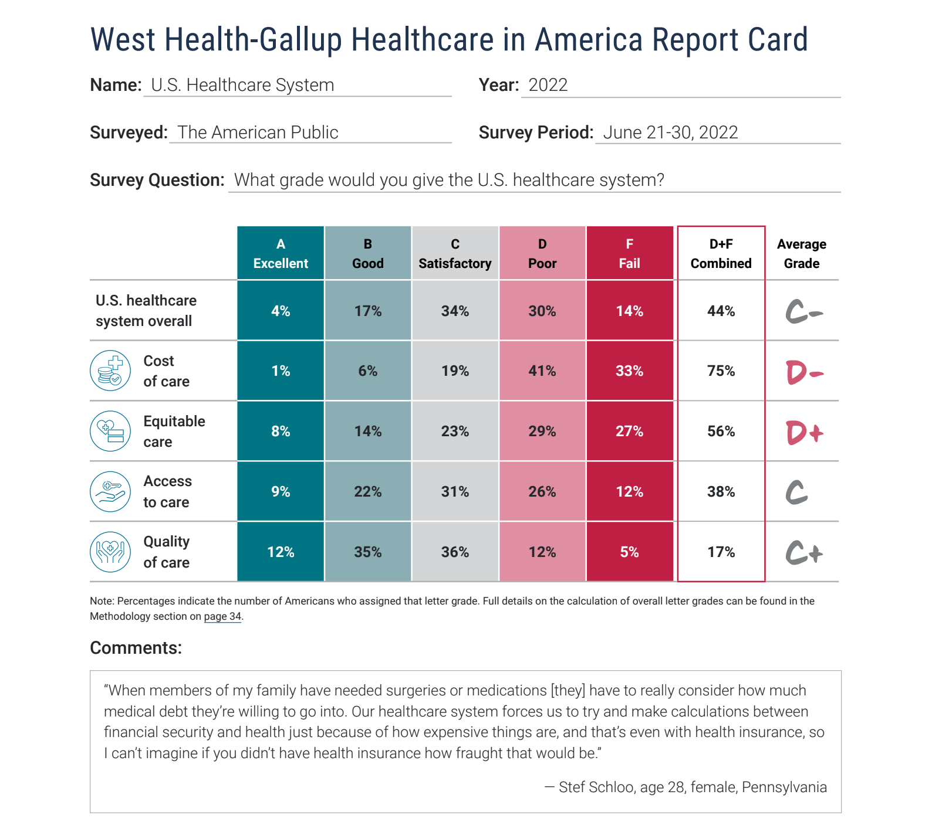

WASHINGTON, D.C. — Mar. 31, 2022 — The West Health-Gallup Healthcare Affordability Index and Healthcare Value Index were created to evaluate the healthcare cost crisis in the United States.

The Value created and the introduction of high deductible plans is a step towards exposing patients to more significant portions of healthcare costs, however, this shift is not without challenges, as patients may face initial financial strain, especially when unexpected healthcare needs arise.

I believe that the population who suffers the most are the ones which can’t not access healthcare at all due to different social factors: age, racism, gender, geo location, education, financial stability so the index of interest for my research will be the Affordability Index more precisely with focus on access to care.

Affordability

The affordability of healthcare in the U.S. is a widespread concern, with minimal differences across gender or racial identities in rating it as poor or failing. This worry extends across income brackets, as both the lowest and highest earners give similarly negative ratings on cost (74% and 73% rate it a D or F, respectively). Despite income-related variations in ratings for access and quality, distress over the burdensome cost of healthcare is universally shared. Large majorities, irrespective of gender, race, or ethnicity, rate the cost poorly, emphasizing that healthcare costs are a significant issue affecting Americans regardless of their financial status.

|  |  |
| --- | --- |

A significant majority of Americans, accounting for 56%, express dissatisfaction with the equity of the U.S. healthcare system, giving it a poor or failing grade. The concept of equity, defined as the ability of every individual to receive quality care without regard to personal characteristics, is perceived negatively by more than half of respondents across various demographic groups. Notably, Black and Asian Americans report lower grades on equity compared to Hispanic and White Americans, and women are more likely than men to assign poor or failing grades in this dimension (61% vs. 50%). Additionally, when evaluating access to care, nearly four in 10 Americans rate it poorly, with women and people of color more inclined than men and White adults to give access a negative grade. These findings underscore widespread concerns regarding both equity and access within the U.S. healthcare system.

*“A friend of mine, her husband, just recently died... During his later days before his death...she couldn’t even get the doctor on the phone or to return her calls... That was due to accessibility…”— Deni Hagains Goss, age 70, female, Pennsylvania*

*“For the richest country on earth I think we have the most deplorable healthcare system...due to its inequity, mainly due to the way it all depends on how much money somebody has whether they get good healthcare or not.” — Anne Courtney Davis, age 71, female, Ohio*

|  |  |
| --- | --- |

Rising healthcare costs have compelled nearly four in 10 Americans to delay or skip healthcare treatments, cut basic household expenses, or borrow money for medical bills in the past six months, with one in six individuals reducing care needed in the past year to cover essential needs like food and rent. Women, Black, and Hispanic Americans are disproportionately affected, with three in 10 women reporting cutbacks on care compared to 22% of men. Over 25% of adults, roughly 70 million people, state they cannot afford quality care if needed today, and 26% skipped needed care due to cost in the prior three months. Disproportionately high rates of this practice are observed among women, Hispanic, and Black adults. Age disparities also emerge, with those aged 65 and older (8%) less likely to cut back compared to those under 50 (21%) and those between 50 and 64 (19%). The age gap is more pronounced among Black respondents, where 30% of those under 50 reported such reductions. This variance likely reflects Medicare eligibility and lower household expenses among older age groups.

|  |  |
| --- | --- |

The Healthcare Affordability Index assesses three critical factors that illustrate the outcomes of Americans facing challenges in affording healthcare:

* Avoiding treatment because of cost
* Skipping prescribed medication or drugs due to cost
* Immediate access to affordable, quality healthcare

Based on these criteria, individuals can be categorized into three groups:

|  |
| --- |
|  |

In 2022, the Healthcare Affordability Index indicates a slight improvement in care affordability, with 61% of Americans classified as Cost Secure in 2022, up from 56% in 2021. This improvement is notably driven by men (up seven points to 67%) and White adults (up six points to 64%). However, other groups, including women (54%), Black adults (56%), and Hispanic adults (49%), showed no significant change in Cost Secure status. Despite an overall decrease in the percentage of Americans struggling with healthcare costs from 44% in 2021 to 39% in 2022, the proportion classified as Cost Desperate remains essentially unchanged at 7%, compared to 8% in 2021. This suggests that gains in affordability have been limited to a specific subset of Americans, with minimal positive impact on those in greater need of improvement.

In the US health system costs are high and quality is low. Mainly the reason behind are the misaligned payment methods- which do not tie costs to outcomes. The health providers are doing redundant and not necessary procedures to the extent that they are prolonging the treatment period for additional services which are being paid by the insurance companies and the patient him/herself. This is not only costly but life-endangering.

In reality with different payment models rather than fee-for-service, the same costs could both buy better quality AND increase accessibility for the three parties involved- patients, insurance companies and the health providers. Triple win!

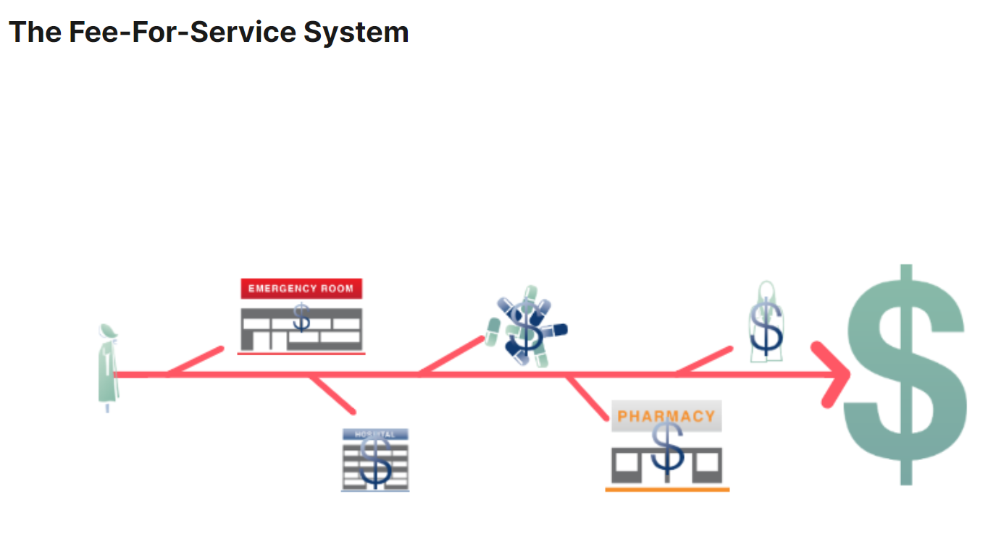

As already explained, the fee-for-service system benefits more of a sick patient than a healthy one and this needs to change.

#### Revolutionizing American Healthcare: A Journey Through Time (1900s-2022)

In the intricate narrative of American healthcare, a paradigm shift known as value-based care has been gradually taking shape since the early 20th century. This transformation from the traditional fee-for-service model gained momentum with visionaries like Dr. Ernest Codman, who championed the measurement of healthcare outcomes, placing patients at the heart of care.

##### Understanding the Big Change: APMs and Value-Based Models

This monumental change transcends mere alterations in payment methods; it signifies a departure from the antiquated practice of paying for each service. The focus now lies on the value that healthcare services bring to patients. Termed Alternative Payment Methods (APMs) or value-based models, these approaches seek to ensure that healthcare isn't merely a profit-driven enterprise but a provider of genuine value to patients.

##### Noticing Recent Trends: A Different Way to Pay for Healthcare

In the past 13 years, the landscape of healthcare payments has undergone significant transformations. While the conventional and expensive payment model still prevails, an increasing number of payments are shifting towards value-based concepts. In 2019, over one-third of U.S. healthcare payments were value-based, marking a substantial increase from 23% in 2015. Key programs such as Medicare Shared Savings and the Medicare Access and CHIP Reauthorization Act (MACRA) played pivotal roles in catalyzing this shift.

##### HCPLAN: Keeping an Eye on Healthcare Payments

Functioning as a vigilant observer, the Health Care Payment Learning & Action Network (HCPLAN or LAN) monitors the prevalence of value-based ideas in healthcare payments. Categorizing these payments, HCPLAN provides insights into the evolving landscape of healthcare.

##### A Journey Through Time: Important Moments Shaping Healthcare

The evolution of healthcare is punctuated by pivotal moments that have sculpted the current landscape:

* Medicare and Medicaid (1965): These foundational programs facilitated healthcare access for older and lower-income individuals, laying the groundwork for linking payments to healthcare effectiveness.
* Managed Care Era (1970s-1980s): The 1970s and 1980s witnessed the rise of groups dedicated to cost control and care coordination, emphasizing preventive care and proactive problem-solving.
* Institute of Medicine Reports (1990s): Reports in the 1990s underscored the importance of quality measurement, patient safety, and patient-centered care.
* Value-Based Purchasing (Early 2000s): The early 2000s saw the emergence of new payment models that correlated money with the quality of care, paving the way for more significant changes.
* MIPPA (2008): MIPPA introduced quality-related provisions, giving birth to the Physician Quality Reporting Initiative (PQRI), later evolving into the Merit-Based Incentive Payment System (MIPS) under MACRA.
* Blue Cross AQC Model Creation (2009): The AQC model introduced a "global" budget for physicians, emphasizing preventive care and offering flexibility for innovation, successfully slowing the rate of healthcare spending growth.
* Affordable Care Act (2010): In 2010, the ACA brought forth transformative ideas like Accountable Care Organizations (ACOs) and bundled payments, aiming to enhance healthcare quality.
* MACRA and Quality Payment Program (2015): MACRA, in 2015, introduced the Quality Payment Program, urging doctors and hospitals to prioritize quality and value in care.
* CMS Primary Care Initiatives (2018): In 2018, CMS launched the Primary Cares Initiative, focusing on delivering high-quality patient-centered care.
* SNF - VBC Program (2018): The SNF VBP program, introduced in 2018, incentivizes skilled nursing facilities (SNFs) to enhance care quality for Medicare beneficiaries by reducing unplanned hospital readmissions.

[https://innovaccer.com/resources/blogs/what-is-the-history-of-value-based-care]

As we traverse this timeline, it's evident that each milestone contributes to the ongoing evolution of healthcare, steering towards a future where value and quality take precedence over traditional payment models.

#### Fee-for-Service vs Value-based-Care

The initial set LAN’s goal was the adoption of Alternative Payment Models (APMs) in 30% of the U.S. health care payments to APMs by 2016 and 50% by 2018.

Commercial health plans, Managed Care Organizations (MCOs), state Medicaid agencies, Medicare Advantage (MA) plans, and Medicare voluntarily participated in a national effort to measure the use of Alternative Payment Models which were assessed and measured regarding the LAN’s APM landscape.

In 2020, 40.9% of U.S. health care payments i.e. 9 public and private payers, representing approximately 238.8 million Americans and 80.2% of the covered population were taken into consideration.

Tha LAN landscape was divided in 4 different categories as a continuum of clinical and financial risk for provider organizations.

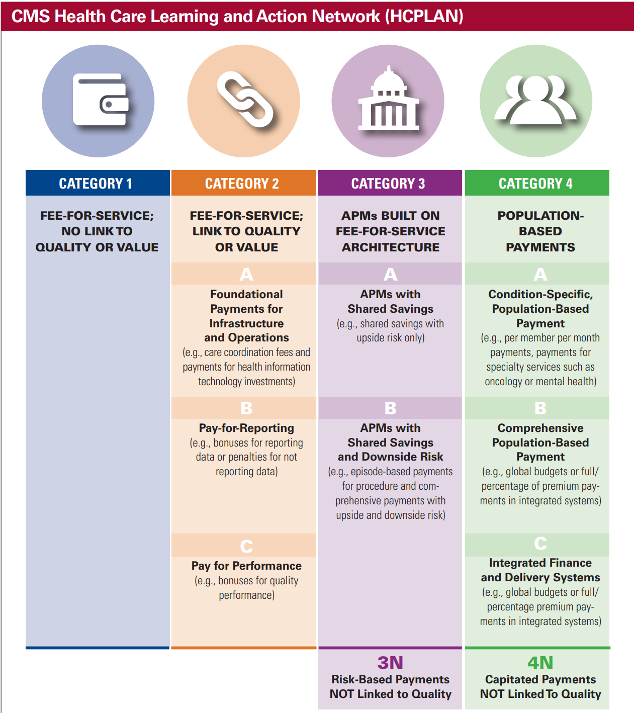

The assessment by the Health Care Payment Learning & Action Network (LAN) reveals a consistent rise in the adoption of alternative payment models (APMs) using fee-for-service frameworks and population-based payments. Starting at 23% in 2015, the share has increased to approximately 41% by 2020. Despite this upward trajectory, the predominant share of funds in value-based agreements still flows through fee-for-service (FFS) structures.

Notably, only a limited number of providers are open to taking financial losses, and merely 4% of arrangements involve population-based payments (Category 4). This poses a significant challenge for health systems aiming to transform their care models to align with APM objectives while being largely dependent on fee-for-service payment arrangements.

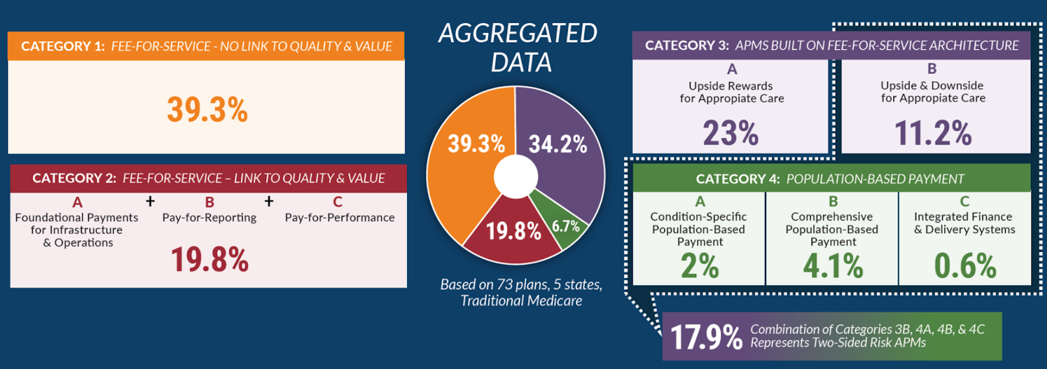

Although LAN fell short of its 2018 goal of achieving 50% APM adoption, reaching 40%, fee-for-service payment methods maintained a higher adoption rate at 59.1%. However, there is optimism among 87% of the 9 public and private payers for increased APM adoption, particularly foreseeing a significant rise in Category 3 APMs built on top of fee-for-service architecture. This underscores a hopeful outlook amid the ongoing complexities of transitioning payment models in the healthcare landscape.

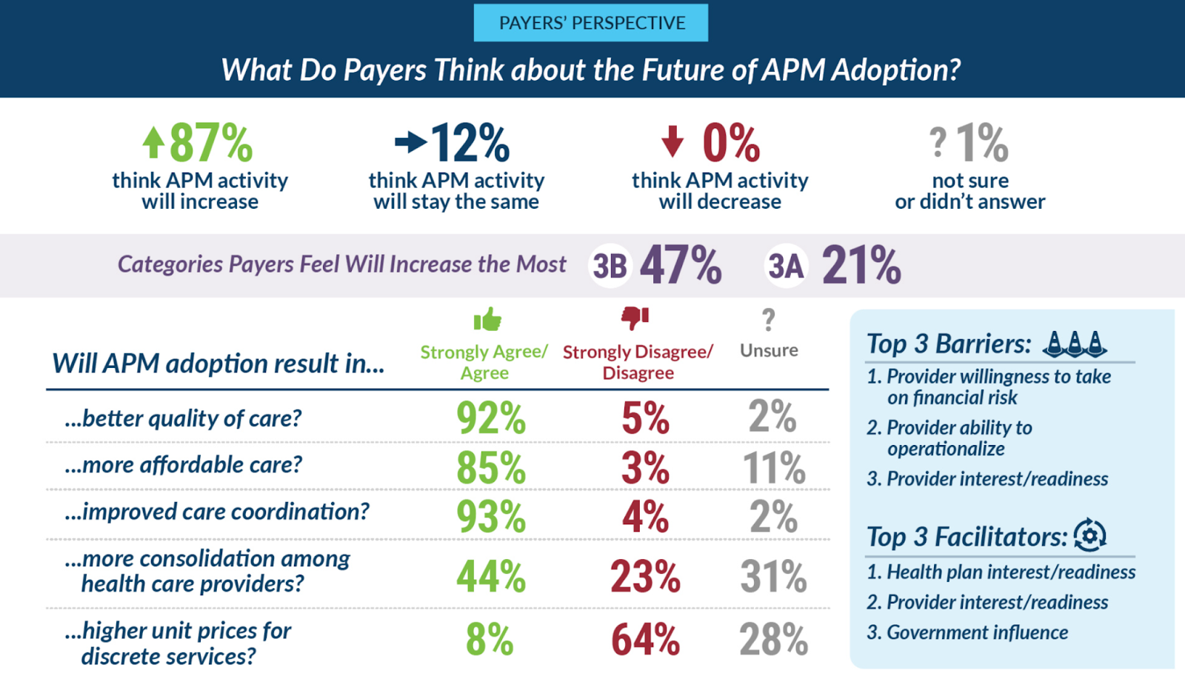

#### The Four Most Common Alternative Care Delivery Models

##### Accountable Care Organizations

An umbrella system of the whole health ecosystem working together towards a predefined overall target. The ACO physicians submit their bills using their customary billing methods, however, the cumulative costs are evaluated against the predefined target. The costs should not be higher since it is against compliance and they could be fined. In other words they are required to assess certain patient outcomes to demonstrate compliance with specific quality benchmarks. There is definitely incentive for the ACO physicians and providers since If they succeed to quality treat the patient below the cost target and hit the quality benchmarks they get shares from the insurance.

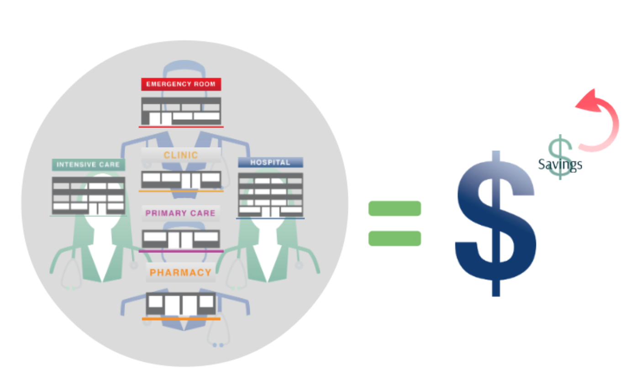

##### Patient-Centered Medical Home Model

Distinguish themselves by offering predetermined monthly payments in addition to existing funding models, aimed at financing a well-coordinated integrated team consisting of primary care providers, nurses, care managers. This additional funding can be allocated for the hiring of nurses or engaging agencies to provide specialized care and attention to crucial patients which could reduce the need for emergency rooms and in the long run the initial extra money could be worth in enhancement of quality of medical care overall and saving on costs with advanced cohesion and coordination among the whole medical ecosystem.

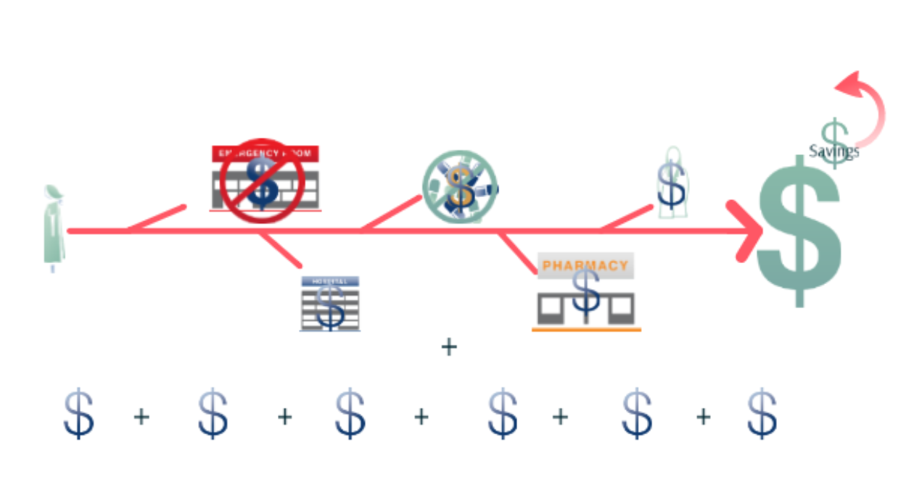

##### Integrated Service Lines or Bundles

This model involves grouping healthcare services into comprehensive packages or "bundles." It focuses on providing coordinated and integrated care throughout a specific healthcare episode, often involving a single payment for a bundled set of services. This approach aims to enhance efficiency, reduce costs, and improve patient outcomes by streamlining the delivery of care within a specific medical condition or procedure.

##### Provider-sponsored Health Plans

Provider-sponsored health plans are insurance plans established and operated by healthcare providers or provider organizations. In this model, healthcare entities take on the role of insurers, offering coverage to individuals or groups. These plans often aim to align healthcare delivery and financing, fostering a more integrated and patient-focused approach. Provider-sponsored health plans can create synergies between insurance and care provision, potentially leading to improved care quality and cost-effectiveness.

[<https://trustees.aha.org/system/files/media/file/2019/10/MarketInsights_CareModelsReport-p8.pdf>]

#### The Rise of ACOs and Medical Homes in Healthcare Transformation

In the realm of healthcare, the adoption of Accountable Care Organizations (ACOs) and Patient-Centered Medical Homes has experienced a significant surge, reaching up to 40% since 2011. This trend is particularly notable in Academic Medical Centers (70%), Community Hospitals (40%), and Critical Access Hospitals (30%).

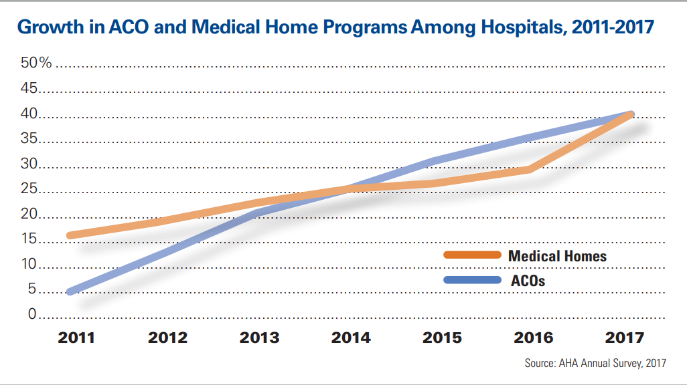

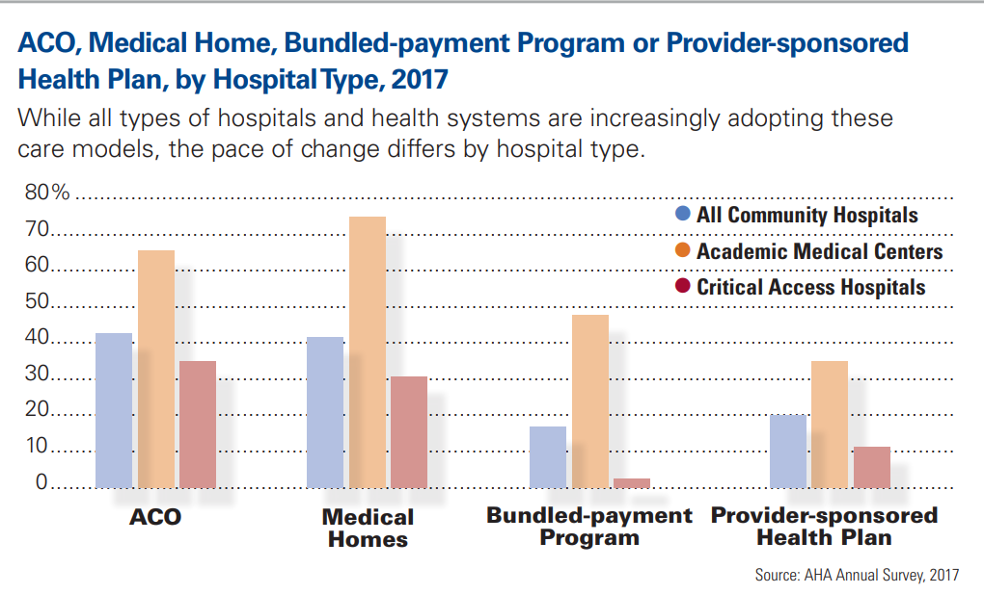

Leading this transformative wave is Caravan Health, specializing in empowering ACOs for excellence in population health management and value-based payment programs. Recognizing a crucial challenge faced by ACOs operating under shared savings/shared risk models—related to scale and spending fluctuations—Caravan Health introduced a strategic solution. In 2019, they launched a national virtual Medicare ACO, aggregating Medicare lives across rural health systems and significantly expanding the reach to cover 225,000 lives.

Caravan's comprehensive approach includes specific care model requirements, an intensive training program, and a robust data analytics platform. This strategy allows smaller, rural providers to achieve the necessary scale for success under Alternative Payment Models (APMs). Lynn Barr, Caravan’s CEO, underscores the goal of standardizing an effective model to yield tangible results and foster transformative change.

In a recent article dated January 30, 2024, Healthcare Innovations reported a remarkable increase in the number of ACOs participating in the Medicare Shared Savings Program (MSSP). The Centers for Medicare and Medicaid Services (CMS) revealed a record 480 ACOs, signifying a 5.13% growth. Notably, 19 new ACOs are eligible for a permanent payment option, receiving substantial advance investment payments (AIPs). The ACO REACH Model and Kidney Care Choices (KCC) model, part of CMS Innovation Center, have also witnessed growth, emphasizing a commitment to enhancing access to high-quality, coordinated healthcare, especially in underserved communities.

https://www.signifyhealth.com/

[<https://www.hcinnovationgroup.com/policy-value-based-care/news/53091122/cms-481-acos-now-in-medicare-shared-savings-program-a-new-high>]

#### Challenges for 100% adoption:

Provider willingness to take on financial risk is the highest challenge in adoption among the health-care providers.

### 2. Multi-payer System

In comparison to other high-income nations, the healthcare insurance and payment system in the United States exhibit significant fragmentation. The use of the term "fragmentation" typically implies a lack of cohesion or integration in the healthcare system, which may have both positive and negative aspects depending on the context and perspective. For instance, fragmentation might be seen as a disadvantage if it leads to inefficiencies, higher costs, or barriers to access. On the other hand, it could be viewed as advantageous if it allows for diverse options and flexibility. The U.S. features a multi-payer system that involves various entities, such as publicly financed programs (e.g., Medicare, Medicaid), as well as commercial insurers and health plans.

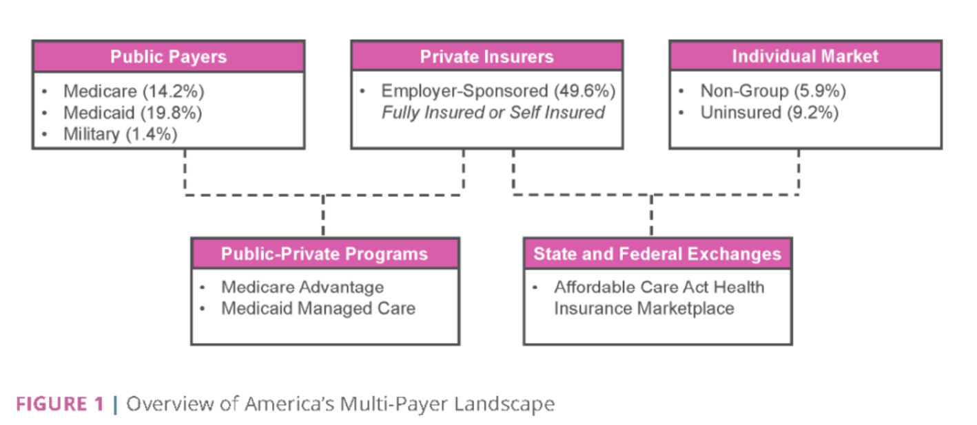

*Does this fragmentation of the healthcare insurance and payment system in the United States implies inefficiencies and greater barriers or alternatives and flexibility?*

#### How did it start?

The evolution of the US medical care system can be traced from its origins rooted in physician autonomy and individual patient purchases during the 1800s to a transformative shift where it became an employment benefit in the 1940s, driven by the need to attract workers during World War II wage controls. Despite numerous attempts, spanning back to President Theodore Roosevelt's administration, to establish health care as a national public good, these efforts consistently fell short.

The emergence of publicly sponsored medical insurance programs, exemplified by initiatives like Medicare and Medicaid, in the United States has primarily been driven by charitable considerations. The prevailing sentiment has been that individuals in vulnerable groups—such as the poor, elderly, disabled, and unemployed—should have access to affordable medical care, not merely as a public good but as an act of compassion. Over time, these endeavors have led to substantial expansions in coverage.

[<https://www.healthaffairs.org/doi/10.1377/hlthaff.2022.01255>]

In the United States, a health coverage gap has led to an inequitable, fragmented, expensive, inefficient, and profit-driven healthcare landscape, leaving over 40 million Americans without insurance. Administrative costs surpass expenditures on major health issues like heart disease and cancer, and these challenges are unique to the U.S. A critical viewpoint attributes the problem to the American multi-payer healthcare system, differing from the single-payer systems adopted by most wealthy nations.

Initially targeting the elderly, Medicare was intended for broader implementation across the American population, with a similar program, Medicaid, developed for low-income families. Despite these efforts, a notable coverage gap persisted between low-income individuals and the elderly. The Affordable Care Act, initiated by President Obama, aimed to address this gap but faced resistance.

Essentially, a single-payer system involves a single entity managing funds for the entire population's healthcare. In contrast, a multi-payer system allows various entities, such as insurance companies, to handle payments. The term "single-payer" can have variations, as seen in some rich economies like Germany, the Netherlands, and Switzerland, where individuals can enroll in multiple insurance plans run by private companies and nonprofits. Other countries, like the United Kingdom, have government-run hospitals and employed physicians. These diverse systems reflect a complex evolution and numerous iterations in pursuit of effective healthcare models

The debate between single-payer and multi-payer healthcare remains a contentious and predominantly partisan issue in the United States. Democratic candidates, particularly in the 2020 election, often advocate for Medicare-for-All, while Republican candidates oppose any legislation resembling a single-payer model.

#### Challenges: Multi-payers vs Single-payer

The conversation about a single-payer system revolves around two key questions: the cost and how to fund it. The cost of a single-payer plan varies depending on factors like the inclusion of long-term care. While critics often cite the unspecified cost as a weakness, potential cost-cutting measures include premiums, deductibles, or copays.

Funding a single-payer system necessitates new taxes, but the type of taxes—payroll, income, or sales—raises concerns and opposition. Senators Elizabeth Warren and Bernie Sanders proposed taxing the top one percent to fund universal healthcare, but the idea of new taxes can be unpopular among the general public.

Advocates argue that despite initial costs, a single-payer system saves money in the long run. Eliminating for-profit private insurers reduces administrative costs, potentially saving over $150 billion annually. While Americans rightly prioritize healthcare costs, a single-payer system aims to alleviate, not worsen, the issue. It seeks to ensure financial security in health crises while requiring a modest upfront investment for long-term benefits.

The American inclination towards skepticism of governmental authority, rooted in a history of revolution, raises concerns about turning healthcare into a government-run system. Critics fear that a single-payer model may lead to inefficiencies. In a multi-payer system, higher payments often result in better service, catering to premium plan holders. The worry is that a shift to single-payer could result in long lines, delays, and increased bureaucracy.

While non-essential and cosmetic services may not be covered under a single-payer plan, concerns about a significant drop in the quality of care are debunked by studies showing no difference in quality, effectiveness, or efficiency between multi-payer and single-payer systems. Instead, single-payer systems are noted for their greater equity.

The fundamental goal of single-payer healthcare is to ensure equitable health services for those who need it most. Although there are valid concerns about its practical implementation, variations in design can drastically impact how a single-payer system provides care. Examples like the single-payer system for veterans in America, despite criticism, show that satisfaction levels can be high, emphasizing the importance of design in shaping the system's outcomes.

Utilizing the frameworks of both the Affordable Care Act and Medicare, a gradual implementation of a single-payer system could extend coverage to every citizen over a decade. This phased approach involves progressively lowering the age requirements and easing admissions criteria for these existing programs. The deliberate and systematic rollout provides flexibility to make necessary adjustments during the process. States can independently determine their level of engagement and adoption pace, facilitating the customization and hybridization of a single-payer model suitable for diverse contexts, regions, and individuals.

[<https://www.mhaonline.com/blog/healthcare-debates-single-payer-vs-multi-payer>]

### 3. No Universal Health-care Coverage

Universal health coverage (UHC) means everyone can get the health services they need without money being a problem. It includes everything from staying healthy to getting treatment when needed. To make this happen, countries should have strong and fair health systems that are connected to the communities they serve. Primary health care (PHC) is the best and most cost-effective way to achieve UHC. Each country can choose its own path to reach UHC based on the needs of its people and the resources available. Investing in PHC ensures that all health needs are identified and addressed well, with a capable health workforce and contributions from all parts of society. This approach also helps deal with factors like the environment and economy that affect health, including preparing for emergencies.

The United States remains the sole high-income nation where such care is not universally guaranteed. Racial health inequalities in the U.S. are deeply ingrained, paralleling the foundational nature of democracy itself. Harvard University's historian of science, Evelynn Hammonds, notes that throughout American history, there has never been a period when the health of Black individuals equaled that of whites, asserting that disparity is inherent in the system. While Medicare, Medicaid, and the Affordable Care Act have made strides in reducing these disparities, no federal health policy has completely eliminated them.

In the first half of 2021, 9.6% of the U.S. population, equivalent to 31.1 million people, lacked health insurance, according to preliminary estimates from the National Health Interview Survey by the Centers for Disease Control and Prevention (CDC).

Breaking down the figures among adults under 65, a significant disparity is evident. Hispanic adults had the highest uninsured rate at 31.4%, surpassing Black (14.7%), white (9.0%), and Asian (6.1%) adults, highlighting a socioeconomic and racial divide in healthcare coverage (CDC, KFF).

Notably, specific groups face a higher likelihood of being uninsured. In the same period, almost a third of the Hispanic population in the U.S. lacked health insurance, making them the second least likely group to have coverage.

Examining industries, employees in the farming, fishing, and forestry sector exhibited the largest insurance coverage gap, with 19.4% of workers being without insurance (CDC). This emphasizes that the likelihood of having health insurance is influenced not just by race and gender but also by the industry and type of work. Those working in food preparation and serving are nearly as likely to be uninsured, with almost one-fifth (19.3%) lacking health coverage.

[https://fortunly.com/statistics/uninsured-americans/#:~:text=Key%20Uninsured%20Population%20Statistics%20for%202024%20-%20Editor%E2%80%99s,adults%20younger%20than%2026%20have%20no%20health%20insurance.]

The terminology surrounding healthcare reform often brings about confusion, with the term "single-payer" lacking a standardized definition.

#### Differences: Universal Coverage vs. Single-Payer System:

Universal coverage strives to ensure that every individual has access to health services, utilizing diverse models such as government-run, private, or hybrid systems. Despite the Affordable Care Act's efforts, the United States falls behind in achieving the comprehensive coverage observed in other developed nations.

##### Single-Payer System:

In a single-payer system, the government takes on the role of the sole entity responsible for healthcare claims, funded through taxes. While numerous countries, including Japan and Canada, have embraced single-payer systems, achieving universal coverage remains a distinct challenge.

##### Two-Tier Systems:

While universal coverage and single-payer systems often align, some countries like Canada and France operate two-tier systems. This model combines basic care through a single-payer system with secondary private coverage for enhanced services.

##### Socialized Medicine:

Socialized medicine involves government funding, the operation of hospitals, and the employment of medical staff. The U.S. Veterans Administration (VA) system exemplifies socialized medicine, unlike Medicare. Contrasting this, the United Kingdom's NHS represents a fully socialized system, while Canada maintains private operation despite having a single-payer system.

#### Challenges:

Some experts propose incremental reform of the U.S. healthcare system, aiming to establish a government-funded safety net for the sick and the poor. This approach resembles the broader application of the Affordable Care Act's (ACA) Medicaid expansion, but it entails healthier, more affluent Americans still needing to purchase their policies.

One notable challenge is the potential establishment of a U.S. single-payer system without achieving universal health coverage. This remains unlikely due to the federal government needing to serve as the single payer.

The lack of political will in the U.S. poses a hurdle, as there is no consensus on whether healthcare should be "free," and there is resistance to excluding individual citizens from health coverage.

Political gridlock surrounding the Affordable Care Act limits the support for enacting such proposals. While it is technically feasible to construct a system providing universal coverage with multiple payers, reaching a consensus remains challenging.

Numerous U.S. legislators advocate for "Medicare for All," a proposal introduced by Senator Bernie Sanders, with substantial support reflected in 121 cosponsors of the Medicare for All Act of 2021 in the U.S. House of Representatives. This initiative envisions the U.S. government providing coverage to all citizens, offering more comprehensive coverage than the existing Medicare program.

Despite accusations of socialized healthcare, it's crucial to note that recent U.S. proposals, including "Medicare for All," do not rely on or incorporate socialized medicine.

## To sum it up:

### Three overarching goals for the US health system:

#### Access - providers in rural areas

#### Equity - different races

#### Affordability - financial capabilities

### Three highest barriers in the US health system:

#### Fee for service Care Model

##### Highest challenge: The highest challenge is the financial risk associated with the Value-Based Care model, as healthcare providers express reluctance due to concerns about long-term profitability and optimization, which contrasts with the pursuit of immediate profit.

#### Multi-payer Insurance Healthcare Model

##### Highest challenge: The highest is the skepticism and fear among Americans regarding the shift to a single-payer healthcare system, rooted in historical concerns about government authority. Critics worry about potential inefficiencies, long lines, delays, and increased bureaucracy, reflecting a broader hesitation to embrace a government-run healthcare system.(There is still a multi-payer vs single-payer debate among the population and the political parties as well)

#### Non Universal Healthcare Coverage

##### Highest challenge: The highest challenge is the lack of political will and consensus in the U.S., which hinders the establishment of a single-payer system or universal health coverage, leading to resistance and political gridlock.

### Four features distinguish top performing countries in the overall ranking of the healthcare system from the United States:

#### 1) they provide for universal coverage and remove cost barriers

#### 2) they invest in primary care systems to ensure that high-value services are equitably available in all communities to all people

#### 3) they reduce administrative burdens that divert time, efforts, and spending from health improvement efforts

#### 4) they invest in social services, especially for children and working-age adults.

[<https://www.commonwealthfund.org/publications/fund-reports/2021/aug/mirror-mirror-2021-reflecting-poorly>

## **Which people are suffering the most in the USA in terms of low quality in healthcare?**

Only 5% of the U.S. adult population perceives high value in their healthcare, indicating a widespread dissatisfaction with the quality of care relative to its cost. This sentiment is sharedacross various demographic groups, emphasizing that the issue of perceived poor value is systemic. Uninsured people are in total 8% of the U.S. population, equivalent to 27 million people.

Based on the Qualitative Analysis and literature review, several groups of people in the USA are particularly affected by financial barriers in healthcare:

* Low-Income Households:

The likelihood of being classified as "Cost Desperate" is more than four times higher for households earning under $48,000 annually compared to those earning $90,000 or more. This indicates that individuals with lower incomes face a more significant struggle in affording healthcare.

* Women, Black, and Hispanic Americans:

About four in 10 adults (41%) reported having debt from unpaid medical or dental bills. Hispanic and Black working-age adults were less likely to have healthcare coverage than White/Non-Hispanic or Asian adults in 2022. Disparities existed among ethnic groups, with Hispanic adults having the largest uninsured percentage (23.4%), followed by Black adults at 11.4%.

Women, Black, and Hispanic Americans are disproportionately affected by rising healthcare costs. Three in 10 women report cutbacks on care compared to 22% of men. Black and Hispanic adults also experience higher rates of skipping needed care due to cost. Black and Asian Americans report lower grades on equity compared to Hispanic and White Americans, and women are more likely than men to assign poor or failing grades in terms of equity. Nearly four in 10 Americans rate access to care poorly, with women and people of color more inclined than men and White adults to give access a negative grade.

* Age Disparities:

Disparities based on age are observed, with those aged 65 and older less likely to cut back on healthcare compared to those under 50 and those between 50 and 64. This variance likely reflects Medicare eligibility and lower household expenses among older age groups.Young adults aged 19 to 25 had the highest uninsured percentage (14%), followed by those aged 26 to 34 at 12.5%.

* Geographical Location:

The South region had the highest percentage of uninsured working-age adults at 7.7%, followed by the West at 4.2%. People in rural areas as well have the biggest challenges in terms of access to care despite the affordability obstacle, most probably because the percentage of low income families in the rural areas is significantly higher.

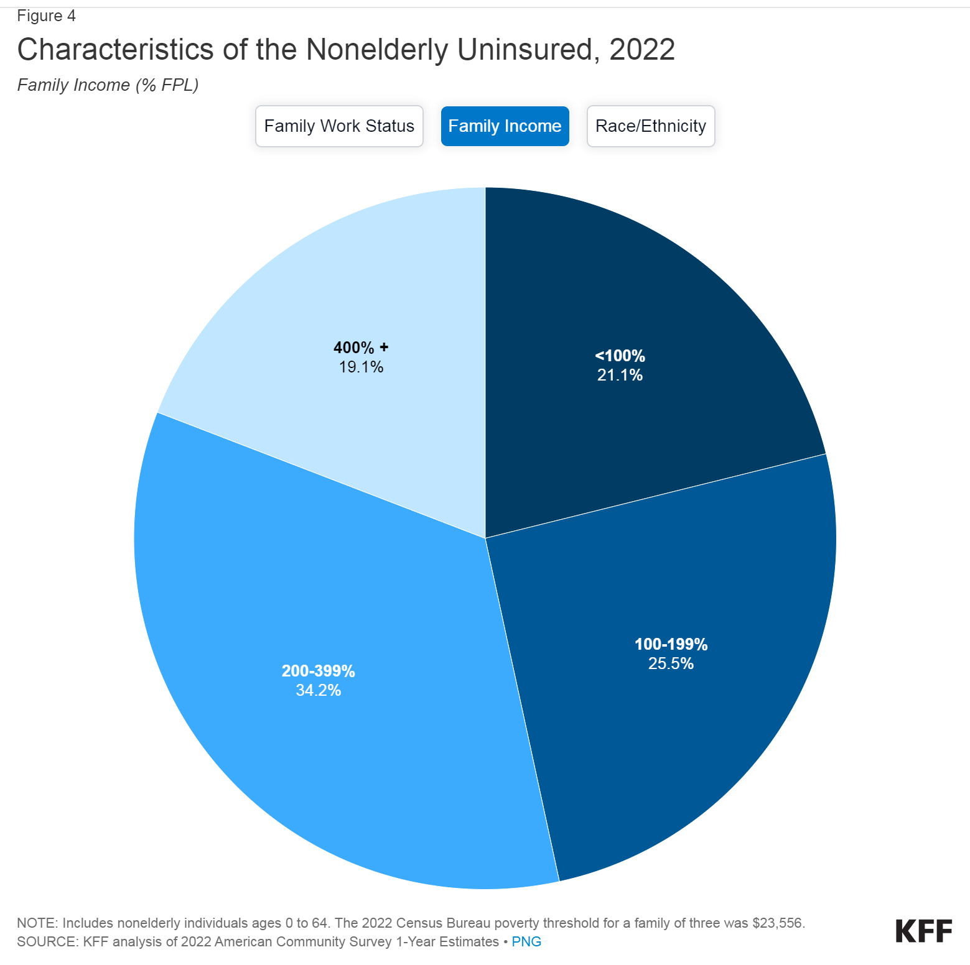

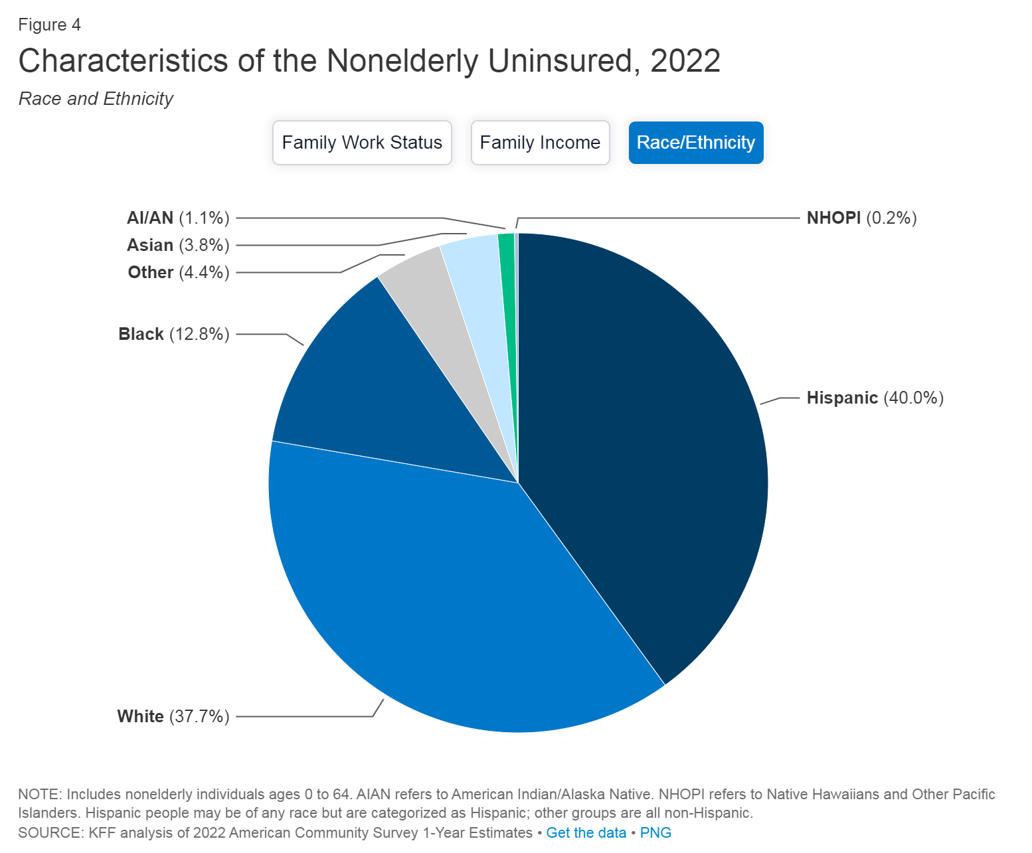

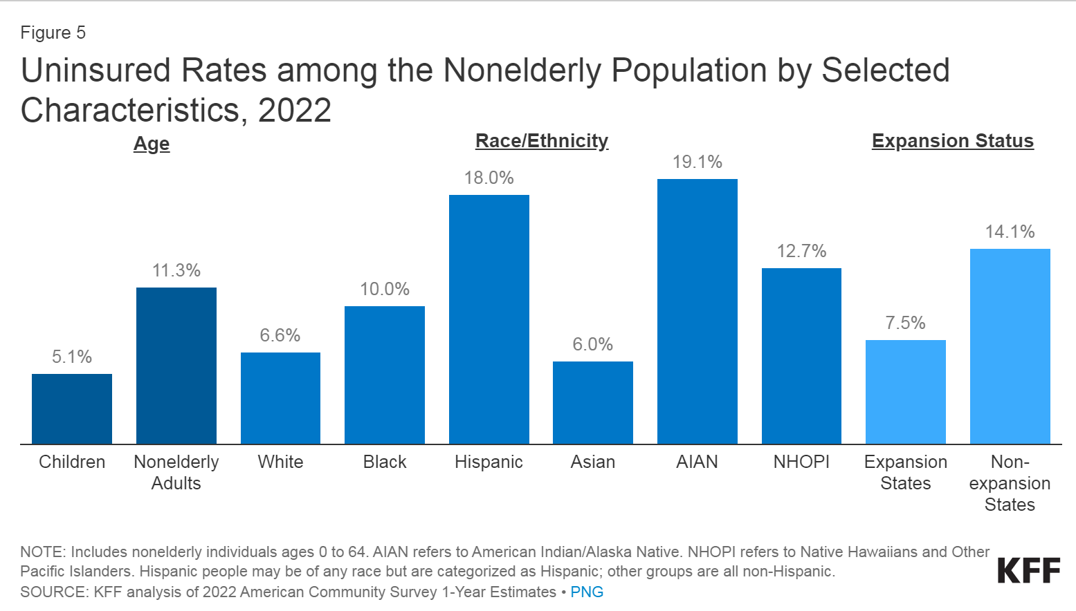

Women, Black, Hispanic, Asian Americans, People in the age group 19-64, People living in the South region, West region, rural area are suffering the most in terms of low quality health-care.

**The next crucial question is which factors have the most influence on the low quality of healthcare?**

The highest number of uninsured people by a report on MARCH 16, 2023.

The majority of uninsured adults are in the age range from 19 until 64 over black or hispanic ethnicity. Women of these ethnicities are even more affected, especially the ones living in rural areas.

***Low income?***

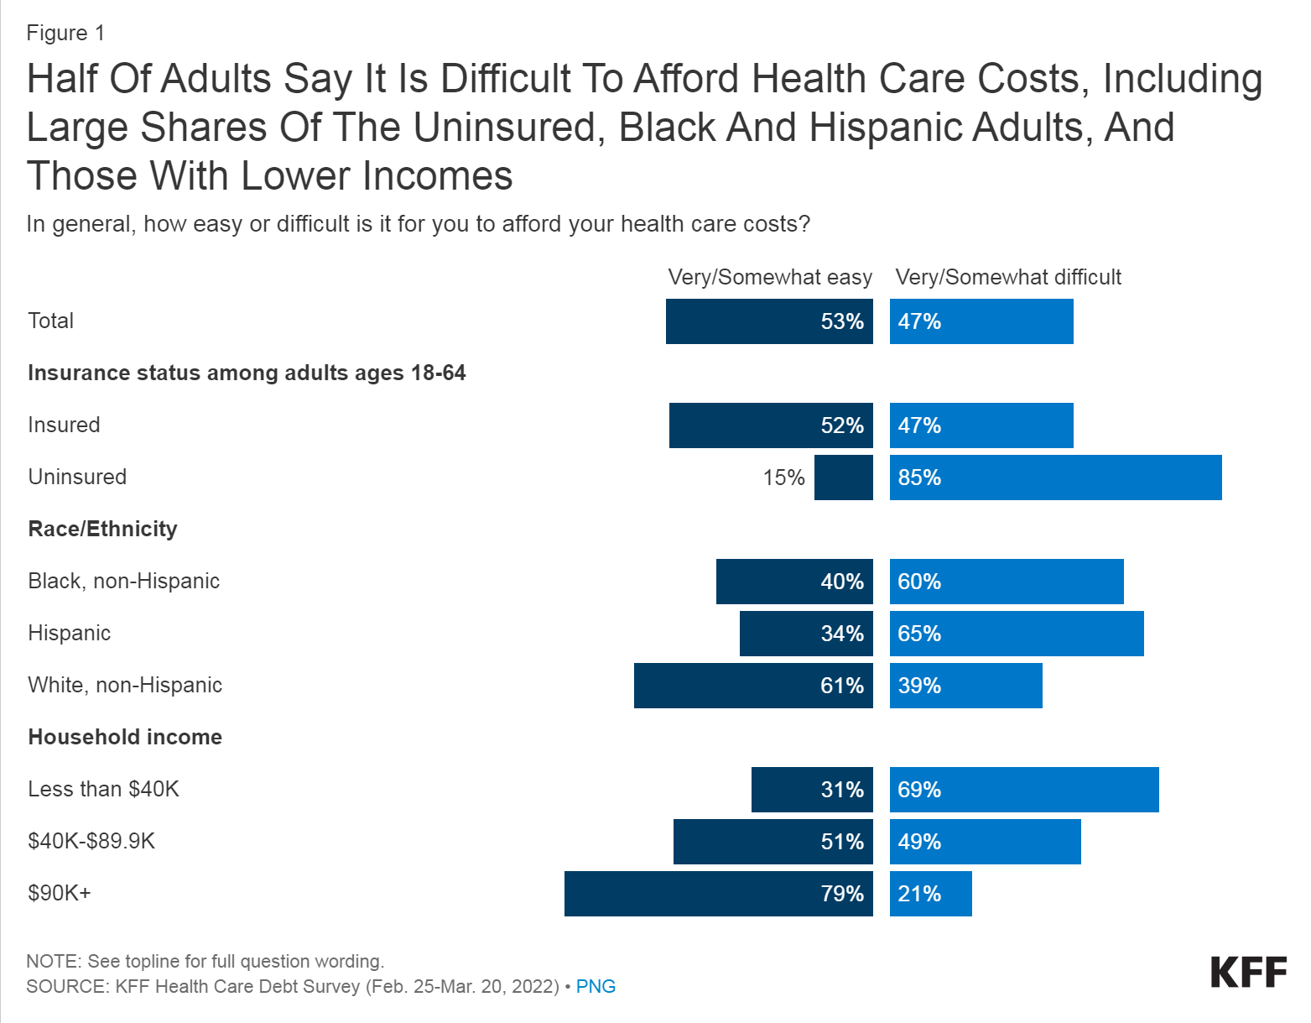

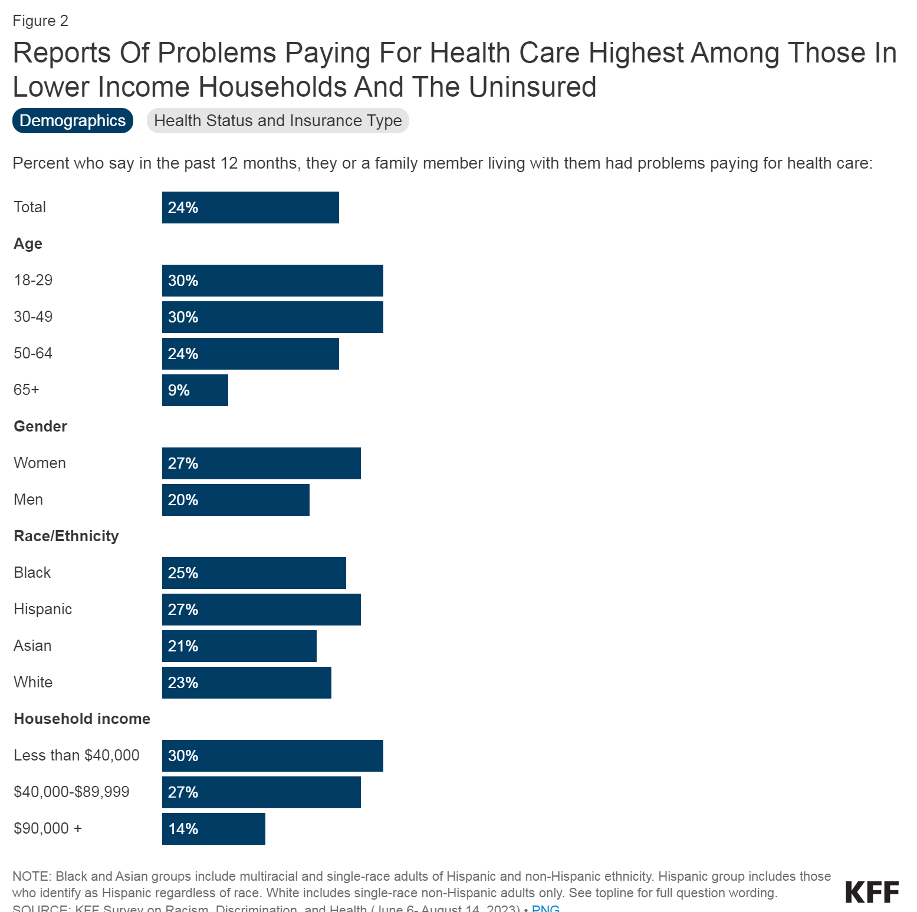

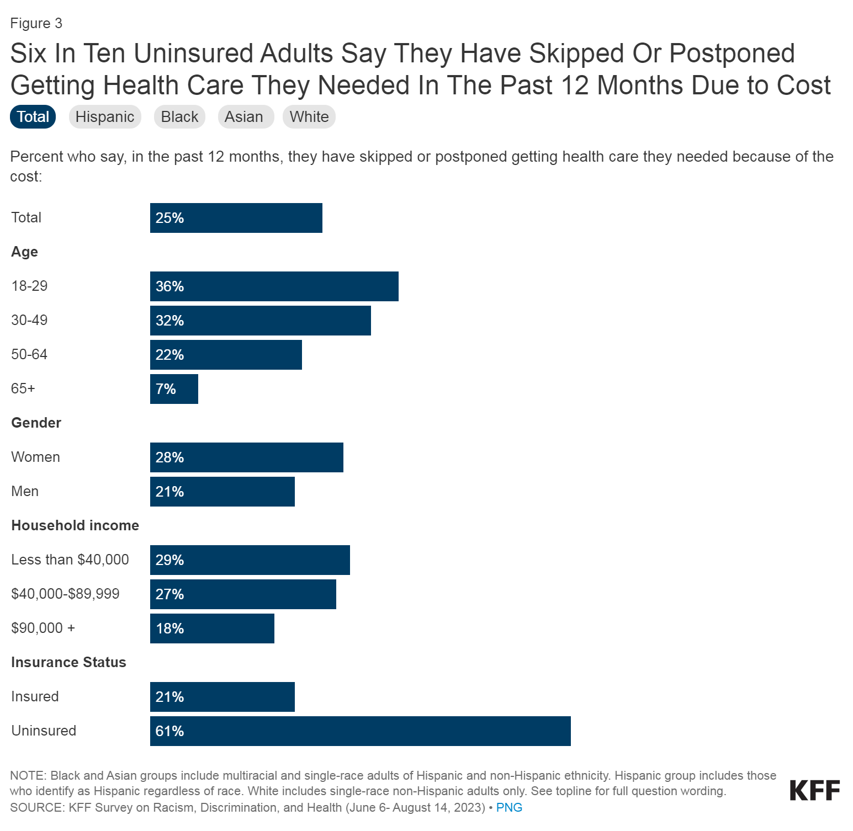

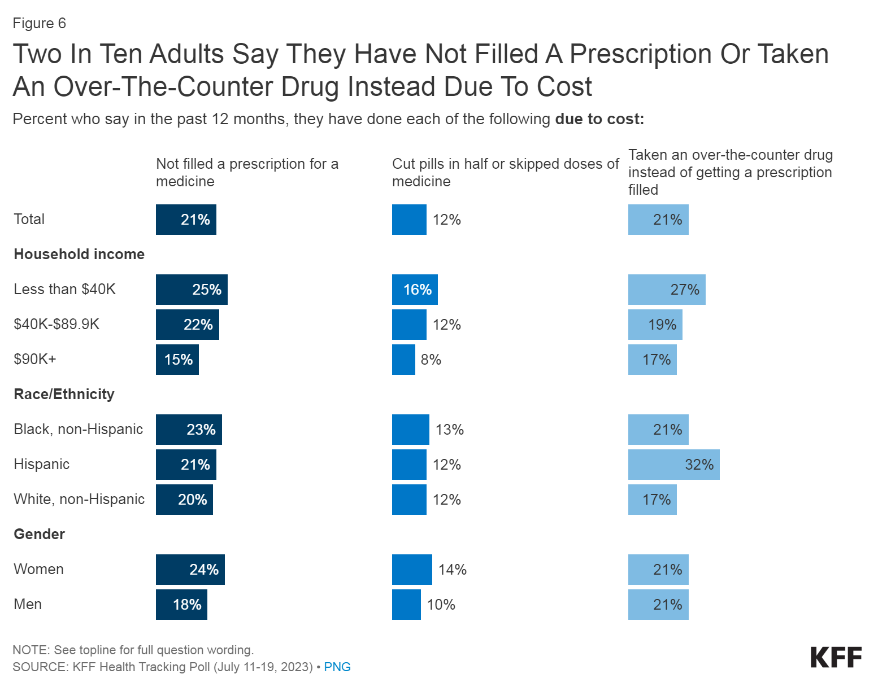

Racial disparities are evident, as 60% of Black adults and 65% of Hispanic adults report difficulty affording healthcare costs, contrasting with 39% of White adults. Additionally, those with annual incomes under $40,000 are over three times more likely to find it challenging to afford healthcare costs than those with incomes exceeding $90,000 (69% vs. 21%). When specifically addressing problems paying for healthcare in the past year, one in four adults indicates challenges, rising to 30% among those under 50 and those with lower incomes. Thirty-three percent of adults in fair or poor physical health report difficulties paying for healthcare. For uninsured adults, half (49%) faced problems paying for healthcare, particularly those in fair or poor health (51%). The cost of care prompts 25% of adults to skip or delay necessary healthcare, with women more likely than men (28% vs. 21%). Immigrant adults, particularly the uninsured, face challenges, as 22% skipped or postponed care, rising to 36% among uninsured immigrants, with 69% citing cost or lack of health coverage as reasons. Even with insurance, 21% of adults report not getting needed healthcare due to cost. Specific types of delayed care include dental services (35%), vision services (25%), visits to doctor's offices (24%), mental health care (18%), hospital services (14%), and hearing services, including hearing aids (10%).

[<https://www.kff.org/health-costs/issue-brief/americans-challenges-with-health-care-costs/>]

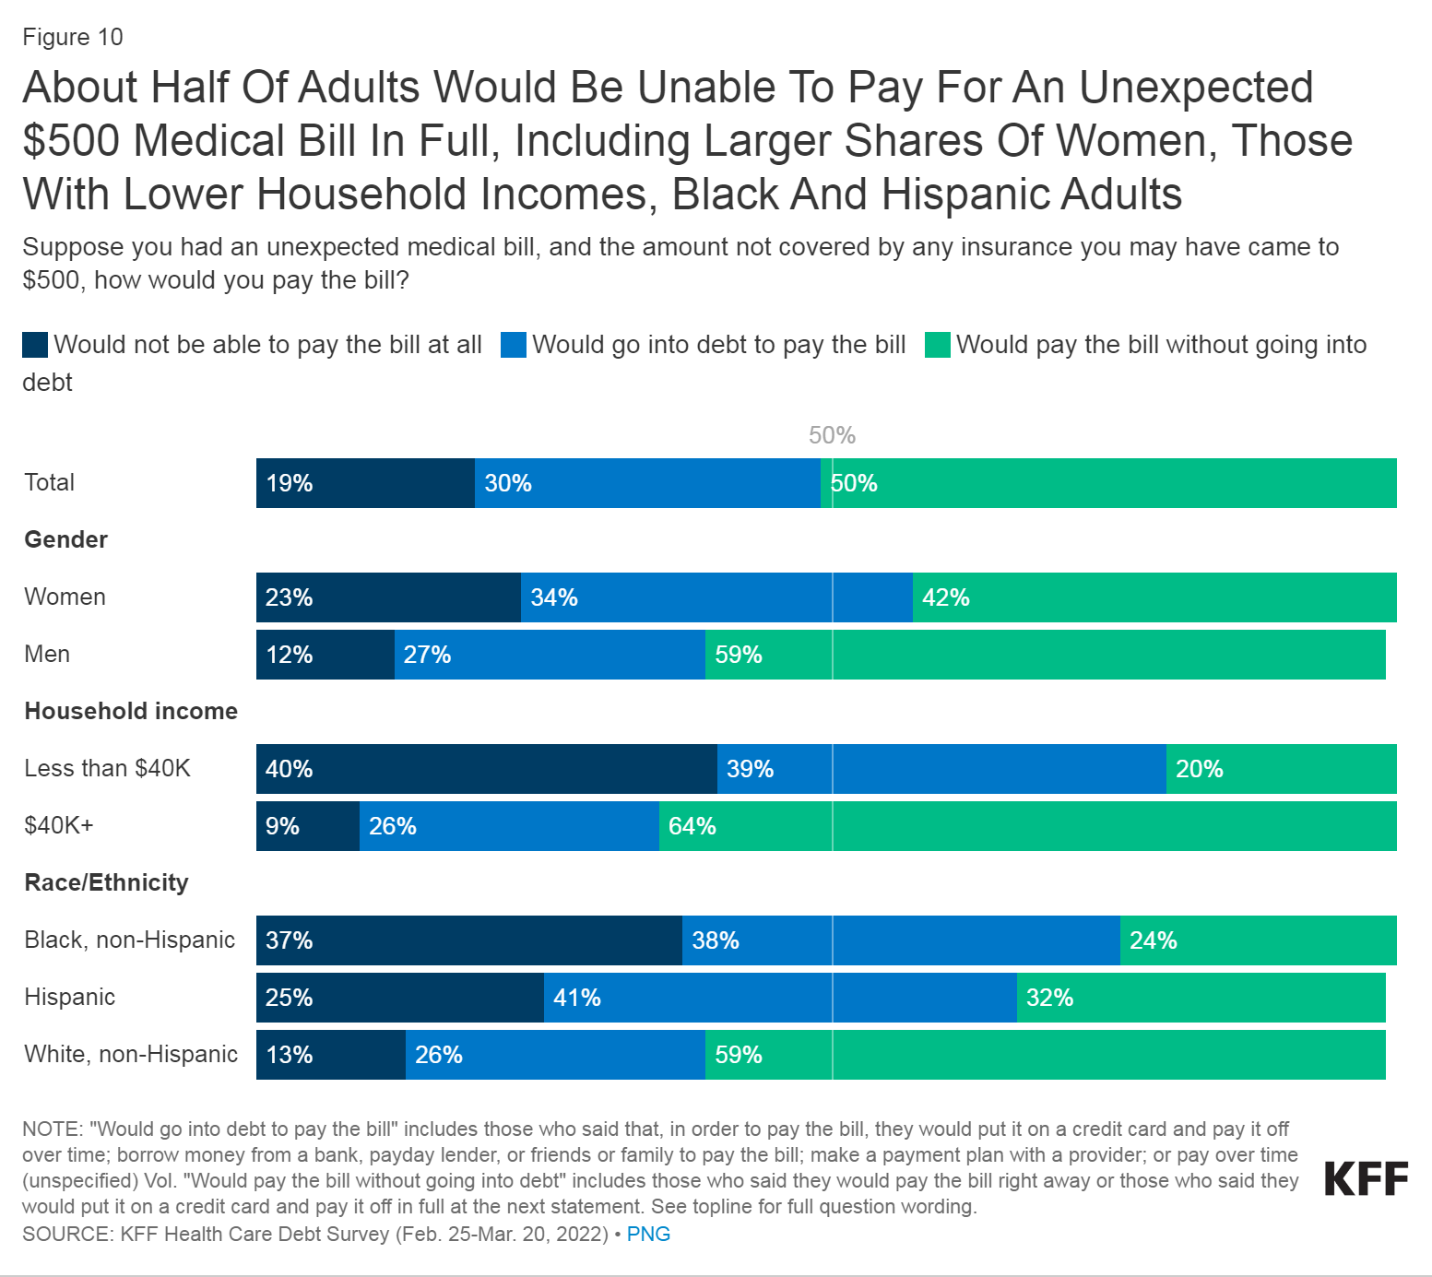

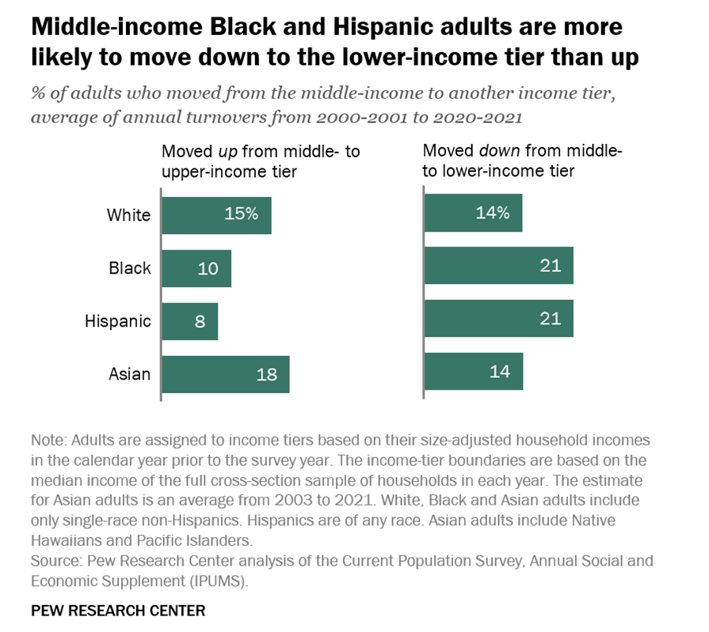

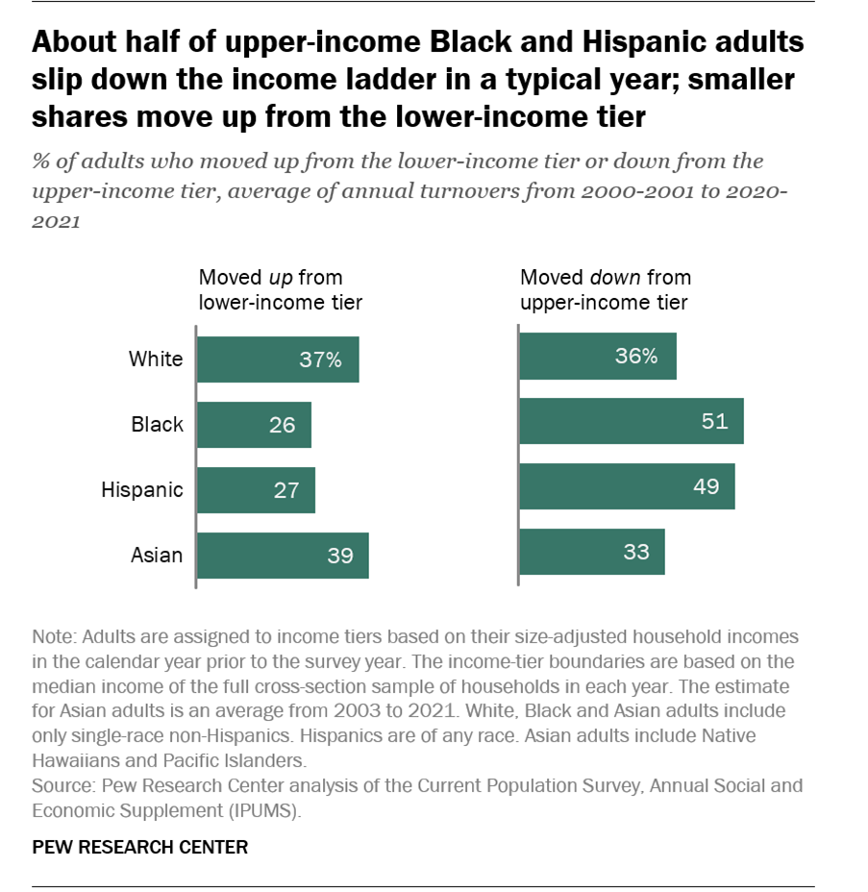

A recent look at the economy in 2021 shows that there are differences in how people are doing financially based on their race and ethnicity. In 2021, about half of White adults were in the middle class, while slightly fewer Black and Asian adults were. Hispanic adults fell in between, with 49%. From 2020 to 2021, a significant number of Black and Hispanic adults, around 20-22%, moved from the middle class to a lower income level, compared to 15% of White adults and 12% of Asian adults. Moving up the economic ladder was more challenging for Black and Hispanic adults, with only 8-12% making the move to upper-income in 2021, while 18-25% of White and Asian adults experienced this kind of progress. Understanding these economic patterns helps us see that not everyone has the same opportunities, and it's important to work towards creating a more fair and equal society for everyone.

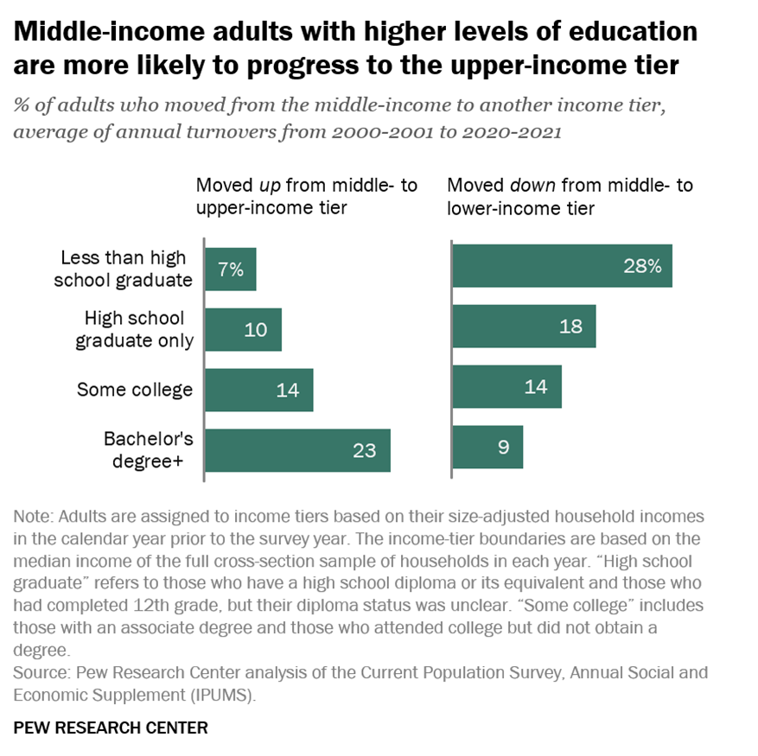

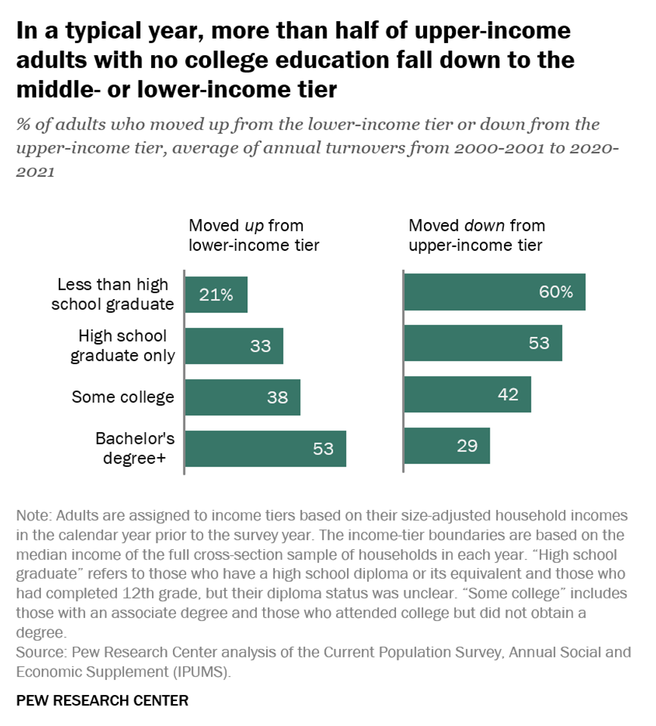

In 2021, financial well-being showed a strong connection to education levels, with adults having at least a bachelor's degree having a lower share (13%) in the lower-income tier compared to those without a high school diploma or its equivalent (57%). Conversely, the upper-income tier had a higher share (39%) among those with at least a bachelor's degree and a lower share (5%) among those with less than a high school education. Over the period from 2000 to 2021, adults without a high school diploma were about three times as likely to move from the middle- to the lower-income tier each year compared to those with at least a bachelor's degree. Conversely, those with at least a bachelor's degree were about three times as likely to move from the middle- to the upper-income tier. Economic transience, the movement across income tiers, was more prevalent among adults with different education levels. Among lower-income adults, those with at least a bachelor's degree were more likely to progress to the middle or upper-income tier annually, while among upper-income adults, those with less than a high school education were more likely to regress to the middle or lower-income tiers each year. The shuffling of adults across economic tiers was driven by changes in household income, with those moving up experiencing significant income increases, and those moving down facing substantial income losses. The pattern suggests that Black and Hispanic adults, as well as those with less education, were more likely than White and Asian adults and more educated individuals to experience income losses than gains.

[<https://www.pewresearch.org/short-reads/2022/05/10/black-and-hispanic-americans-those-with-less-education-are-more-likely-to-fall-out-of-the-middle-class-each-year/>]

***No access to healthcare?***

Healthcare coverage among minorities

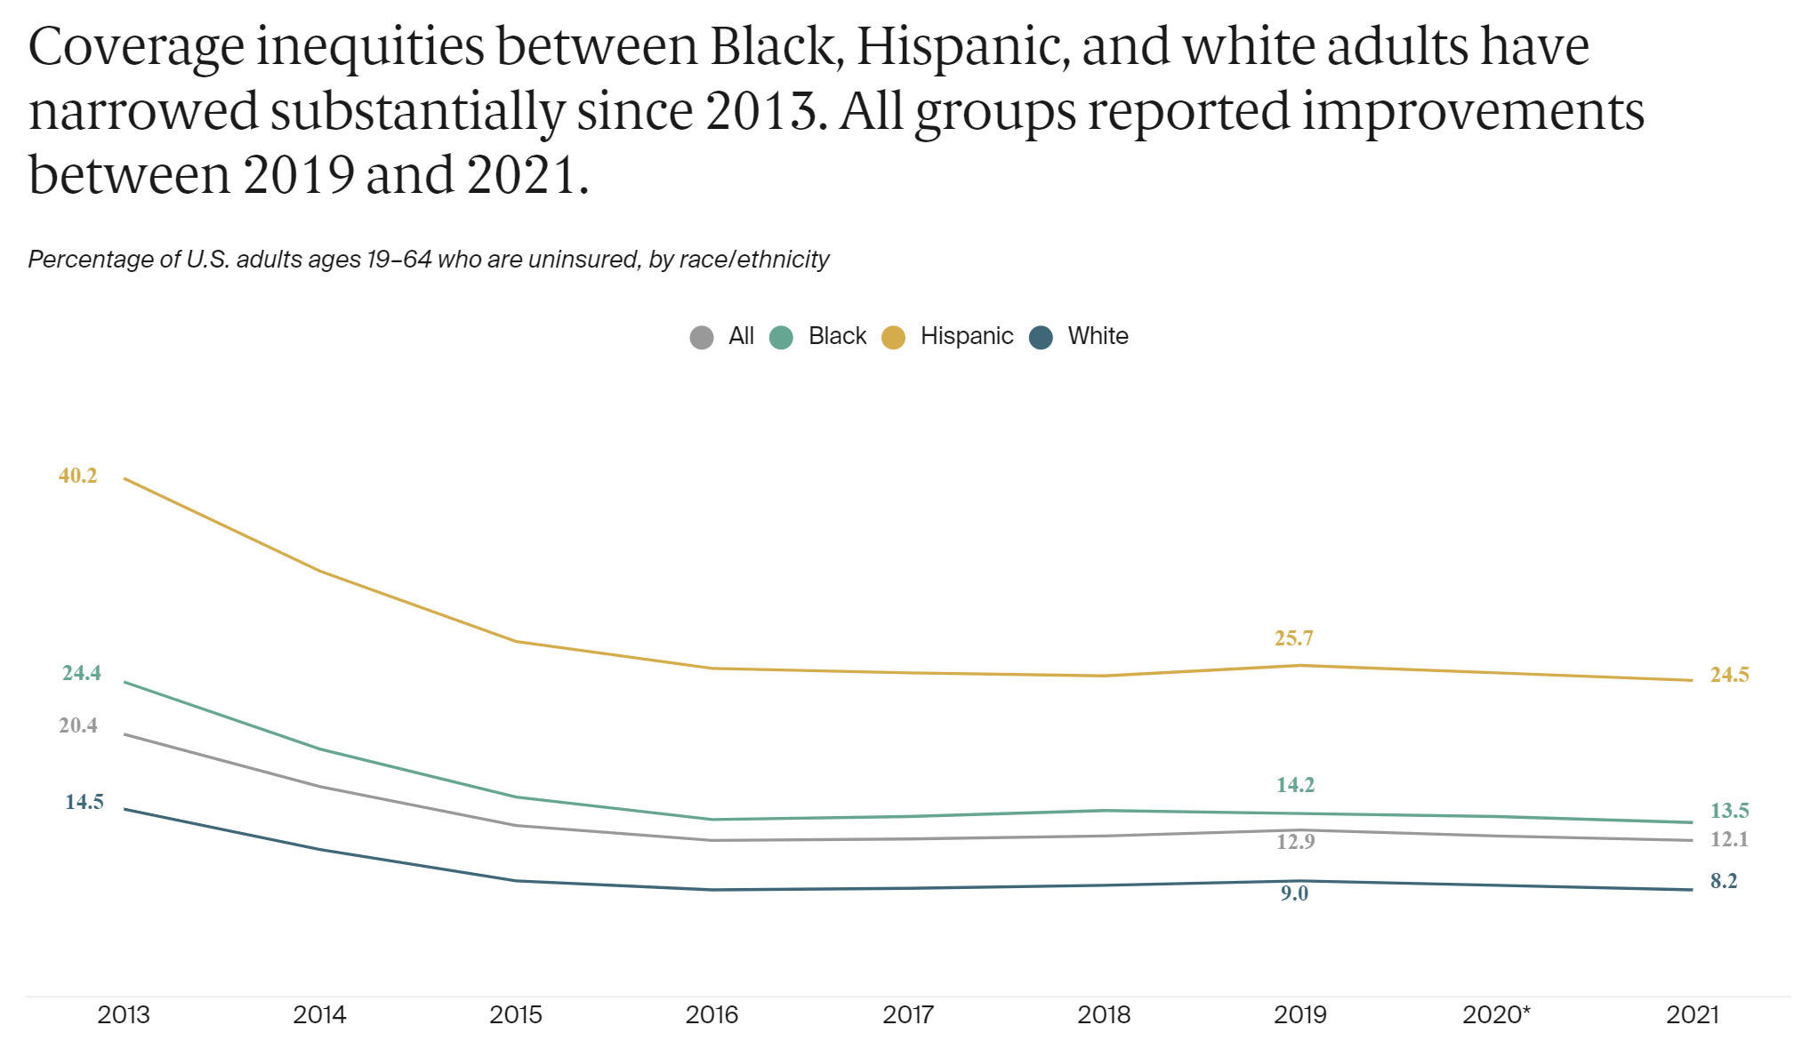

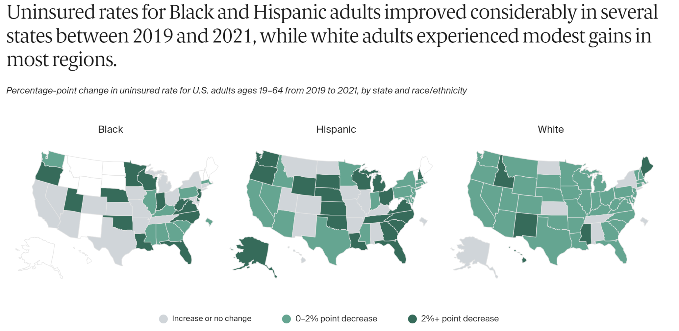

[<https://www.commonwealthfund.org/publications/issue-briefs/2023/mar/inequities-coverage-access-black-hispanic-adults>]

Insurance coverage rates showed improvement for Black, Hispanic, and white adults from 2013 to 2021, narrowing the gaps between racial/ethnic groups. The disparity between Black and white adults decreased from 9.9 to 5.3 percentage points, and the gap between Hispanic and white adults reduced from 25.7 to 16.3 points.

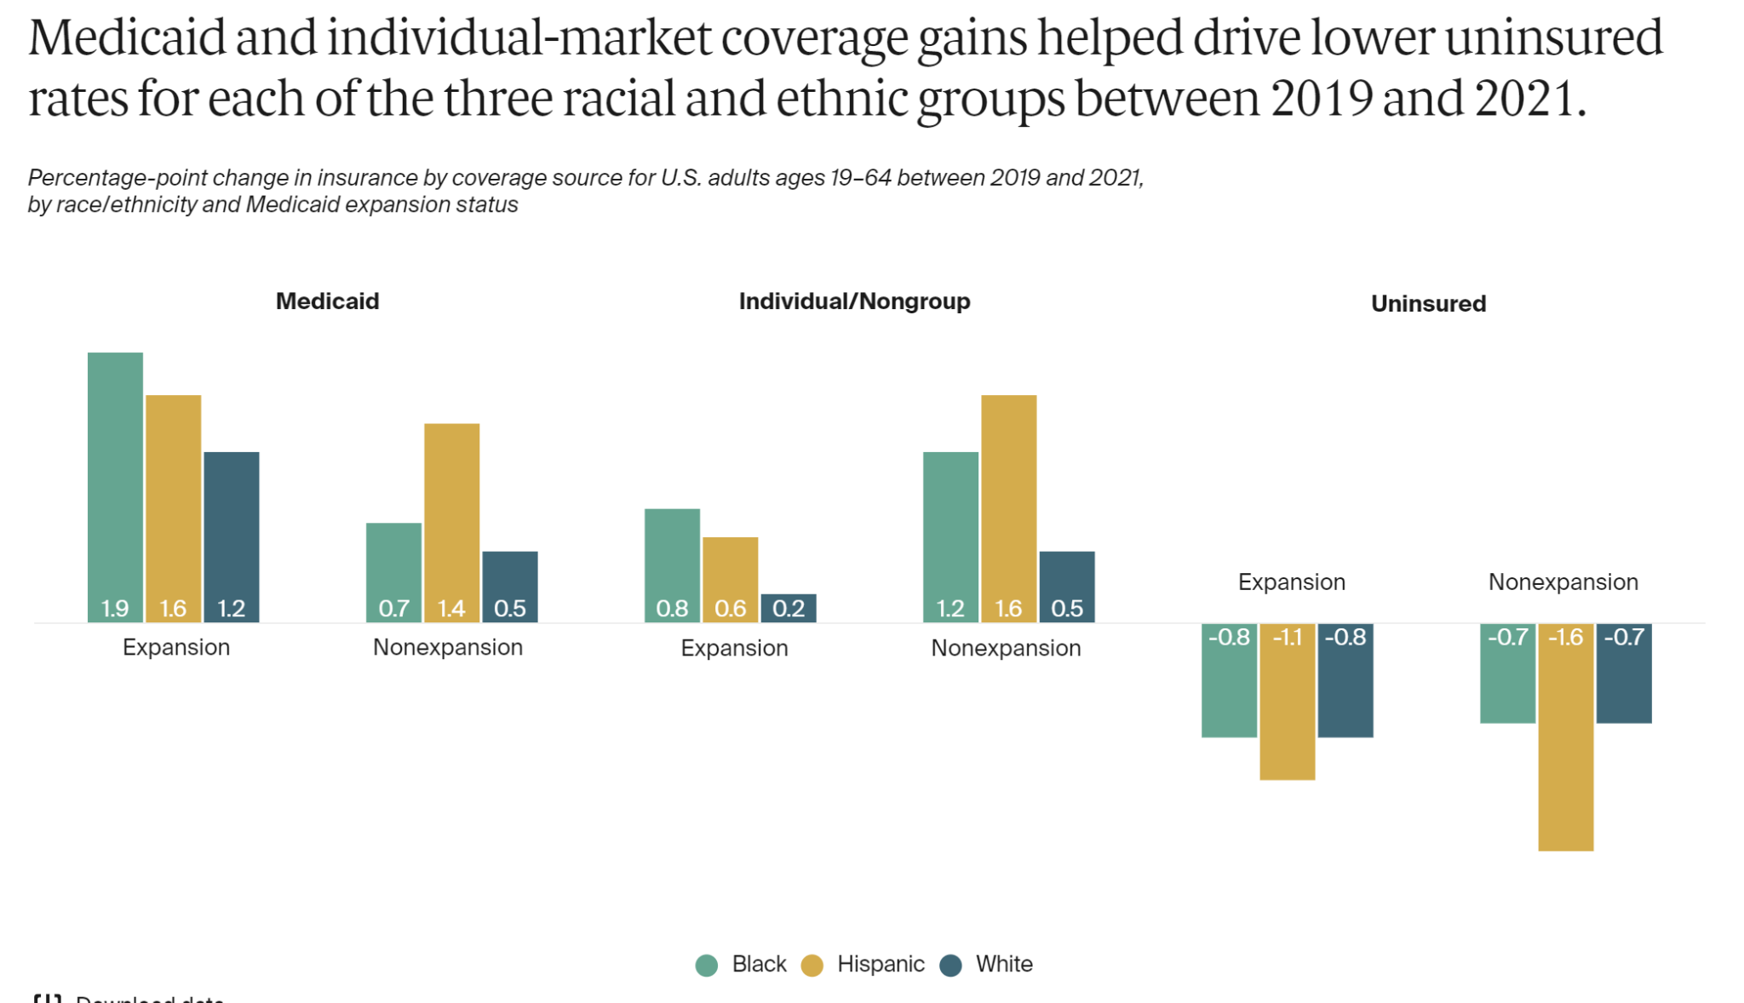

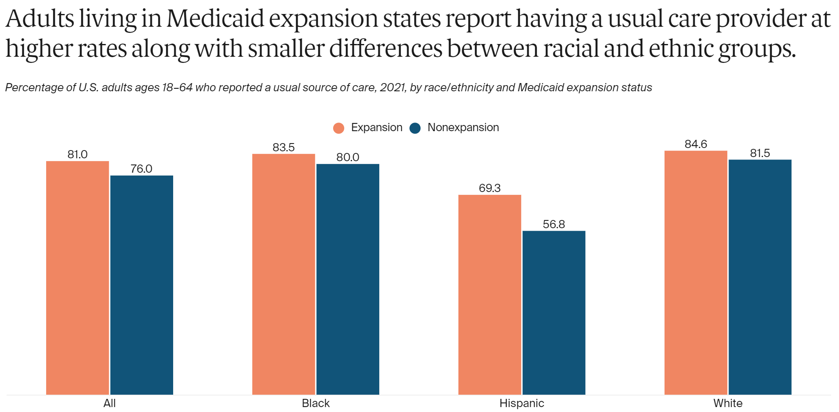

Throughout the initial two years of the COVID-19 pandemic, uninsured rates for adults in all three groups improved, regardless of whether the states had expanded Medicaid or not. Black and Hispanic adults saw more significant gains in Medicaid and individual-market coverage compared to white adults from 2019 to 2021.

States that expanded Medicaid eligibility between 2013 and 2021 exhibited higher rates of insurance coverage and improved healthcare access. Additionally, these states experienced smaller disparities between racial/ethnic groups and more significant overall improvements compared to states that did not expand Medicaid.

Following Virginia's Medicaid expansion in 2019, the uninsured rate for lower-income adults significantly decreased compared to neighboring North Carolina, a state that did not expand Medicaid, leading to a narrowing of disparities between Black and white adults.

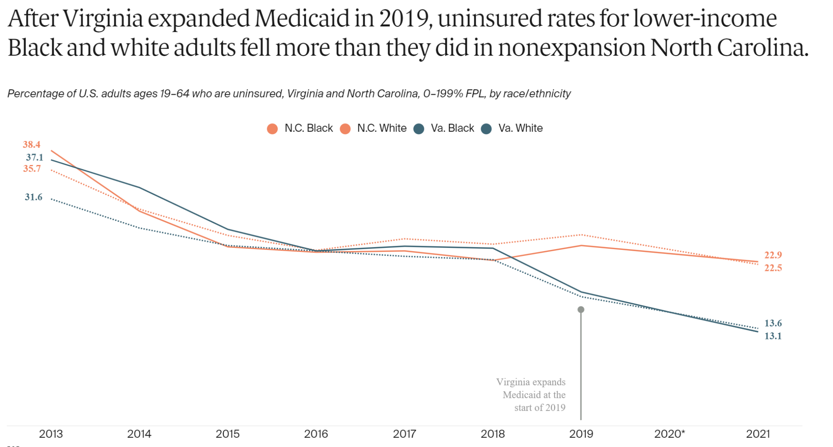

States that haven't expanded Medicaid contain higher proportions of lower-income Black and Hispanic adults compared to their white counterparts.

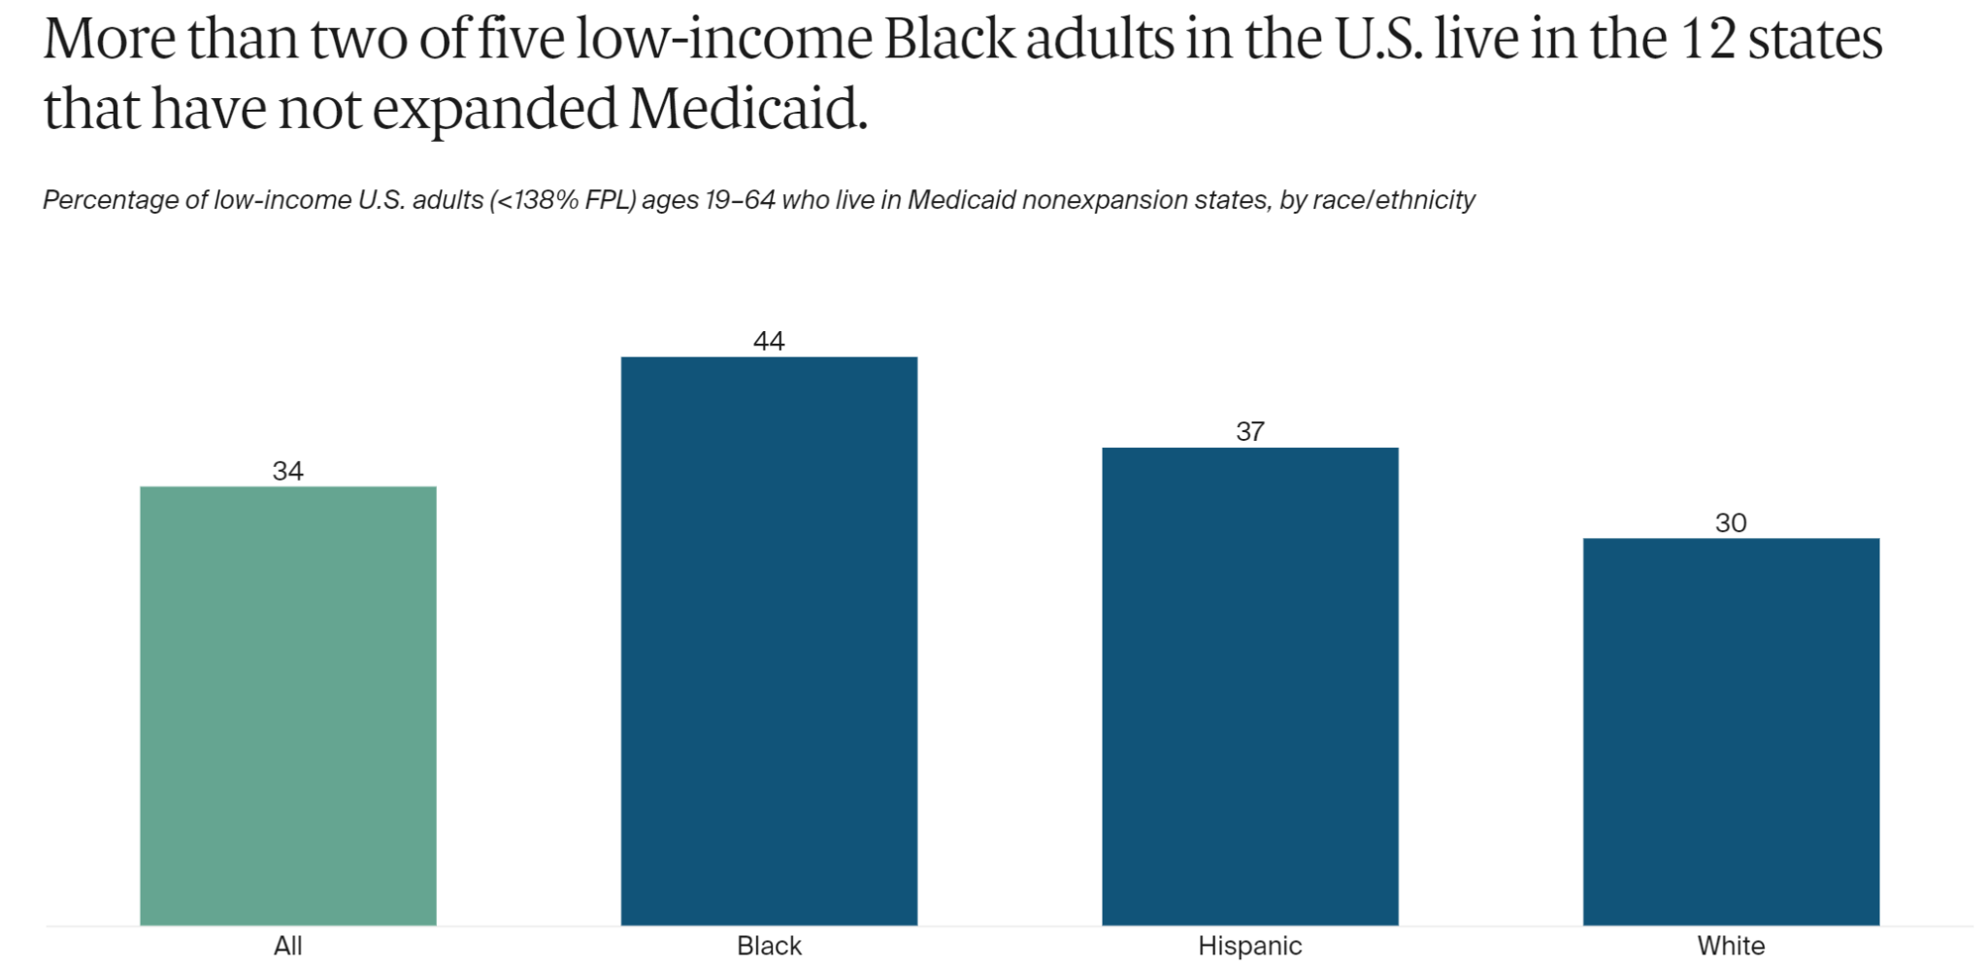

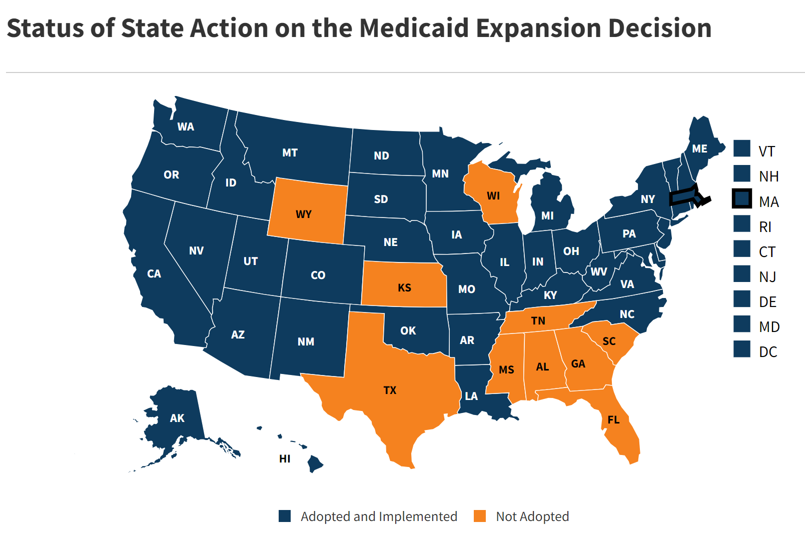

Over the past decade, the Affordable Care Act (ACA) has significantly contributed to advancing racial equity in health care, primarily through increased access to affordable coverage. Medicaid expansion, a key component of the ACA, has been associated with notable gains in coverage, improved access, and reduced racial/ethnic disparities. The COVID-19 pandemic further emphasized the critical role of these policies, especially Medicaid, in ensuring access to healthcare.

Recent Medicaid expansions in seven states and the potential expansion in others highlight the ongoing efforts to improve coverage. However, challenges persist, with key health outcomes deteriorating during the pandemic, particularly for people of color.

Wyoming, Kansas, Texas, Wisconsin, Tennessee, Mississippi, Alabama, Georgia, South Carolina, and Florida have not implemented the Medicaid expansion. This decision has resulted in more than 2.1 million individuals being caught in the "coverage gap." These individuals fall within the income range that would qualify them for Medicaid, yet they are unable to access it due to their respective states not adopting the expansion, as reported by the Center on Budget and Policy Priorities.

[https://www.commonwealthfund.org/publications/issue-briefs/2023/mar/inequities-coverage-access-black-hispanic-adults]

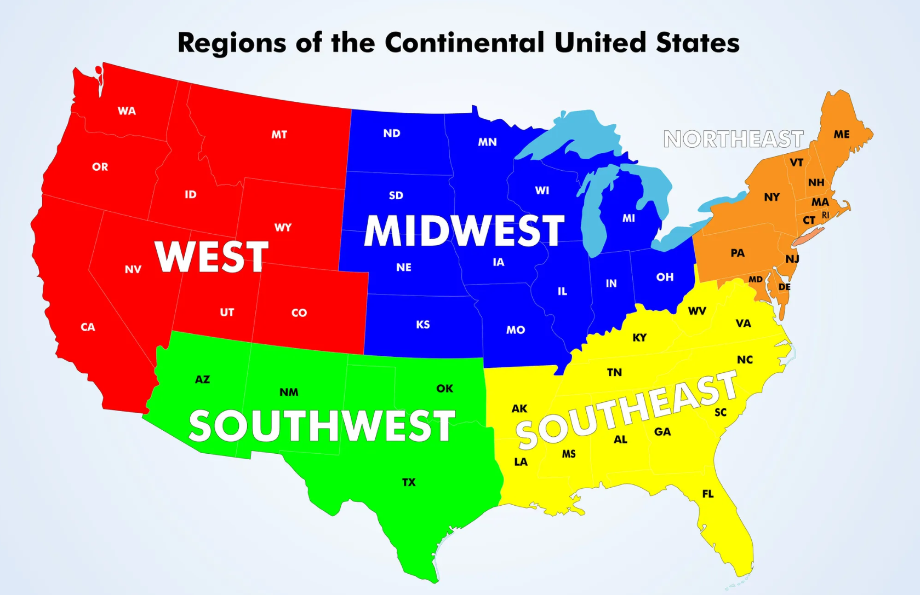

The majority of the states which have not expanded and have very limited eligibility threshold regarding Medicaid are located in the Southeast and southwest region of the country, and there is a strong correlation with the amount of uninsured people with access to Medicaid. This could be one of the reasons why people in the southwest and southeast areas are more affected by the low quality of healthcare.

Where are the Hispanic and Black people mostly located?

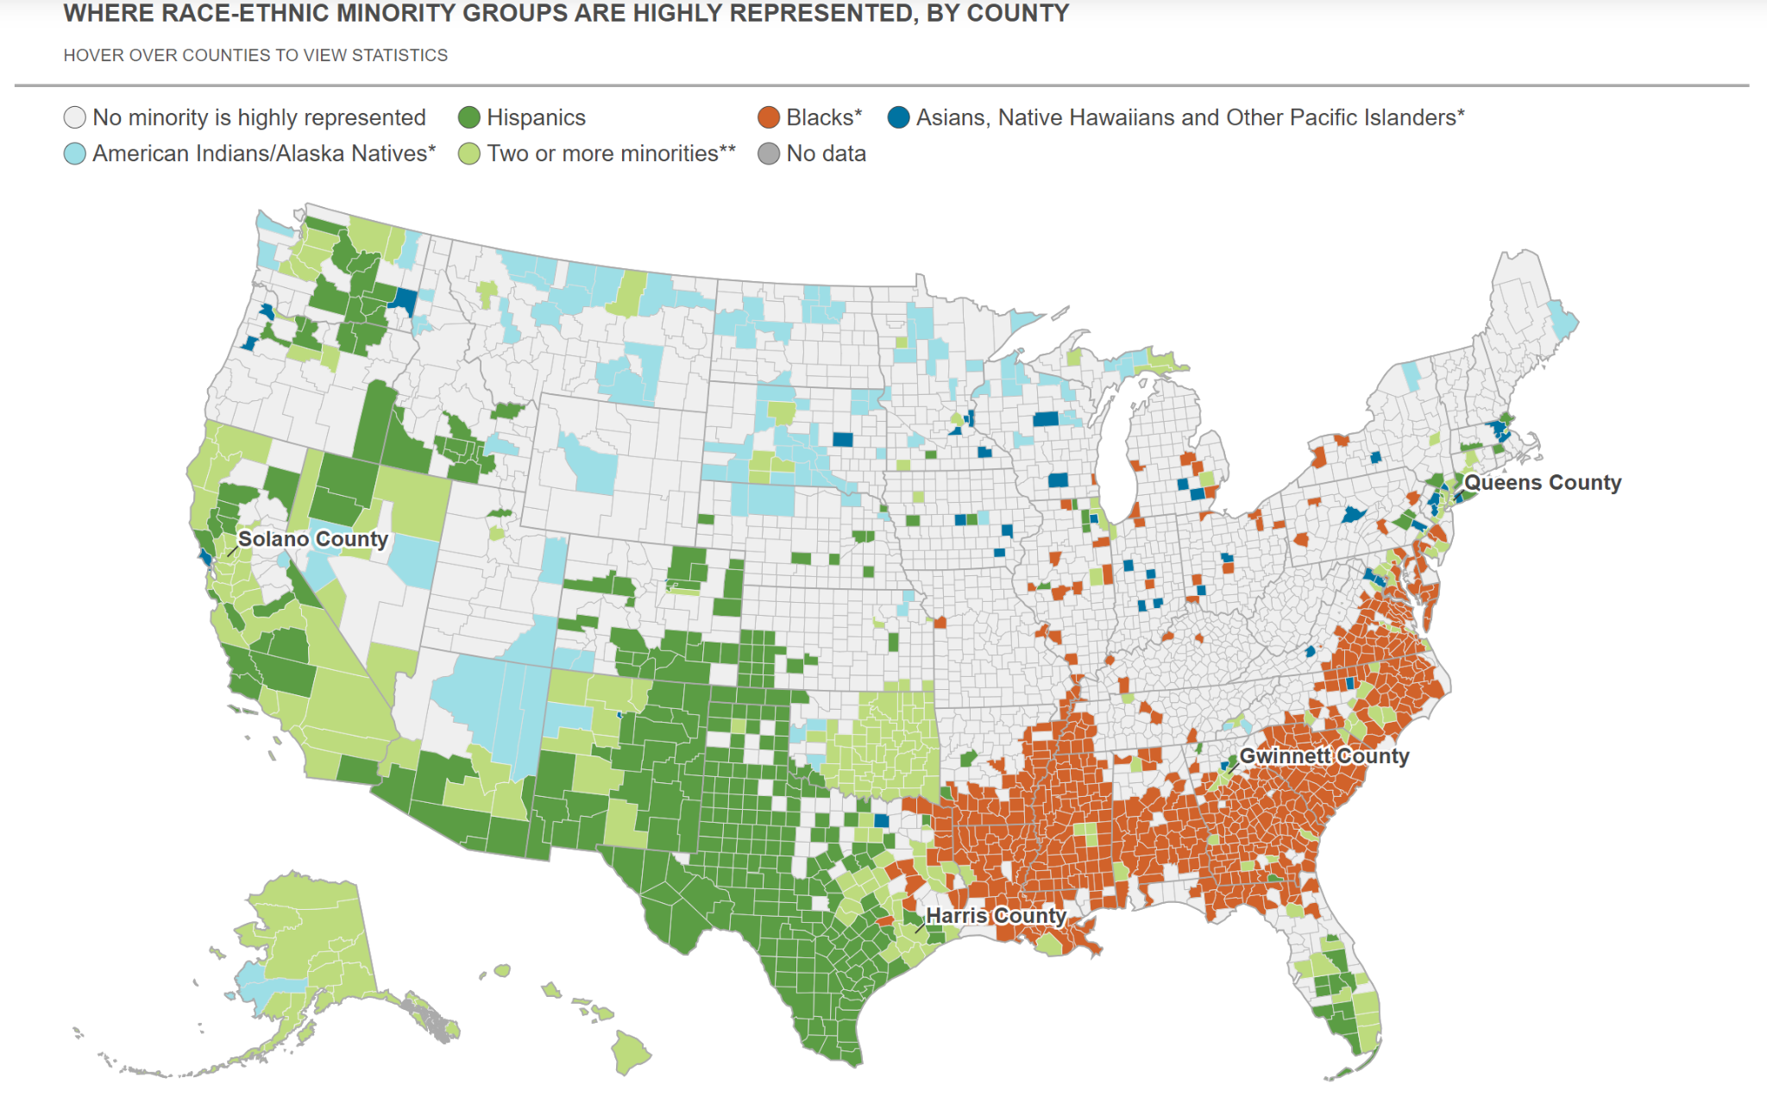

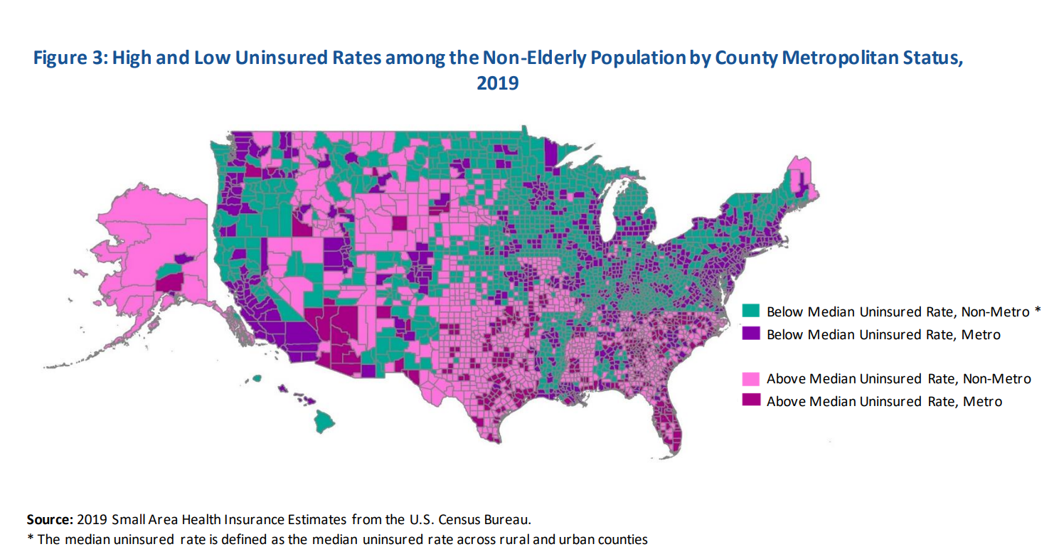

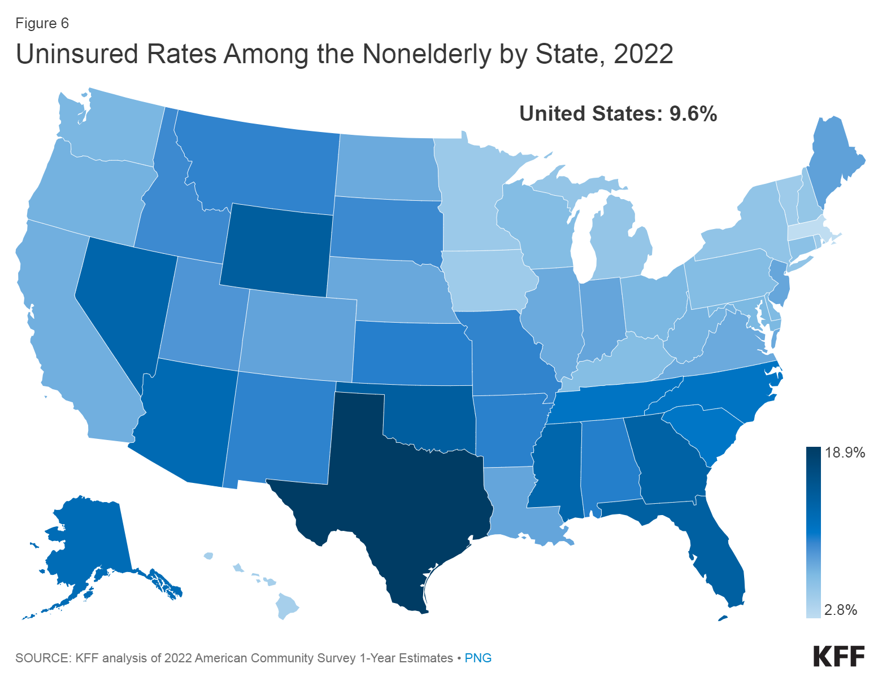

Latino or Hispanic Presence:

* Prominent in counties across California, Texas, the Mountain West, the Southeast, urbanized Northern regions, and smaller communities nationwide.

Black Population:

* Concentrated in Southern counties, with 58% of the national Black population residing in the South. Also present in Northern urban areas and parts of the West, often alongside other nonwhite groups.

Diversity in Metropolitan Areas:

* Large metropolitan areas showcase varying diversity profiles. Among the top 100, 27 have two or more highly represented nonwhite groups. Notable examples include New York, Chicago, Houston, Dallas, Los Angeles, San Francisco, and San Diego.

Metro Areas with Single Ethnic Group Dominance:

* Some metro areas predominantly represent a single nonwhite group. For example, 29 metro areas in the South have a high Black population, 13 in the West and South have substantial Latino or Hispanic populations, and four areas—Seattle, Portland, Ore.; Minneapolis-St. Paul; and Boston—have significant Asian American presence.

Detailed State Breakdown:

* California: Significant Latino or Hispanic and Asian American populations, diverse ethnic concentrations in metropolitan areas.
* Texas: Notable Latino or Hispanic presence, especially in Harris County.
* New York: Diverse populations in Queens County.
* Illinois: Cook County exhibits diverse ethnic concentrations.
* Georgia: Gwinnett County stands out for diverse populations.
* Florida: Miami features a high representation of Latino or Hispanic and Black populations.
* Washington: Asian American populations are highly represented.
* North Carolina: Some consideration for potential diversity due to ongoing legislative actions.
* Oregon: Portland stands out for a significant Asian American presence.
* Minnesota: Minneapolis-St. Paul has a notable Asian American population.
* Massachusetts: Boston features a significant Asian American population.
* Oklahoma and Alaska: High representation of American Indian and Alaska Native populations. [https://www.brookings.edu/articles/mapping-americas-diversity-with-the-2020-census/]

Southeast regions are populated by Hispanic people and southwest are notably populated by black population which unifies with the above mentioned observation that south regions have higher percentage of uninsured people vs the west east and northern regions and as well as that the highest number of uninsured people or unsatisfied people regarding healthcare are from hispanic and afro american ethnicity.

Do rural areas have an impact on lower health-care quality?

What is considered a rural area?

Defining rural areas sparks disagreement among researchers, with the Center for American Progress relying on U.S. Census Bureau and U.S. Department of Agriculture data, primarily using the metro-nonmetro classification. While recognizing limitations, such as changes in county classification over time, the authors expand categories and emphasize the broader cultural meaning of "rural." The urban-rural continuum, incorporating population and city proximity, provides a nuanced perspective, revealing the diverse nature of American communities beyond the constraints of a binary metro-nonmetro distinction.

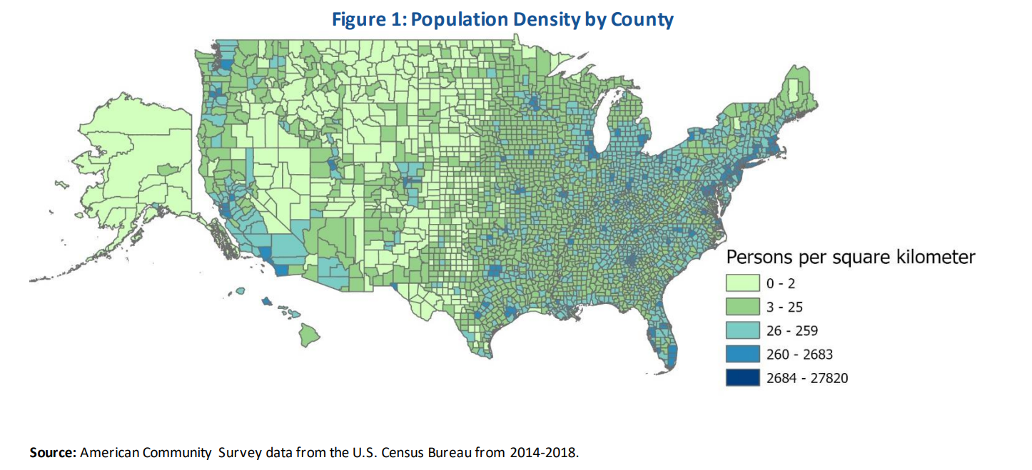

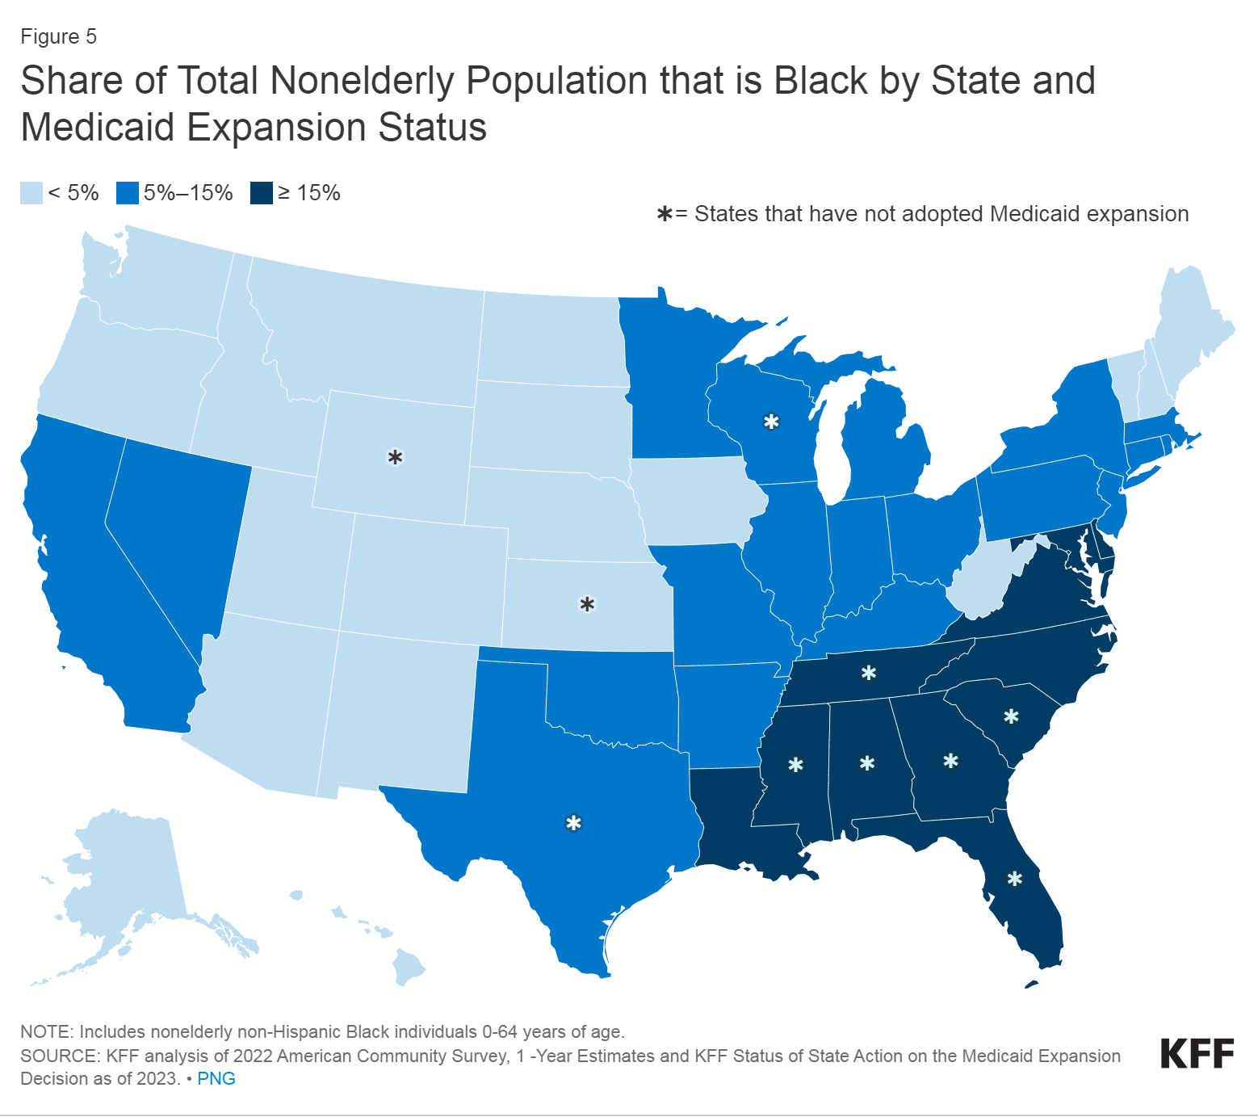

In the United States, approximately 61 million people, constituting 19% of the total population, reside in rural areas. These regions exhibit considerable diversity in characteristics such as racial/ethnic composition, geography, socioeconomics, and healthcare access. Notably, certain rural areas, such as remote American Indian/Alaska Native tribal areas, face unique challenges due to their large size and sparse population. A closer look at the population density map reveals lower densities in regions like the Great Plains, Southwest, Alaska, and upper New England, highlighting the vast expanses with limited population concentration.

Rural residents, on average, experience lower median incomes and are less likely to be insured compared to their urban counterparts. Moreover, rural populations tend to be older, with a higher proportion of adults aged 65 and older, bringing additional health challenges such as chronic conditions, limited mobility, and difficulties accessing healthcare services. The data emphasizes that one in five rural residents is Black, Hispanic, American Indian/Alaska Native, Asian American/Pacific Islander, or of mixed race. These racial/ethnic groups in rural areas often face additional barriers to care and disparities in health outcomes.

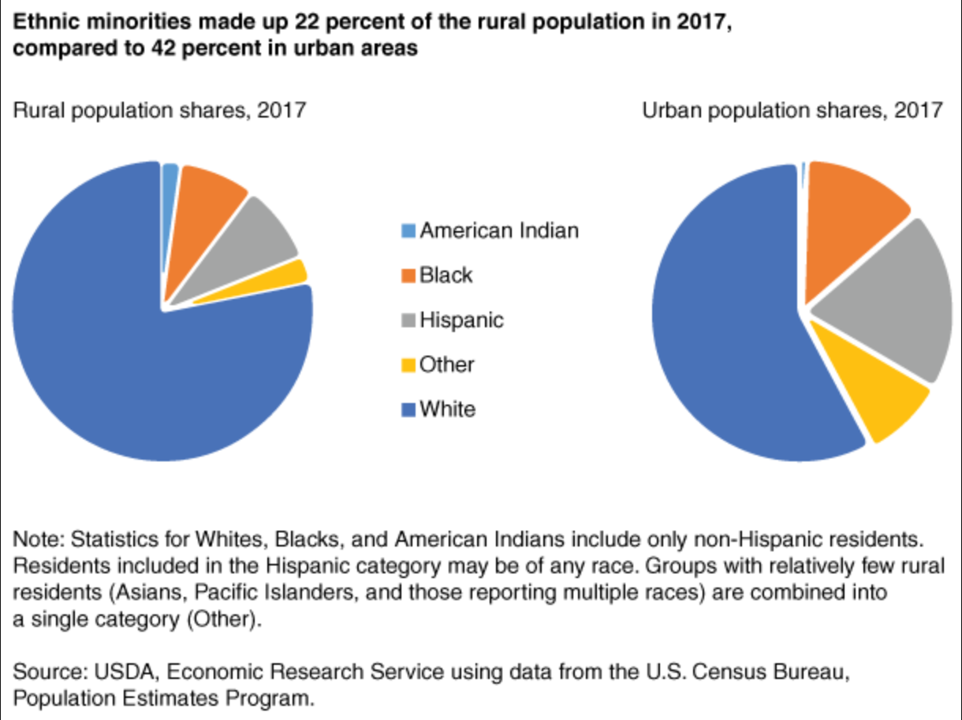

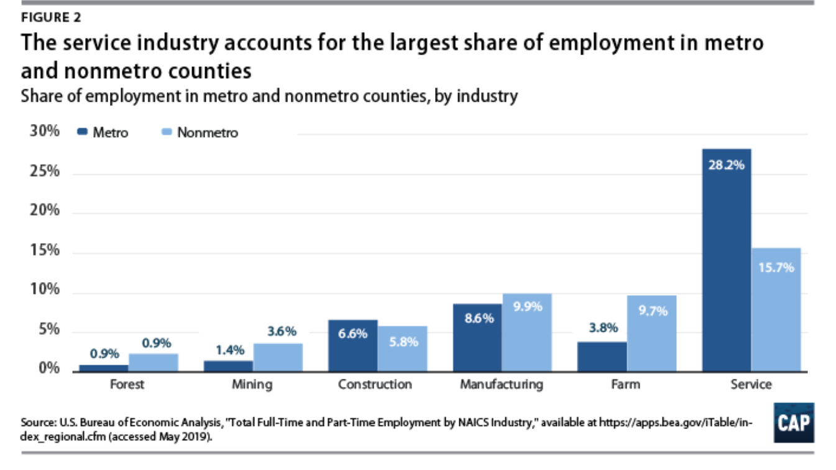

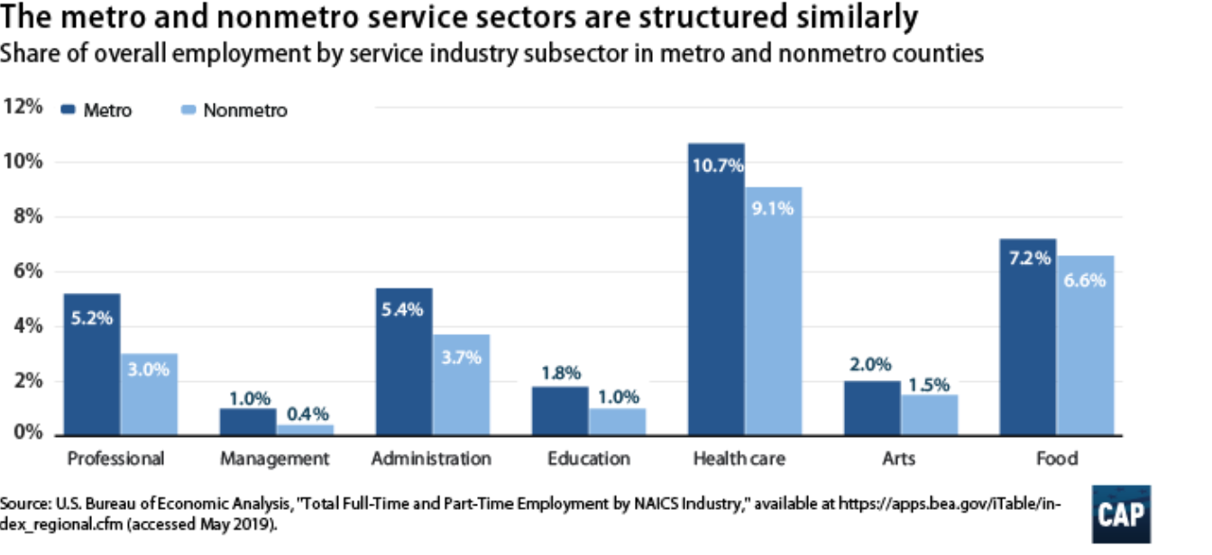

Marginalized rural communities, often overlooked in discussions about rural economic challenges, include people of color, immigrants, LGBTQ individuals, and disabled people. While rural America is proportionately less diverse, it is still home to significant populations of African Americans, Native Americans, and Latinx individuals facing unique challenges. Native Americans, especially in nonmetro-adjacent counties, and Latinx individuals in the Southwest are clustered in rural areas. These populations often experience difficulties with internet access, financial strain, and lower reported quality of life compared to the broader rural population.

The disability rate in rural America is higher than the national average, posing additional structural barriers to prosperity. Disabled rural residents face challenges accessing healthcare due to hospital closures, receive less specialized support services, and have employment rates that have yet to fully recover from the Great Recession. Economic difficulties are further compounded by feelings of loneliness and isolation.

* Education and financial literacy

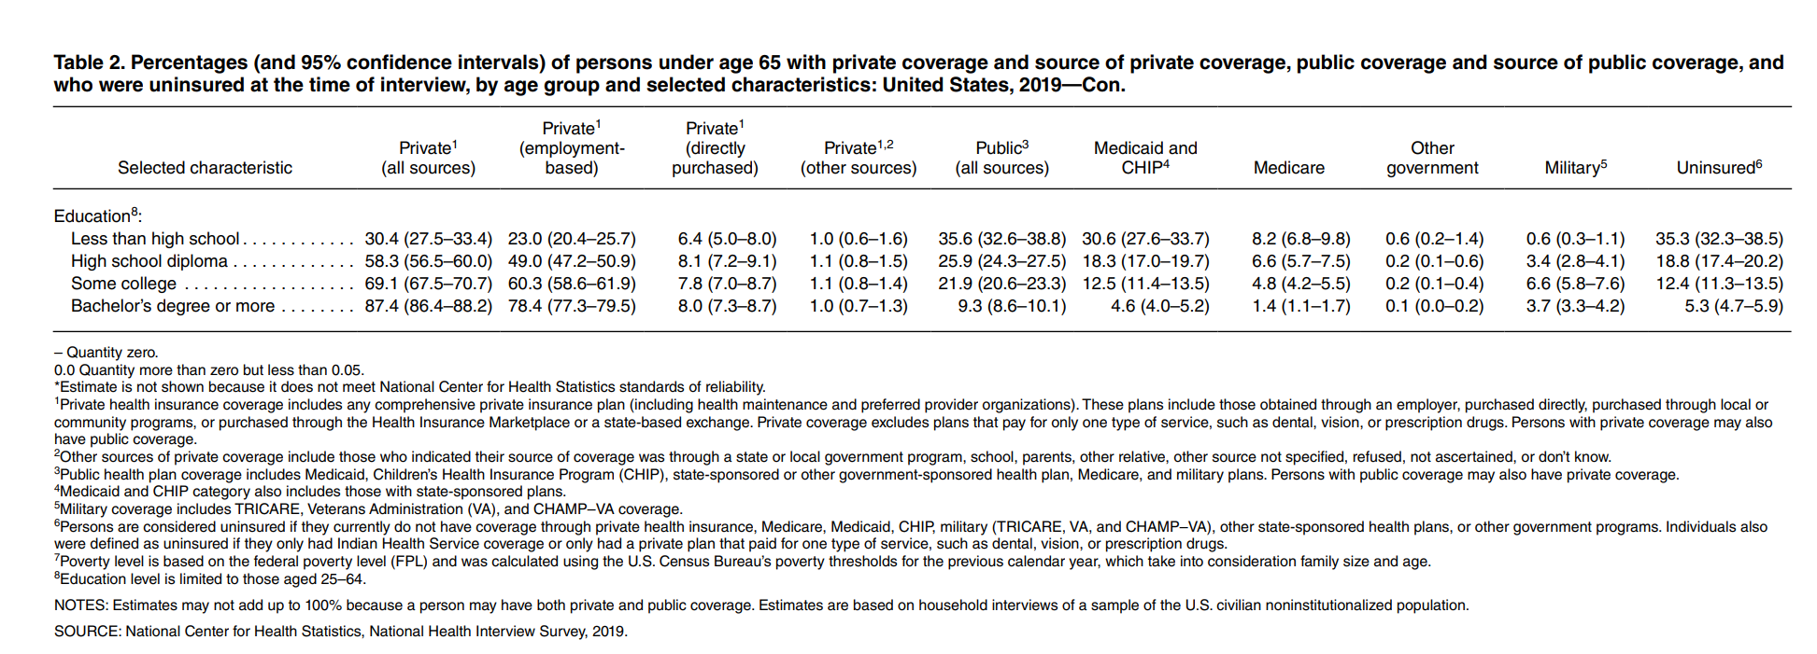

As already assumed, the level of education has a strong correlation with the quality of healthcare.

As the level of education increases from less than high school diploma till bachelor or more, the percentage of uninsured people decreases from 35.3% until 5.3% correspondingly.

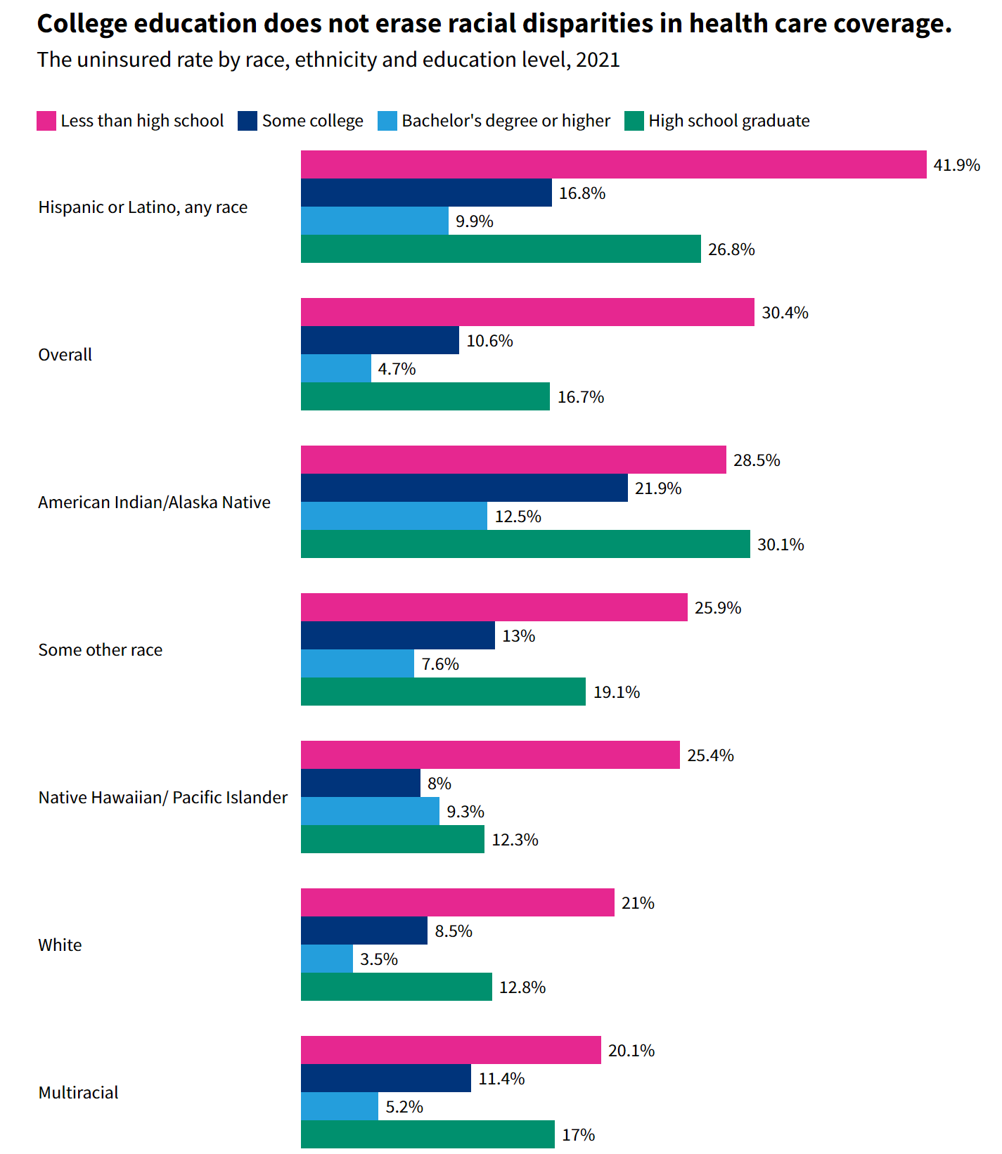

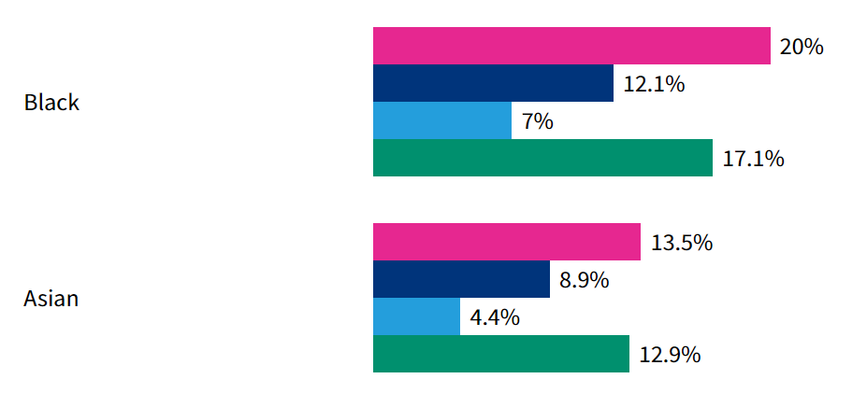

Racial and ethnic disparities in health insurance coverage persist across all education levels, even among the most educated individuals. Despite trends indicating that college-educated individuals are less likely to be uninsured, these disparities persist. In 2021, the uninsured rate for those with a bachelor's degree or higher was 7 percentage points lower than the national average of 11.9%.

However, college education does not eliminate racial disparities in health care coverage. The data reveals varying uninsured rates by race, ethnicity, and education level. For instance, while people without a high school diploma had high uninsured rates (30.4%), Hispanic individuals who did not graduate high school had the highest uninsured rates (41.9%) compared to their white counterparts (21%).

Since education is not an isolated factor it is evident that a combination of social factors affect the higher number of uninsured hispanic and black population.

***Is it possible that maybe financial literacy among these minorities affects the statistics? Could unawareness or unwillingness of eligibility for Medicaid or Marketplace plan among these groups also enhance the barriers in healthcare?***

Limited financial literacy may lead to challenges in understanding and navigating complex healthcare systems, insurance plans, and available resources. This lack of awareness can result in missed opportunities for eligible individuals to enroll in programs like Medicaid or Marketplace plans, hindering their access to necessary healthcare services.

Unawareness of eligibility criteria, enrollment processes, and available assistance programs can create barriers to accessing healthcare coverage, preventive services, and timely medical interventions. Additionally, cultural and linguistic factors may contribute to these challenges, further complicating communication and understanding of healthcare options.

Financial literacy involves skills that enable individuals to make informed decisions about budgeting, debts, and investing. Recent discussions highlight the connection between financial literacy and the racialized wealth gap, revealing income disparities along racial lines. In 2020, the Federal Reserve's data showed a stark contrast in median and mean incomes between White and Black Americans. While an income gap has long been acknowledged, debates persist about its cause. Some argue that financial literacy, evidenced by surveys showing lower financial knowledge among Black Americans, contributes to the wealth gap. However, attributing the racialized wealth gap solely to financial illiteracy oversimplifies the complex issue. Structural and institutional inequities, such as racial disparities in incarceration rates, post-incarceration income loss, unequal school funding, and eviction rates, play pivotal roles in sustaining economic oppression among Blacks. Placing blame on financial literacy neglects systemic issues rooted in institutionalized racism and biased policies. While financial education is crucial, addressing social complexities and advocating for systemic change is essential to bridging the racialized wealth gap.

The following statistics succinctly illustrate this narrative:

* Data from EdBuild in 2018 uncovered a stark contrast, revealing that predominantly White school districts receive an annual funding surplus of $23 billion compared to predominantly Black school districts.

## **Do these vulnerable patients have insurance, but also high copayments / high deductibles? Or are these vulnerable patients unable to get insurance, and fully exposed to the catastrophic financial consequences of a health issue?**

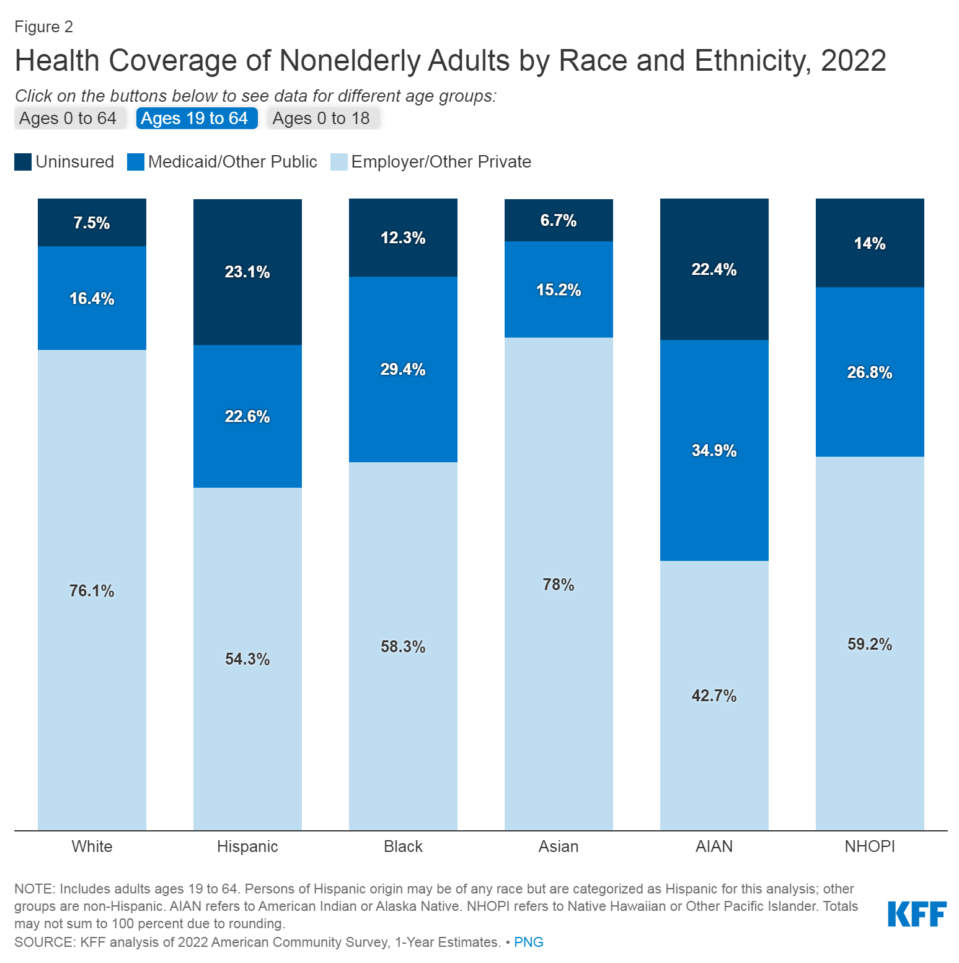

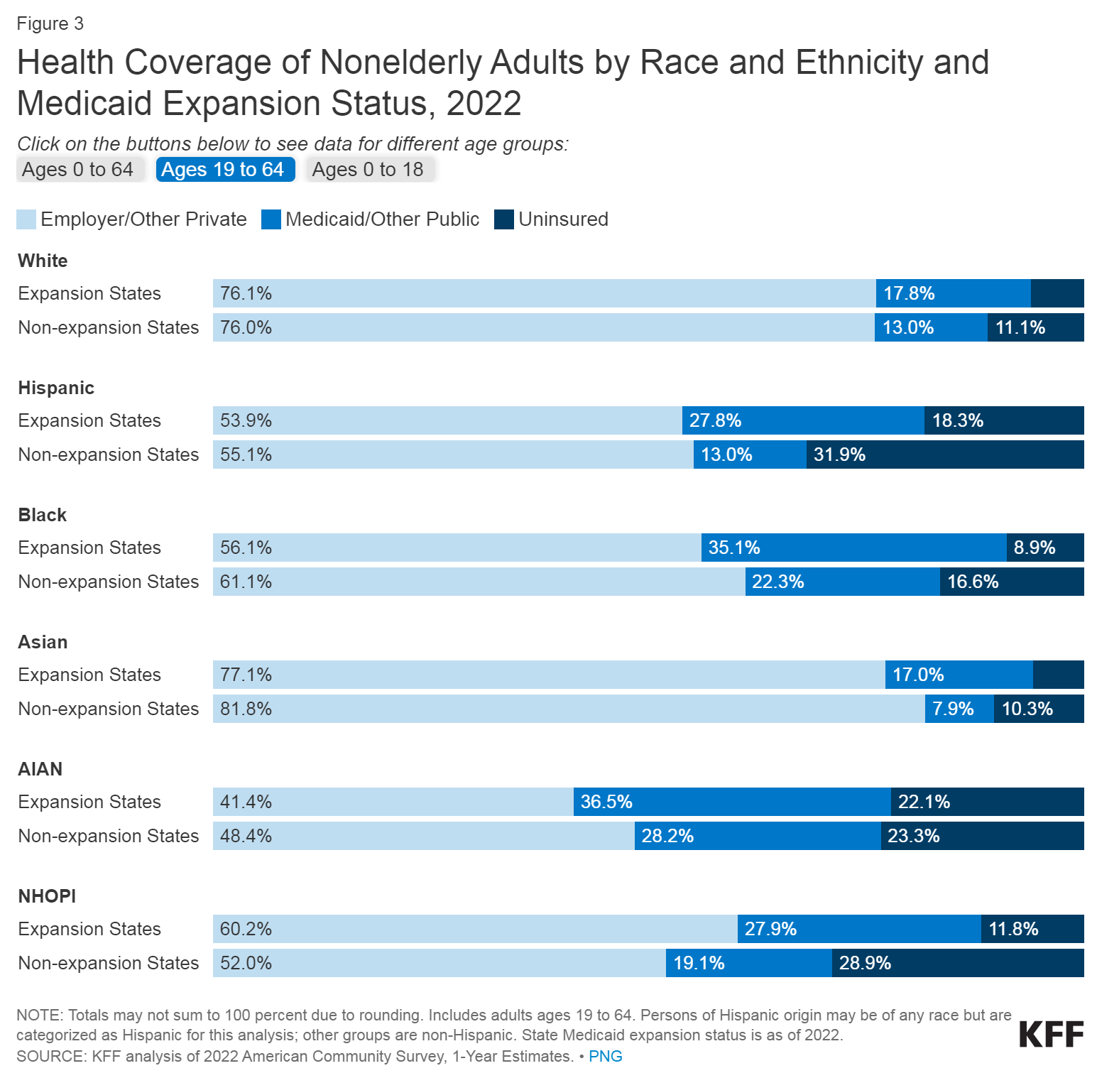

Coverage eligibility among the uninsured in 2022 presents opportunities to expand enrollment in Medicaid or Marketplace coverage; however, eligibility is not uniform across racial and ethnic groups, leaving many without assistance. In general, six out of ten uninsured individuals in 2022 were eligible for financial aid, either through Medicaid or subsidized Marketplace plans. The remaining four out of ten were deemed ineligible due to factors such as falling within the Medicaid coverage gap in non-expansion states, having access to what is considered an affordable Marketplace plan or employer coverage, or facing restrictions based on immigration status. Nevertheless, the proportion of the remaining uninsured eligible for assistance varied by race and ethnicity. Notably, uninsured nonelderly Black individuals were more likely than their White counterparts to be caught in the Medicaid coverage gap in states without Medicaid expansion. Additionally, uninsured nonelderly Hispanic and Asian individuals were less likely than White individuals to qualify for coverage options, partially due to a higher prevalence of noncitizens facing immigrant eligibility restrictions within these groups.

In 2022, 64.2% of uninsured nonelderly adults cited unaffordable coverage as the primary reason for lacking insurance. Most uninsured individuals are in low-income families, with the majority having at least one worker in the family. Racial and ethnic disparities persist, and despite policy efforts, the high cost of insurance remains a significant barrier. The uninsured face challenges in accessing healthcare, often delaying or forgoing care due to costs. Uninsured nonelderly adults in 2022 were nearly twice as likely as those with insurance to struggle with affording healthcare costs.

The uninsured population in 2022, numbering 25.6 million, comprises mostly adults in low-income families, with a substantial representation of people of color. Despite the overall decrease in the uninsured rate, disparities persist across states and regions, particularly in non-expansion states. While gains in Medicaid coverage were significant, disparities in the uninsured rate persist for nonelderly Hispanic and American Indian/Alaska Native populations.

Cost remains a major obstacle to coverage, with 60.7% of nonelderly uninsured workers lacking access to employer-sponsored health benefits in 2022. Among workers offered coverage, cost is often a deterrent, given the 42% increase in total premiums for family coverage from 2013 to 2022, outpacing wage growth.

Medicaid eligibility variations across states and limited eligibility for adults in non-expansion states contribute to coverage gaps. Lawfully present immigrants face a five-year waiting period for Medicaid eligibility, while undocumented immigrants are ineligible for federally funded coverage. Financial assistance is available to many uninsured individuals under the ACA, but barriers to awareness and enrollment persist, leaving four in ten outside the reach of the ACA due to factors such as non-expansion of Medicaid or immigration status.

Uninsured statistics in 2021 in non-expanding states:

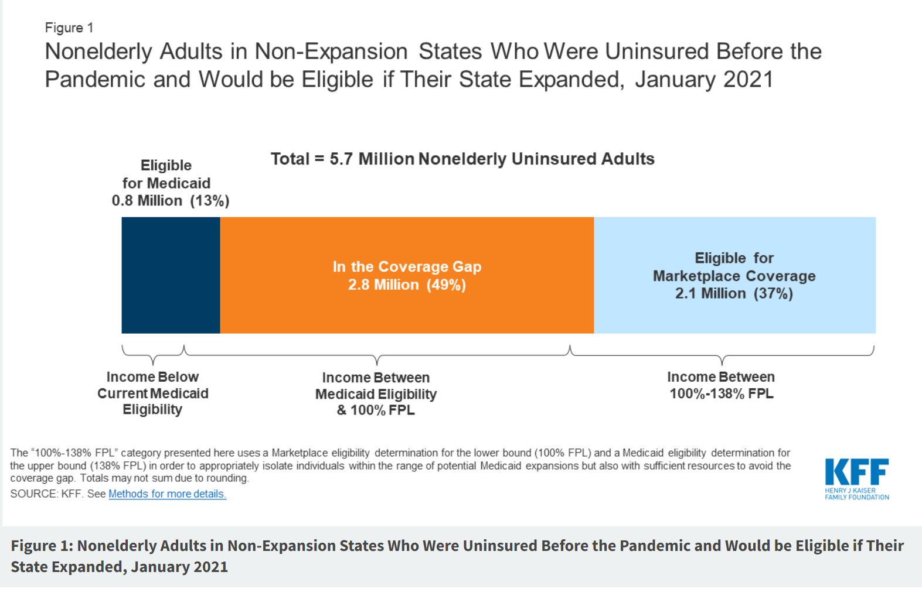

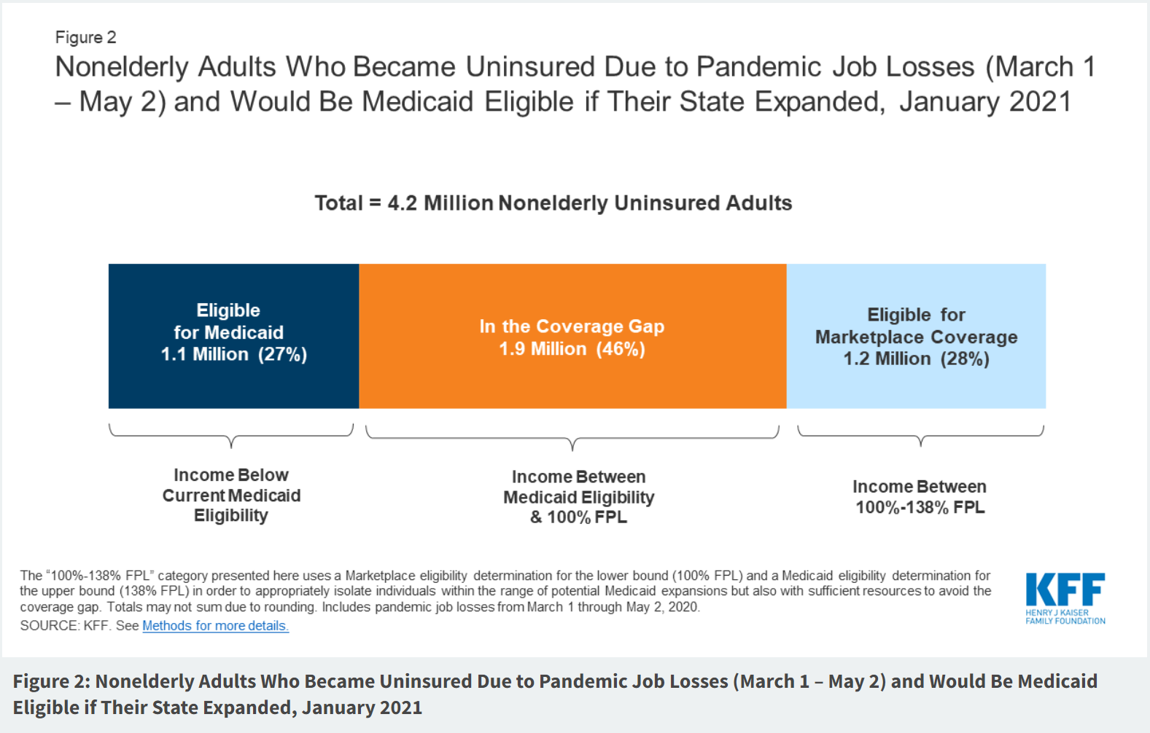

Uninsured statistics in 2023 in non-expanding states:

Drastic improvement from 2021 until 2023 in the percentage of non-elderly uninsured people especially among the ones in the coverage gap.

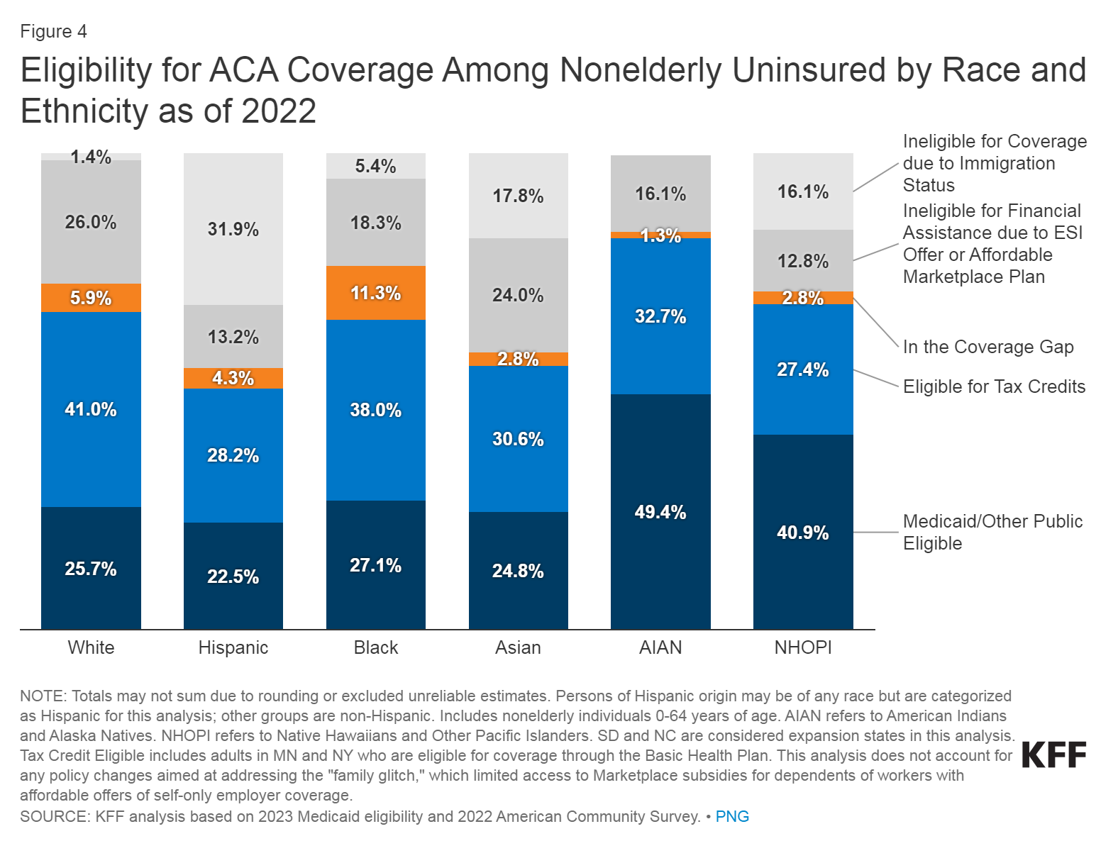

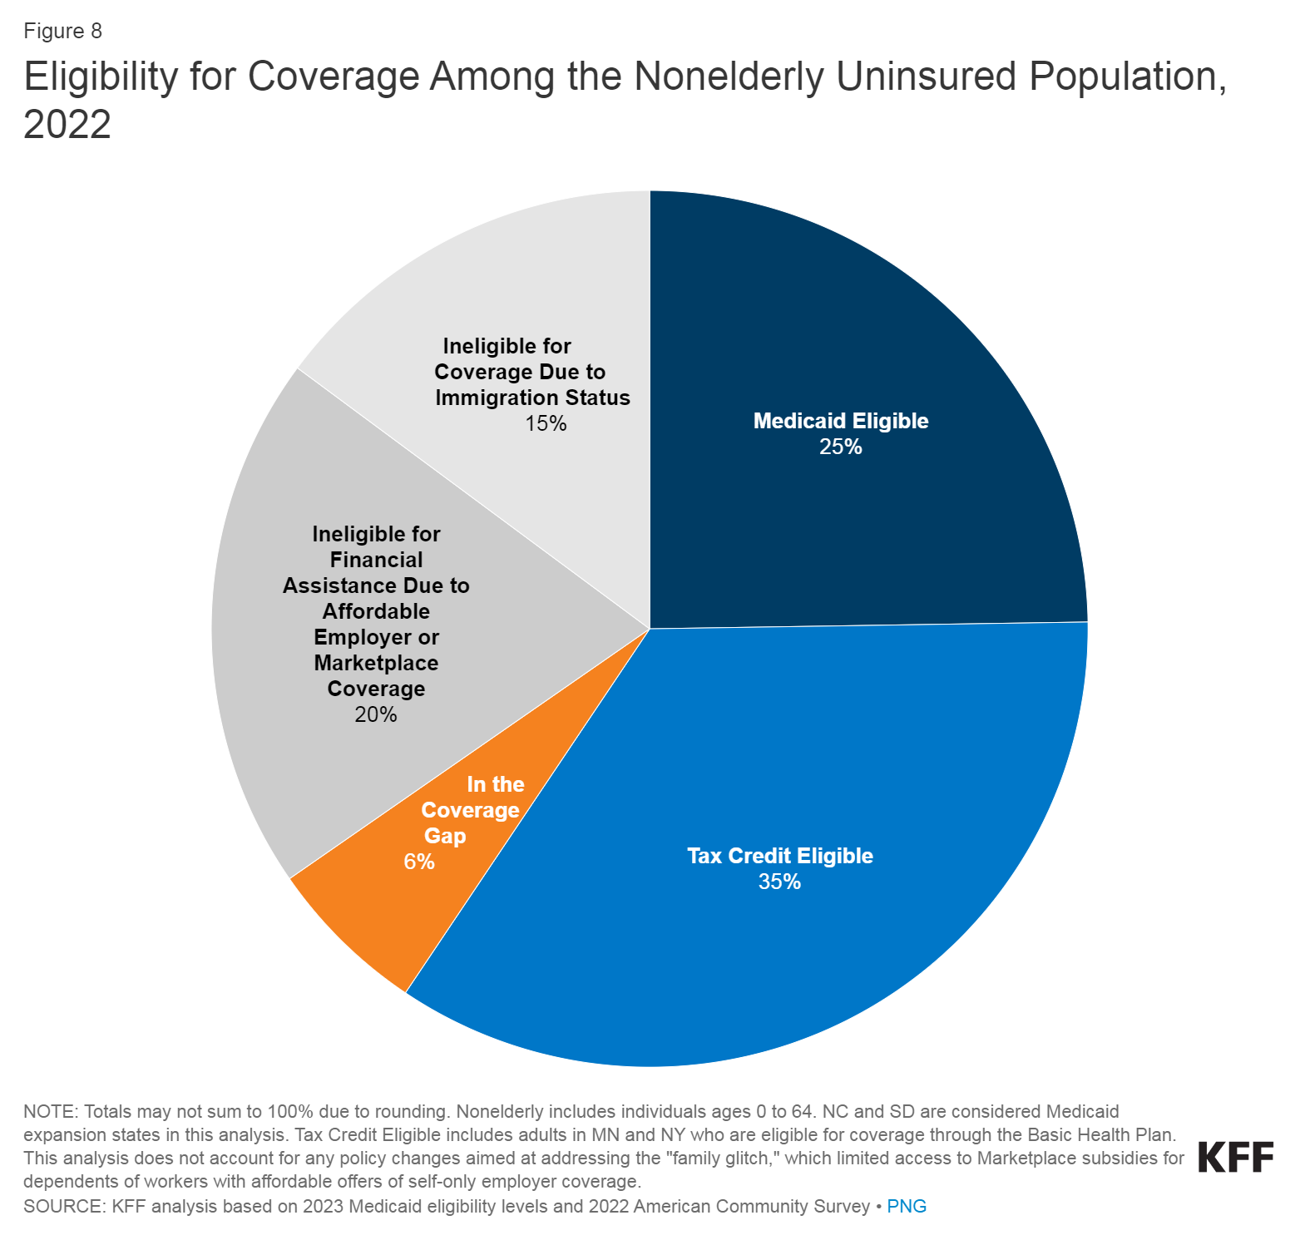

In early 2023, the United States achieved a historic low uninsured rate of 7.7%, significantly down from 2020, with approximately 6.3 million people gaining health coverage. Notable factors contributing to this improvement include enhanced Affordable Care Act (ACA) subsidies, the Inflation Reduction Act, continuous Medicaid enrollment, state Medicaid expansions, and extensive Marketplace outreach by the Biden-Harris Administration.

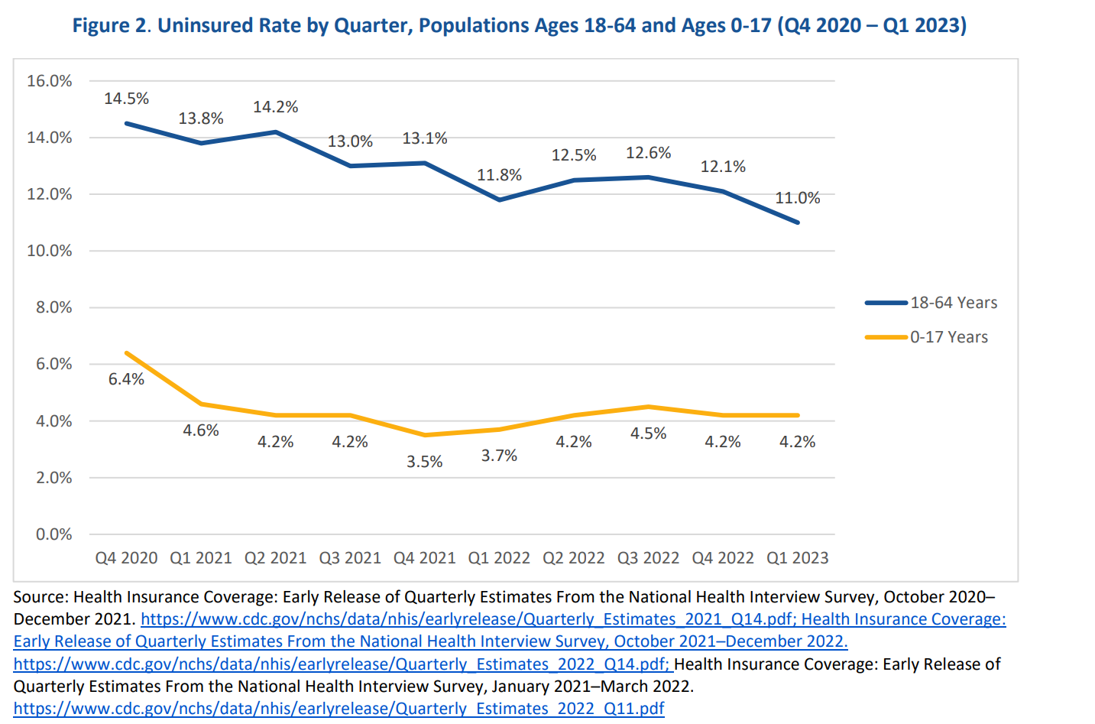

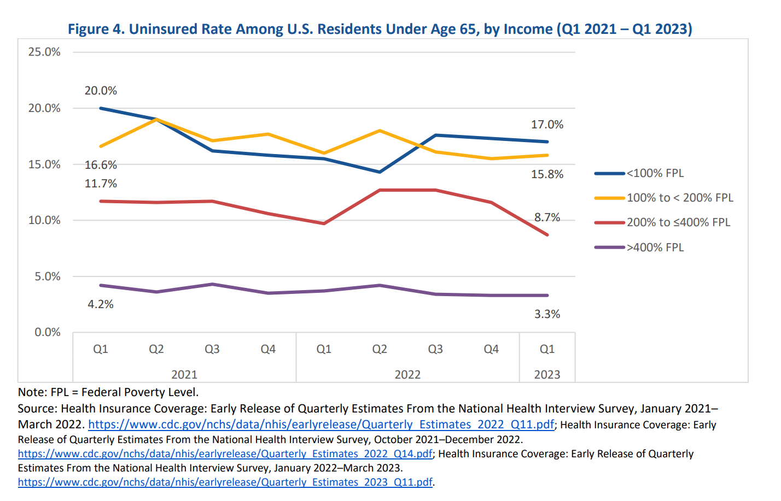

Uninsured rates for adults aged 18-64 dropped from 14.5% in late 2020 to 11.0% in early 2023, and for children aged 0-17, it decreased from 6.4% to 4.2%. Approximately 5.8% of adults reported having ACA Marketplace coverage in early 2023, compared to 4.4% in 2020. The largest declines in uninsured rates occurred among individuals with incomes below 100% and between 200% and 400% of the Federal Poverty Level (FPL).

These positive results are attributed to the Biden-Harris Administration's policies, including record-breaking ACA Marketplace enrollments in 2022 and 2023, continuous Medicaid coverage conditions, and legislative actions enhancing subsidies. However, the first quarter typically marks the lowest uninsured rate, and transitions in coverage may occur over the year. Medicaid continuous coverage conditions ended in April 2023, leading to potential transitions from Medicaid to other sources of coverage.

State-specific analyses show reductions in uninsured rates across all states, with significant improvements in states that expanded Medicaid. Massachusetts had the lowest uninsured rate at 2.5%, while Texas, without Medicaid expansion, had the highest at 18.0% in 2021.

Interesting findings:

The information provided indicates that a substantial portion of vulnerable patients falls into the category of being uninsured. The uninsured population in 2022, numbering 25.6 million, comprises mostly adults in low-income families, with significant representation from people of color. Despite efforts to decrease the overall uninsured rate, disparities persist, particularly in non-expansion states. Additionally, the high cost of insurance remains a significant barrier, with 60.7% of nonelderly uninsured workers lacking access to employer-sponsored health benefits in 2022. Even among those offered coverage, the cost often serves as a deterrent.

While the focus is primarily on the uninsured, there is also an acknowledgment of challenges related to high copayments and deductibles. For instance, the difficulty in affording coverage is a prominent reason for lacking insurance among uninsured nonelderly adults, with 64.2% citing unaffordable coverage as the primary barrier. This suggests that, for some, even if they have insurance, the associated costs such as high copayments and deductibles may still present challenges, contributing to their vulnerability. However, the predominant emphasis is on the barriers faced by those without insurance, exposing them to the catastrophic financial consequences of health issues.

## ***Financial support in Rural Areas***

As the Affordable Care Act (ACA) marked its ten-year milestone, this analysis reviews a substantial body of research spanning from January 2014 to January 2020, exploring the impact of Medicaid expansion on coverage, access to care, and economic measures. The analysis includes 404 studies, with 80 new studies since the last update. The ACA provides financial assistance to eligible individuals and families to make health insurance more affordable. Premium tax credits help reduce monthly premium costs, and cost-sharing reductions lower out-of-pocket expenses like copayments and deductibles.

The ACA established Health Insurance Marketplaces (Exchanges) where individuals and families could shop for and purchase private health insurance plans. These plans offer essential health benefits and are categorized into metal tiers: Bronze, Silver, Gold, and Platinum.

The ACA provides financial assistance to eligible individuals and families to make health insurance more affordable. Premium tax credits help reduce monthly premium costs, and cost-sharing reductions lower out-of-pocket expenses like copayments and deductibles.

The ACA prohibits health insurance companies from denying coverage or charging higher premiums based on pre-existing conditions. This provision ensures that individuals with health issues can still obtain and afford health insurance.

The ACA defined a set of essential health benefits that all individual and small group health insurance plans must cover. These include services such as hospitalization, prescription drugs, preventive services, and maternity care.

1. Medicaid:
   * Purpose: Medicaid is a joint federal and state program that provides health coverage to low-income individuals and families, including some low-income adults, children, pregnant women, elderly adults, and people with disabilities.
   * Eligibility Criteria:
     + Eligibility varies by state but generally includes individuals and families with low income, and specific categories such as pregnant women, children, elderly, and disabled individuals.
   * Benefits:
     + Coverage:
       - Comprehensive Coverage: Medicaid provides a comprehensive range of healthcare services. While specific benefits can vary by state, federal law mandates certain essential health benefits, including hospital and doctor visits, prescription drugs, preventive care, maternity care, mental health services, and more.
       - Medically Needy Programs: Some states have programs for individuals who may have high medical expenses but do not meet traditional income criteria. These programs may allow people to "spend down" their income on medical expenses to become eligible for Medicaid.
     + Access to Care:
       - Provider Networks: Medicaid beneficiaries usually have access to a network of healthcare providers, including doctors, hospitals, and clinics. However, the availability of providers may vary by state, and some Medicaid recipients may face challenges in finding healthcare professionals who accept Medicaid.
       - Primary Care Physicians: Medicaid typically emphasizes the importance of primary care, encouraging regular check-ups and preventive care to manage health conditions proactively.
       - Managed Care Organizations (MCOs): Many states use managed care models to organize and deliver Medicaid services. MCOs can help coordinate care and improve access to services.
     + Economic Measures:
       - Expansion had diverse economic effects, including state budget savings, revenue gains, and overall economic growth.
       - State savings were noted by offsetting costs in other areas.
       - Reductions in uncompensated care costs for healthcare providers and gains in employment were associated with expansion.
       - While Medicaid is designed to be affordable, some beneficiaries may have minimal cost-sharing requirements, such as copayments or premiums. However, these costs are generally much lower than those in private insurance plans.
   * Application:
     + Applications are typically handled through state Medicaid agencies.
2. Marketplace Coverage (Health Insurance Exchange):
   * Purpose: The Health Insurance Marketplace, also known as the Exchange, is a platform where individuals and families can shop for and purchase private health insurance plans.
   * Eligibility Criteria:
     + Generally open to U.S. citizens and lawfully present immigrants who do not qualify for Medicaid and do not have access to affordable employer-sponsored insurance.
   * Benefits:
     + Coverage varies by plan but usually includes essential health benefits such as hospitalization, prescription drugs, preventive services, and more.
     + Access to Care:

* Networks of Providers: Marketplace plans typically have networks of healthcare providers, including doctors, hospitals, and specialists. It's essential for individuals to check if their preferred healthcare providers are in-network to maximize coverage and minimize out-of-pocket costs.
* Preventive Services: Marketplace plans often cover preventive services at no additional cost, encouraging individuals to receive regular check-ups, screenings, and vaccinations to detect and prevent health issues early.
* Coordinated Care: Some Marketplace plans, especially those operating under managed care models, may emphasize coordinated care to improve health outcomes and efficiency.
  + - Premium Tax Credits: The ACA provides premium tax credits to eligible individuals and families with incomes between 100% and 400% of the federal poverty level. These tax credits help reduce the monthly premium costs of Marketplace plans.
    - Cost-Sharing Reductions (CSRs): CSRs reduce out-of-pocket costs, such as copayments and deductibles, for individuals and families with incomes between 100% and 250% of the federal poverty level. These reductions are applied to Silver-tier plans.
    - Affordability and Subsidies: The goal of Marketplace subsidies is to make health insurance more affordable for those who may not have access to employer-sponsored coverage and don't qualify for Medicaid.
  + Application:
    - Applications are submitted through the Health Insurance Marketplace during the open enrollment period. Special Enrollment Periods are available under certain qualifying life events.
    - Individuals can enroll in or make changes to their Marketplace plans outside of the annual open enrollment period if they experience certain qualifying life events, such as marriage, birth or adoption of a child, or loss of other health coverage.

1. Tax Credits (Premium Tax Credits):
   * Purpose: Premium Tax Credits are a form of financial assistance to help eligible individuals and families afford health insurance purchased through the Health Insurance Marketplace.
   * Eligibility Criteria:
     + Generally, individuals and families with income between 100% and 400% of the federal poverty level may qualify for premium tax credits.
   * Benefits:
     + Reduces the monthly premium cost of a health insurance plan purchased through the Marketplace.
   * Application:
     + Applicants indicate their estimated annual income during the Marketplace application process, and the tax credits are applied directly to the monthly premium.
2. CHIP
3. Medicare

***Medicaid***

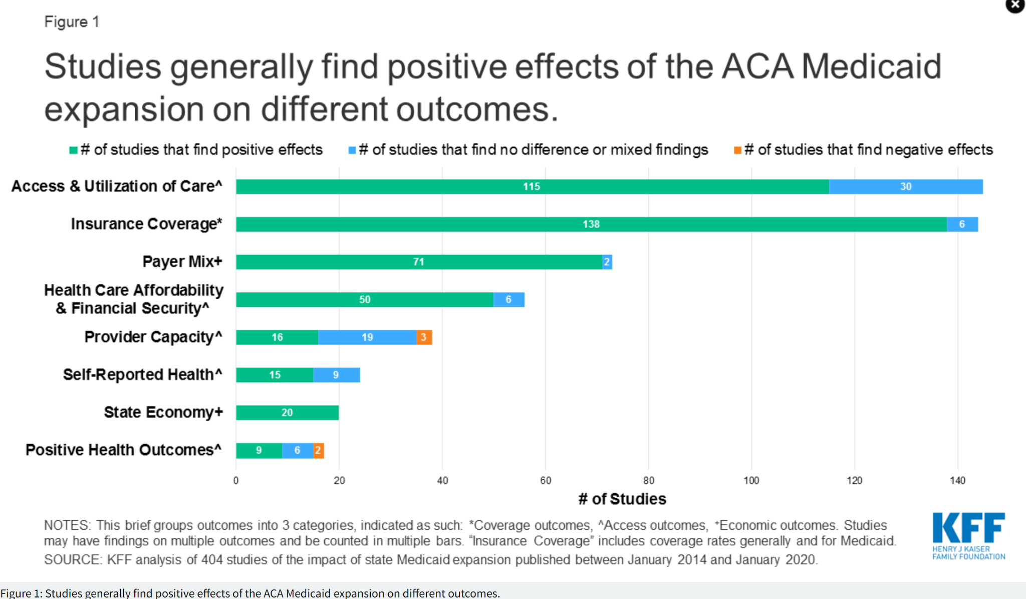

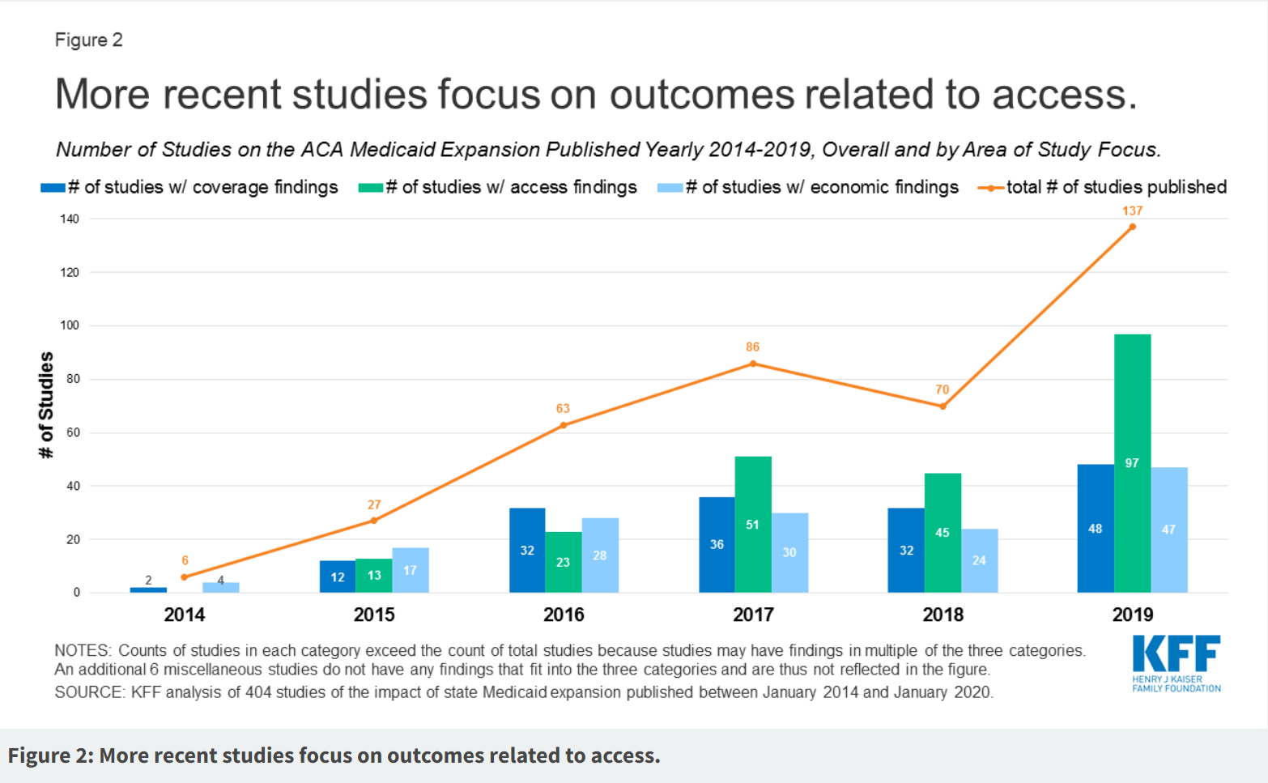

Despite similarities in many demographic characteristics between uninsured non-elderly individuals in rural and urban areas, rural areas maintain higher overall uninsured rates. In 2019, the uninsured rate stood at 16.0% in rural areas compared to 12.9% in urban areas. This suggests persistent challenges in healthcare accessibility for rural residents. However, federal and state healthcare coverage programs, including Medicaid, CHIP, Marketplace, and Medicare, play a crucial role in providing comprehensive health insurance coverage for millions of rural residents. The report highlights an opportunity to extend coverage further through these programs, emphasizing the need for targeted policies to address rural-urban disparities and ensure equitable health coverage for all.

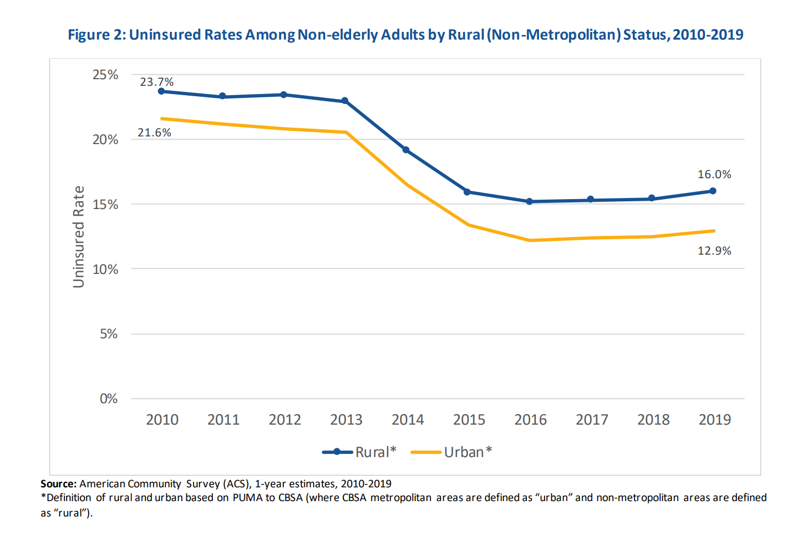

Over the last decade, the Affordable Care Act has contributed to a drop in uninsured rates in rural areas from 23.7 percent in 2010 to 16.0 percent in 2019. However, rural areas still exhibit higher uninsured rates compared to urban counterparts (16.0% vs. 12.9% in 2019). Geographically, areas in the South, Southeast, and Midwest often grapple with elevated uninsured rates, emphasizing the importance of tailored policy decisions to address the unique challenges faced by rural communities and ensure equitable health coverage for all.

Medicaid and CHIP are crucial for millions with low incomes in rural areas. They cover 1 in 6 people aged 19-64 in rural places, and 22% of rural residents are covered by both Medicaid and Medicare. Since the ACA in 2010, Medicaid coverage in rural areas increased from 12.2% to 17.1%.

Medicaid also helps pregnant individuals in rural areas, covering half of rural births in 2018. However, the impact of Medicaid can differ between states, with expansion states having lower rural uninsured rates. In non-expansion states, the uninsured rate in rural areas is high at 21.5%, showing a coverage gap as already explained.

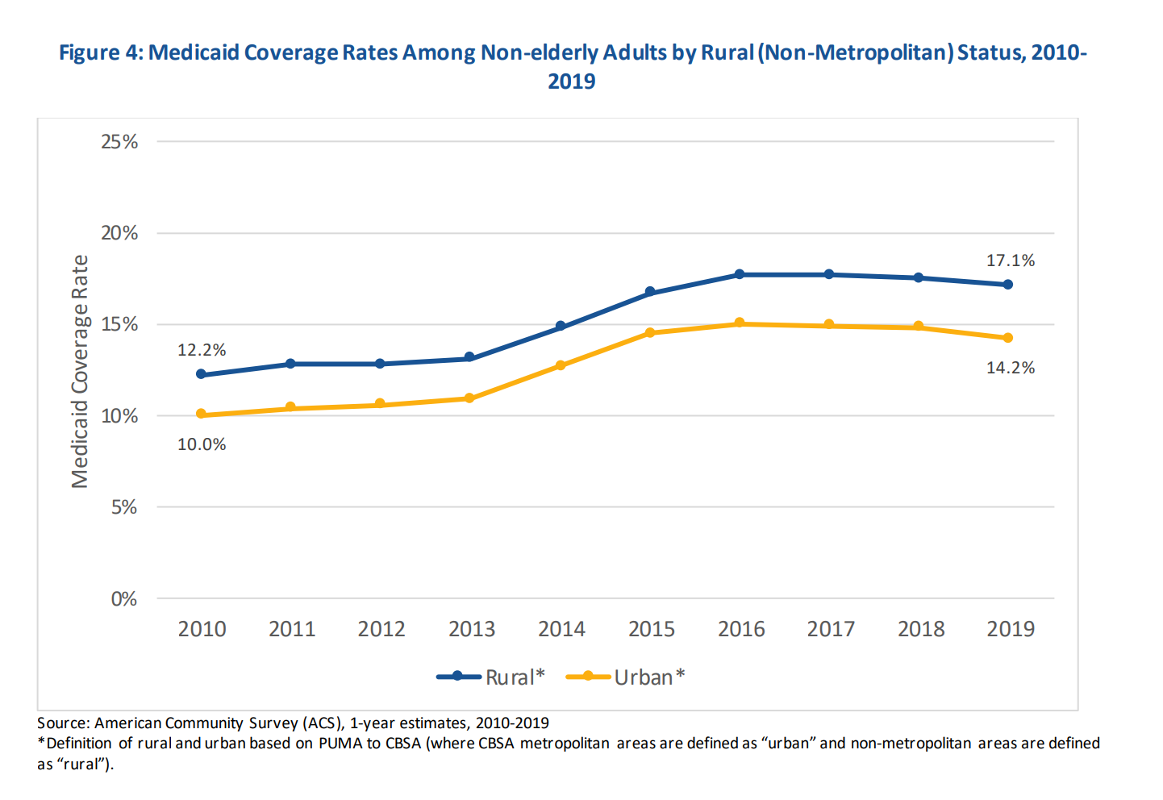

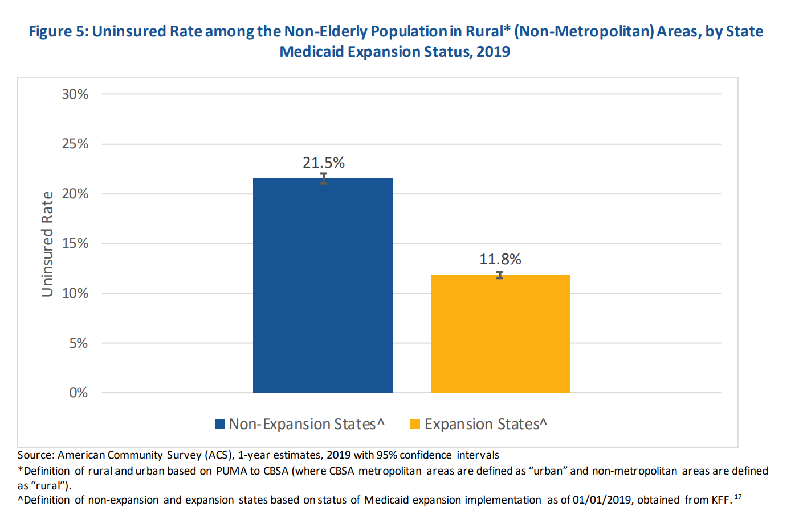

The states Wyoming, Kansas, Texas, Wisconsin, Tennessee, Mississippi, Alabama, Georgia, South Carolina, and Florida are the states which yet have to implement Medicaid so their citizens can use the benefits of healthcare.

* Wyoming: Western United States
* Kansas: Central United States (Midwest)
* Texas: Southern United States (Southwest and South Central)
* Wisconsin: Central United States (Midwest)
* Tennessee: Southern United States (Southeast)
* Mississippi: Southern United States (Southeast)
* Alabama: Southern United States (Southeast)
* Georgia: Southern United States (Southeast)
* South Carolina: Southern United States (Southeast)
* Florida: Southern United States (Southeast) and the Eastern United States

These states are spread across different regions, with some in the Midwest, Southwest, and Southeastern parts of the country. Southwest and southeastern parts are the ones which are populated by minorities from the ethnicities of interest. There is definitely a correlation between the implementation of Medicaid and the barrier of healthcare.

***ESI Offer or Affordable Marketplace Plan***

While Medicaid helps and is a significant factor towards overcoming healthcare inequities and giving greater access coverage,, the ACA Marketplace is essential for those who can't get Medicaid or other affordable coverage. Rural areas often have fewer choices, but the American Rescue Plan (ARP) makes coverage more affordable. The ARP improves premium tax credits, making health plans with zero or low premiums more accessible.

Research suggests that the expansion of Medicaid has led to more significant declines in the rate of uninsured individuals in rural areas compared to urban regions. Furthermore, Medicaid expansion is linked to an uptick in visits to Community Health Centers in rural settings, covering a diverse range of services such as mammograms, mental health, and substance use disorder treatments. In rural areas with initially high uninsured rates, Medicaid expansion correlates with improved financial performance for hospitals and a reduced risk of hospital closures. Despite these positive outcomes, several states with substantial rural populations have chosen not to expand Medicaid as already described.

Around 15% of plan selections in HealthCare.gov states come from rural areas, proving the ongoing importance of the Marketplace. After the ARP, many enrollees can access affordable health plans, which is good news. However, there are still many uninsured people, and the ARP helps a large percentage of them find affordable coverage on HealthCare.gov.

The ACA Marketplace serves as a crucial health insurance option for individuals and families with lower to middle incomes who don't qualify for Medicaid and lack access to other affordable coverage like employer-sponsored insurance or Medicare. However, rural areas face challenges as they often have fewer insurers participating in the federal Marketplace on HealthCare.gov and State-Based Marketplaces (SBMs).

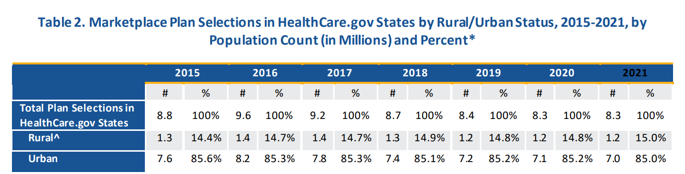

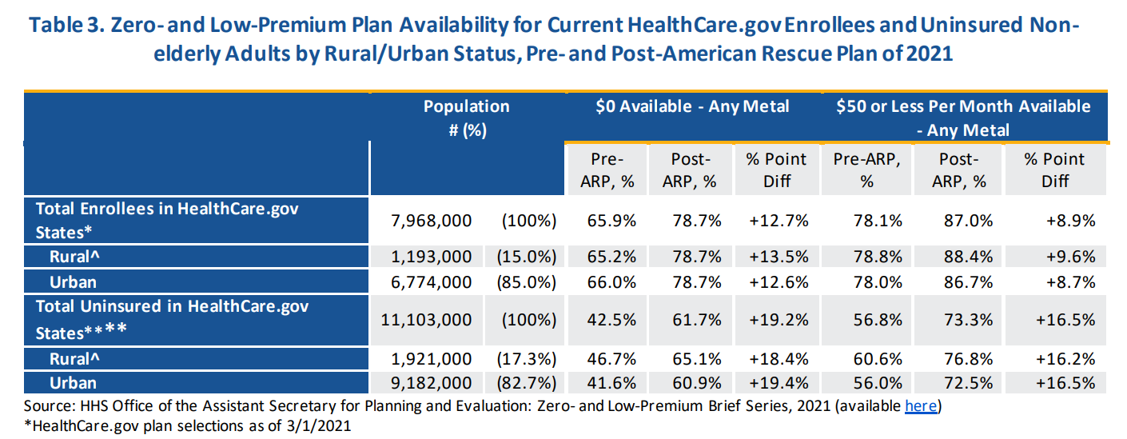

The American Rescue Plan (ARP) has made health insurance more affordable for many Marketplace consumers, including those in rural areas. According to Table 3, the ARP has increased the availability of zero- and low-premium health plans for individuals enrolled in HealthCare.gov. In rural counties, approximately 78.7% of current enrollees can now access these plans, similar to the percentages in urban areas. Moreover, a higher percentage of uninsured non-elderly adults in rural counties (65.1% for zero-premium and 76.8% for low-premium) may find affordable health plans on HealthCare.gov compared to urban areas. This means that around 1.3 million people in rural areas now have the option to choose at least one zero-premium health plan.

***Tax credits in Rural Areas***

If an individual's income is below the threshold for Medicaid expansion in their state, they may be eligible for premium tax credits to reduce the cost of a Marketplace plan. It's essential for individuals in non-expansion states to explore their options on the Health Insurance Marketplace and determine whether they qualify for financial assistance through premium tax credits or other subsidies.

***Federal poverty level***

Numerous benefits offered by both federal and state governments are linked to the Federal Poverty Level (FPL) or specific percentages thereof. The FPLs, alternatively referred to as federal poverty guidelines, undergo annual updates. Here are the FPLs applicable for the year 2024, categorized according to family size. The initial column displays the annual income, while the subsequent columns present the corresponding monthly incomes.

100% FPL:

If your income falls below 100% of the Federal Poverty Level (FPL), your state is obligated to cover your Medicare expenses through the Qualifying Medicare Beneficiary (QMB) program. This program, a Medicare Savings Program, is accessible if you qualify for Medicare due to age (65 or older) or disability. Additionally, several states set the 100% FPL as the income threshold for Medicaid eligibility for adults.

133% FPL:

The 133% FPL serves as the income limit for Medicaid expansion in states that opted to expand Medicaid under the Affordable Care Act (ACA or "Obamacare"). Medicaid expansion allows for a 5% income disregard, effectively extending eligibility to those under 138% of the poverty level in expansion states. In certain states, children, pregnant women, parents, and childless adults may also qualify for Medicaid under the 133% FPL.

135% FPL:

For incomes below 135% of the FPL, various Medicare Savings Programs become available. The Qualifying Individual (QI) program, which covers the monthly Part B premium, is one such program. Additionally, the Specified Low-Income Medicare Beneficiary (SLMB) program, with an income limit of 120%, provides the same benefit—payment of the monthly Part B premium. The 135% FPL is also the income limit for qualifying for Medicare Part D's Extra Help full subsidy, covering premiums, deductibles, and reduced per-prescription copayments.

150% FPL:

The 150% FPL serves as the threshold for qualifying for Medicare Part D's Extra Help partial subsidy, which reduces premiums, deductibles, and per-prescription copayments. For married individuals whose spouses are in Medicaid-paid nursing homes, 150% FPL is utilized for the "minimum monthly maintenance needs allowance" starting from July 1 of each year.

200% FPL:

The Qualified Disabled and Working Individuals (QDWI) program has an income limit of 200% FPL. This program allows individuals who no longer qualify for Medicare due to employment to continue receiving Medicare benefits. The QDWI program, similar to the SSI program, disregards half of the income earned from work.

250% FPL:

Eligibility for out-of-pocket savings for the Silver health care plan available through the HealthCare Marketplace (Obamacare) is determined based on an income limit of 250% of the FPL.

400% FPL:

Individuals with incomes below 400% of the FPL are eligible for a lower-cost premium when enrolling in a health care plan through the Health Care Marketplace.

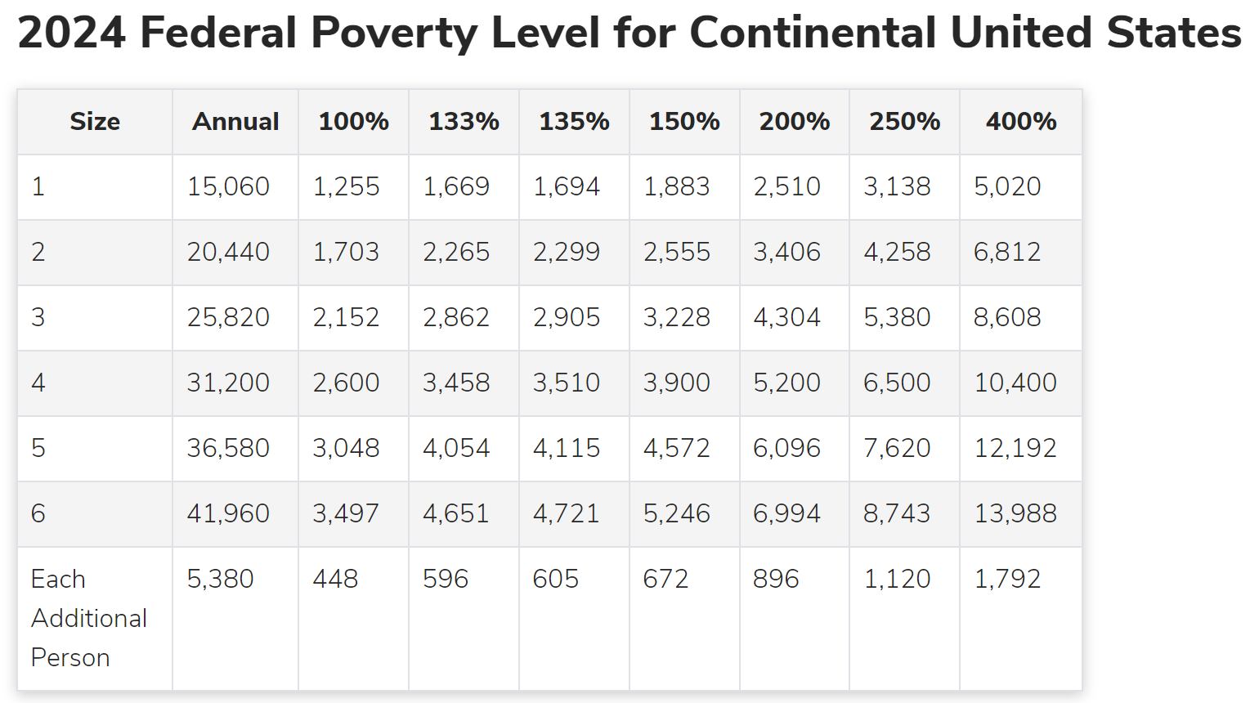

For example there are outliers among the states,, the Federal Poverty Levels (FPLs) for Hawaii and Alaska are elevated to account for the elevated cost of living in these states.

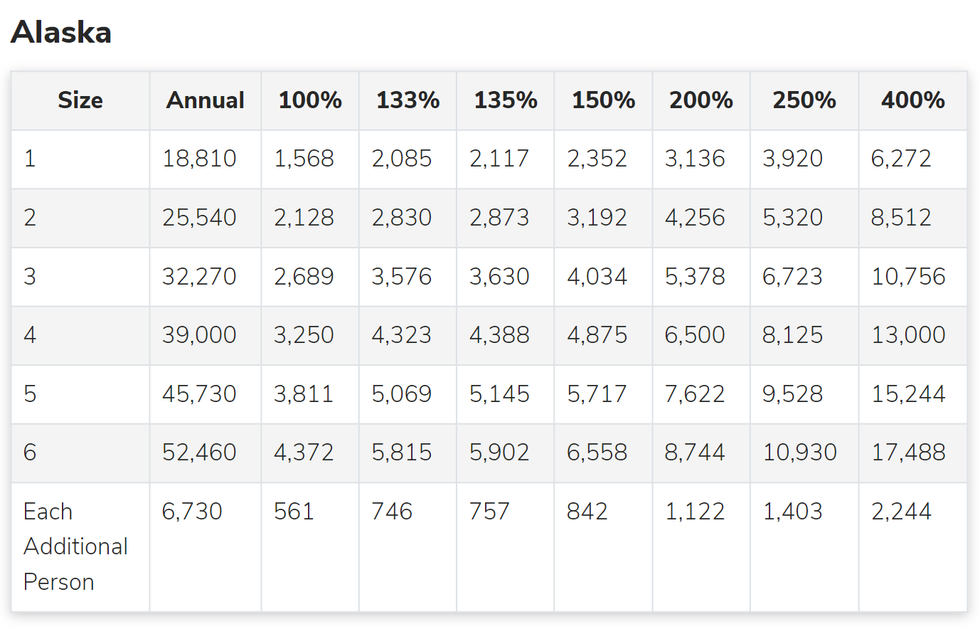

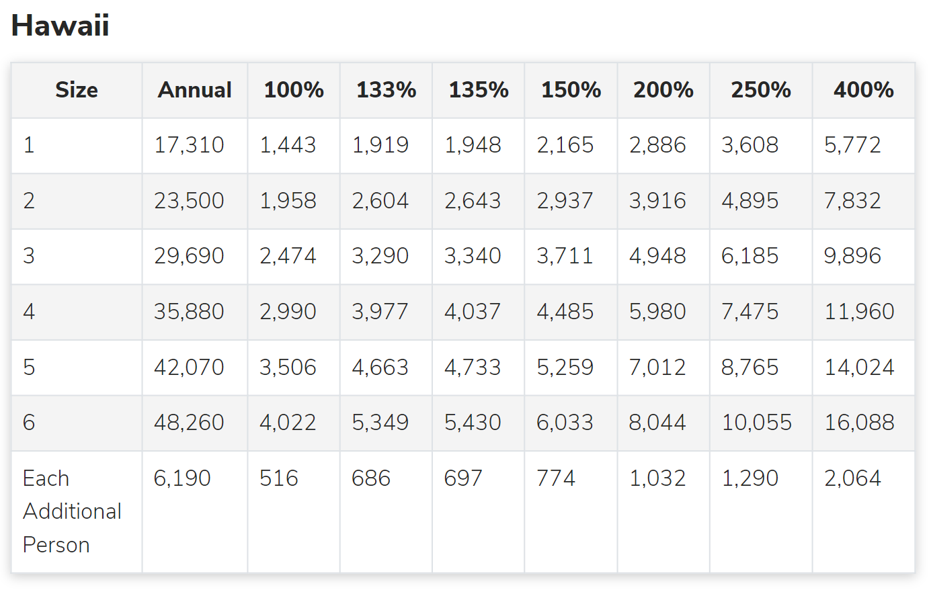

[<https://www.nolo.com/legal-encyclopedia/federal-poverty-level-eligibility-medicare-medicaid-benefits.html>]

***Total number of uninsured non-elderly population per states which have not expanded Medicaid***

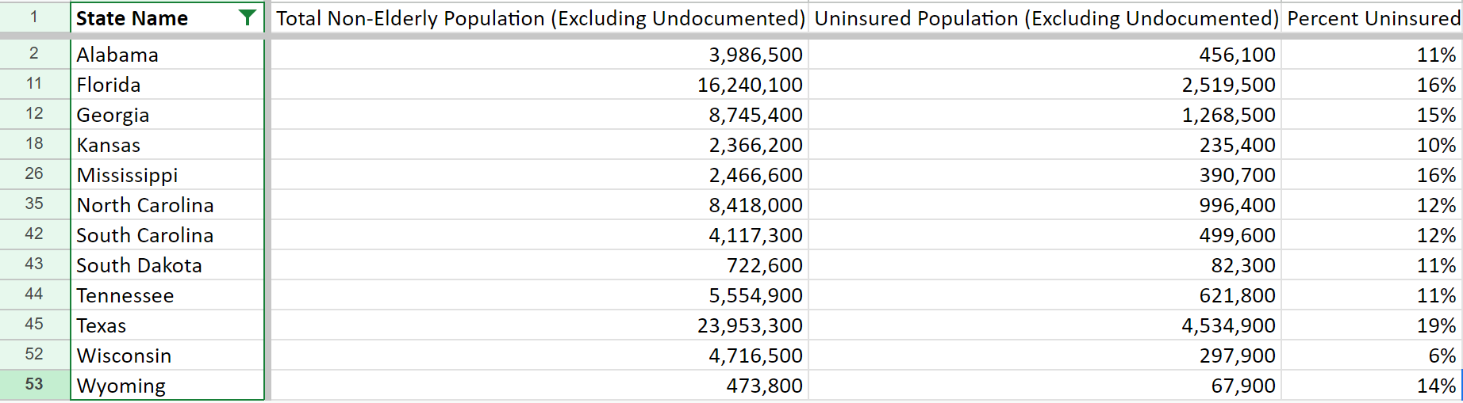

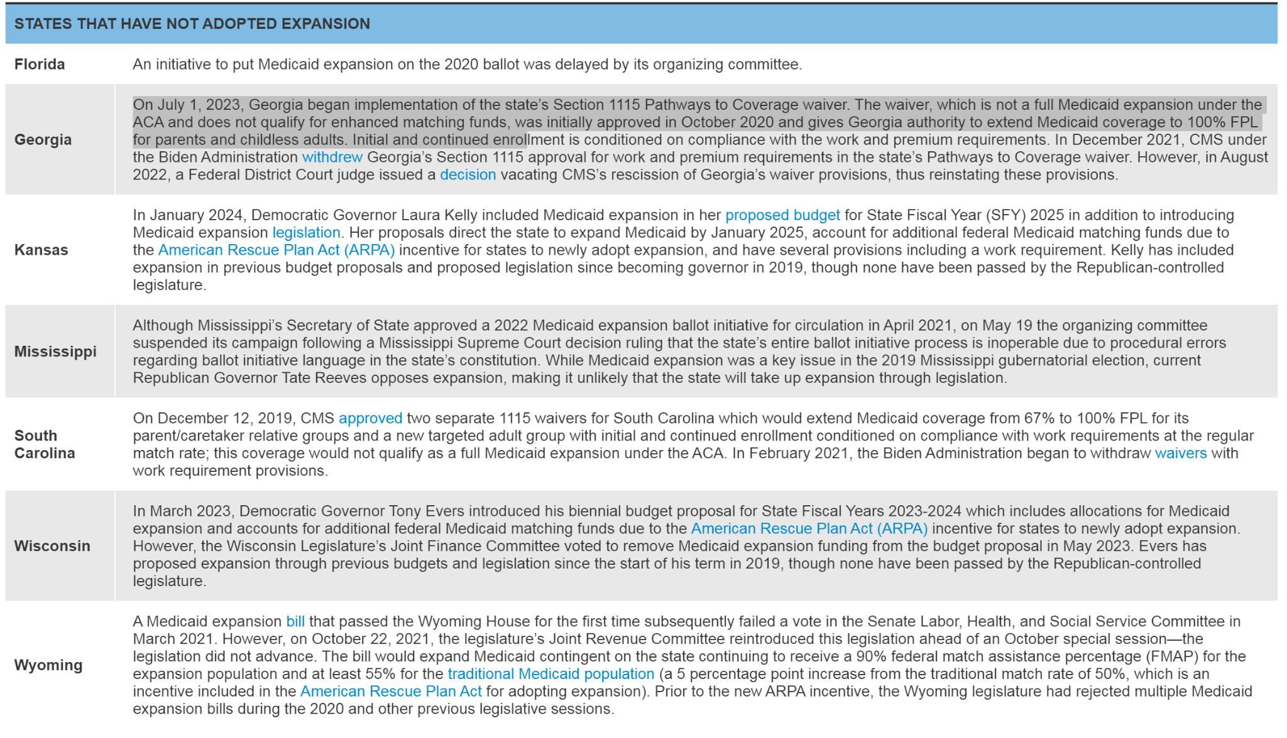

Low income + education + financial illiteracy are correlated - Medicaid and medicare coverage and eligibility autoenrollment

Rural - No access, incentives for hospitals and value based care model

***Coverage gap***

The term "coverage gap" refers to a situation that can occur in states that have chosen not to expand Medicaid under the Affordable Care Act (ACA). In these non-expansion states, there may be a gap in health coverage for individuals with incomes below the poverty level. Here's how the coverage gap typically works:

* Medicaid Expansion Threshold:
  + The ACA originally intended for Medicaid expansion to cover individuals with incomes up to 138% of the federal poverty level. This expansion aimed to provide health coverage to more low-income adults who were previously ineligible for traditional Medicaid.
* Non-Expansion States:
  + Some states decided not to expand Medicaid, leaving a group of low-income individuals with incomes below the poverty level without access to Medicaid coverage.
* Income Threshold for Marketplace Subsidies:
  + On the Health Insurance Marketplace, premium tax credits (subsidies) are available to individuals with incomes between 100% and 400% of the federal poverty level. Below 100%, individuals were intended to be covered by Medicaid.
* Coverage Gap:
  + In non-expansion states, individuals with incomes below the poverty level may find themselves ineligible for Medicaid because the state did not expand the program. At the same time, they may also be ineligible for premium tax credits on the Marketplace because their income is below the threshold.
* Limited Options for Affordable Coverage:
  + As a result, these individuals may face challenges obtaining affordable health coverage. They might not qualify for Medicaid, and without premium tax credits, private insurance through the Marketplace may be financially out of reach for them.

***Potential eligibility for states if Medicaid expanded***

* Minimum 23% Maximum 49% of the uninsured population in non-expanding states would be eligible for Medicare expenses through the Qualifying Medicare Beneficiary (QMB) program.

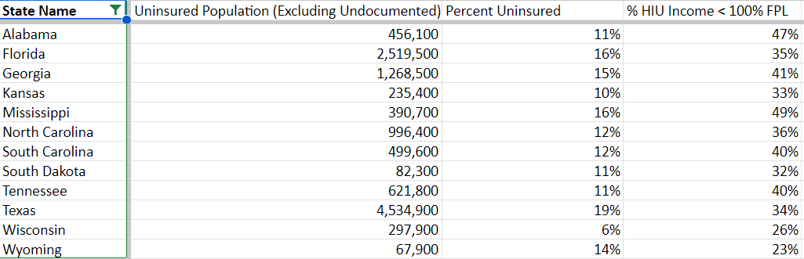

* Minimum 7% Maximum 12% of the uninsured population in non-expanding states would be eligible for Medicare expenses with a 5% income disregard extending eligibility to individuals under 138% of the poverty level, and certain populations like children, pregnant women, parents, and childless adults may qualify under this limit.Several Medicare Savings Programs, including the Qualifying Individual (QI) program covering the Part B premium, and the Specified Low-Income Medicare Beneficiary (SLMB) program, which shares the same benefit, have income limits, and the 135% Federal Poverty Level (FPL) serves as the threshold for qualifying for Medicare Part D's Extra Help full subsidy, encompassing premium coverage, deductibles, and reduced per-prescription copayments.

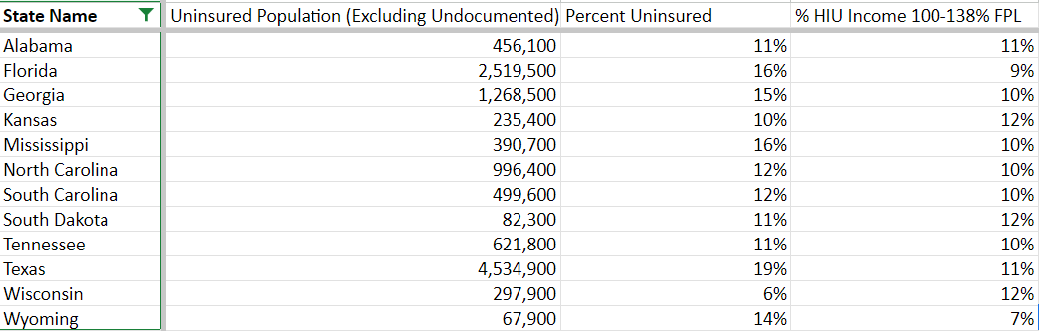

* Minimum 21% and maximum 31% of the uninsured population in non-expanding states would be eligible for financial assistance. The 150% Federal Poverty Level (FPL) is the threshold for eligibility for a partial subsidy under Medicare Part D's Extra Help, reducing premiums, deductibles, and per-prescription copayments; additionally, for married individuals with spouses in Medicaid-paid nursing homes, 150% FPL determines the "minimum monthly maintenance needs allowance" from July 1 each year. The Qualified Disabled and Working Individuals (QDWI) program has a 200% FPL income limit, allowing individuals who no longer qualify for Medicare due to employment to maintain their Medicare benefits, and it, like the SSI program, disregards half of the income earned from work.

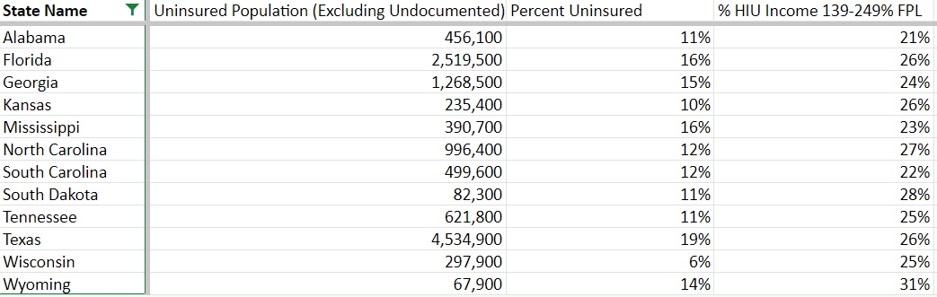

* Minimum 11% and maximum 21% qualify for cost savings on the Silver health care plan offered through the HealthCare Marketplace (Obamacare) is established by an income threshold set at 250% of the Federal Poverty Level (FPL).

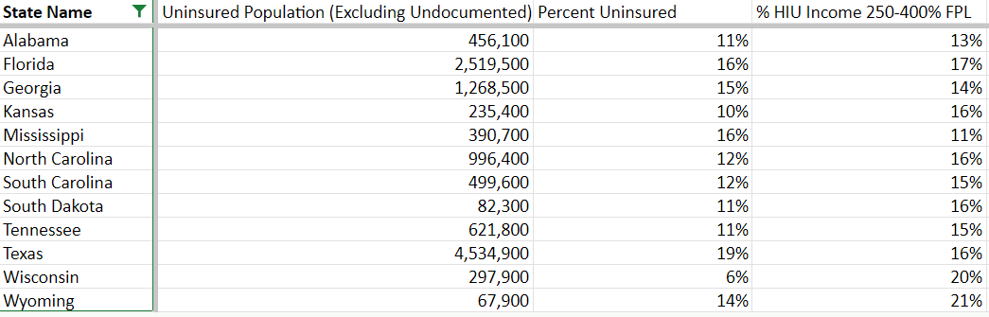

* Minimum of 8% and maximum of 19% of uninsured individuals with incomes below 400% of the FPL are eligible for a lower-cost premium when enrolling in a health care plan through the HealthCare Marketplace.

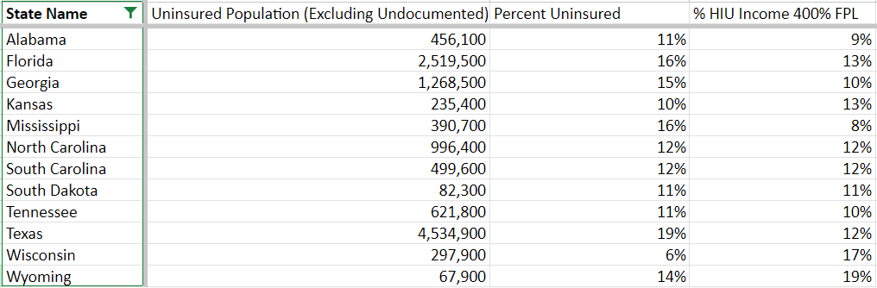

* Potential 26,086,300 uninsured people could get financial waiver, benefits and cost-cutting with the Medicaid expansion and Marketplace Plans in non-expanding states in the United States. I previously mentioned that Uninsured people are in total 8% of the U.S. population, equivalent to 27 million people. So these could possibly cover all people who are uninsured and exposed to catastrophic medical expenses.

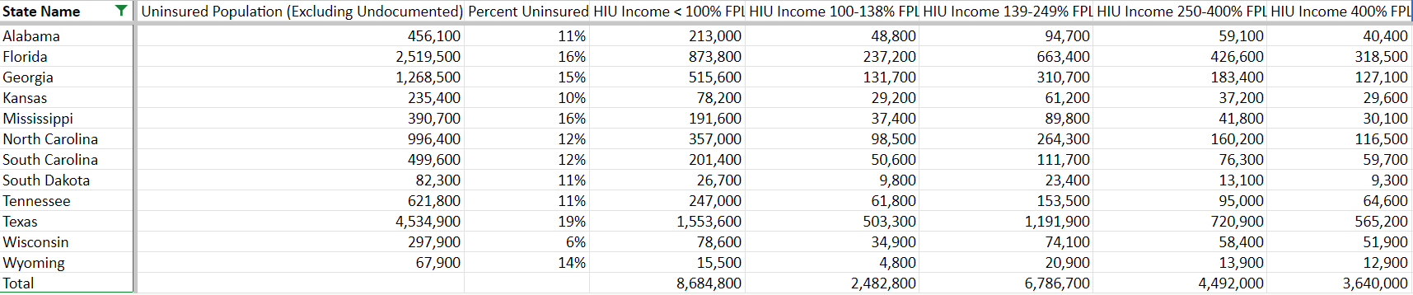

***Non-financial barriers to Healthcare***

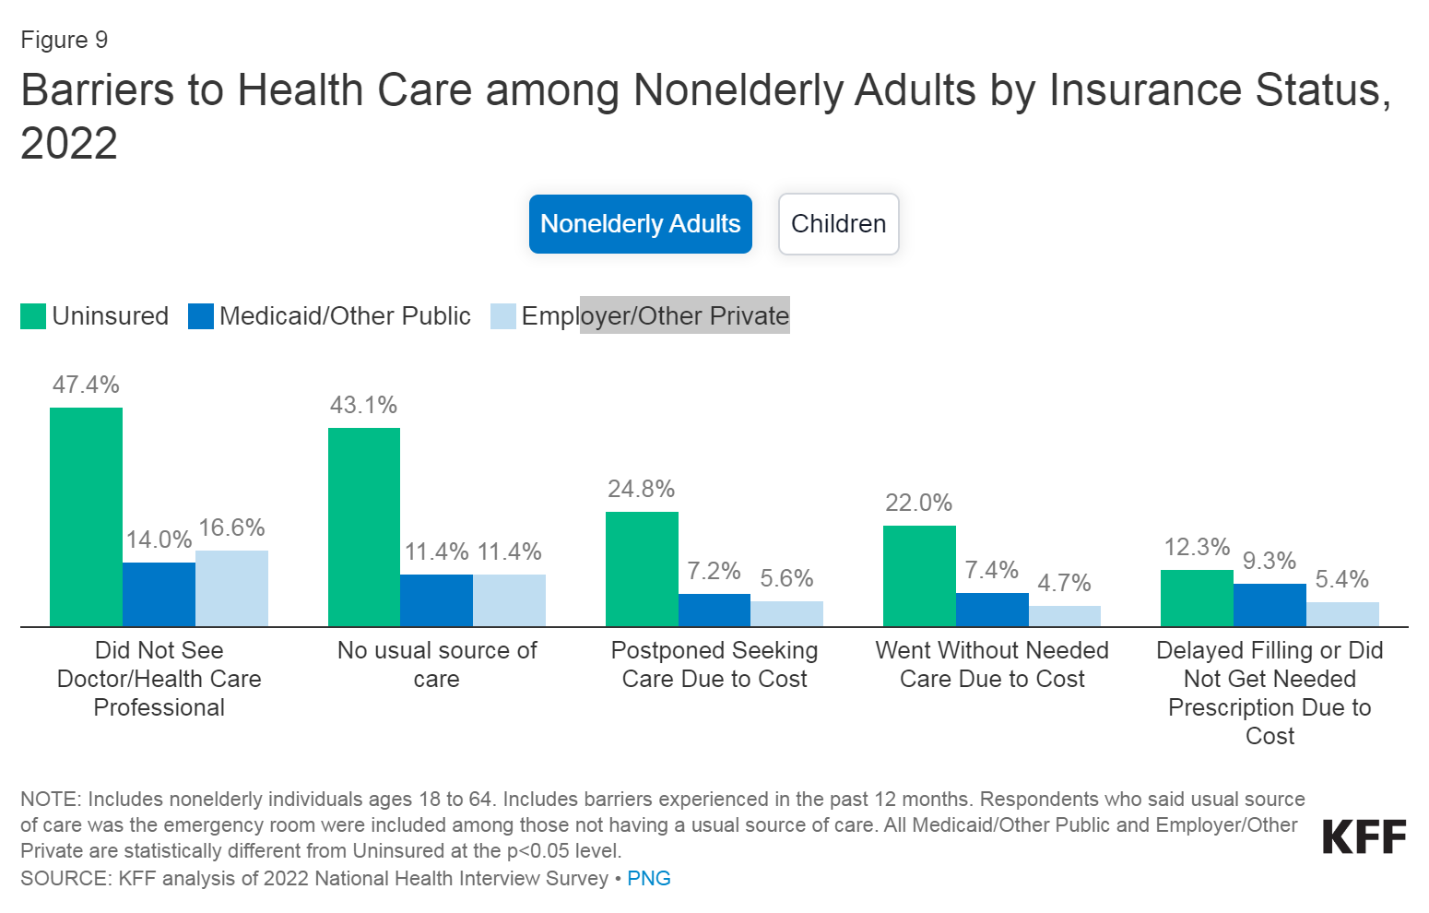

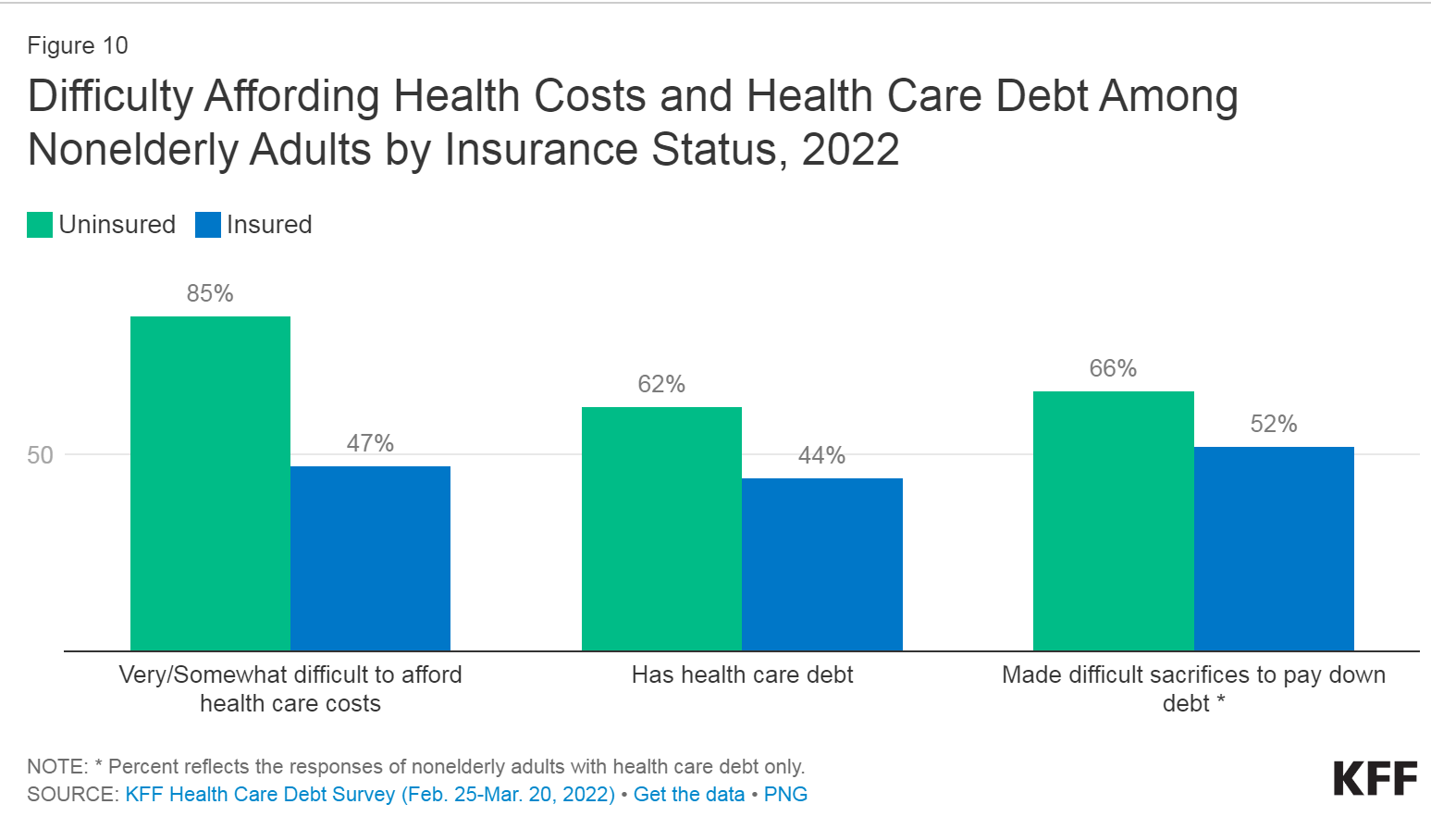

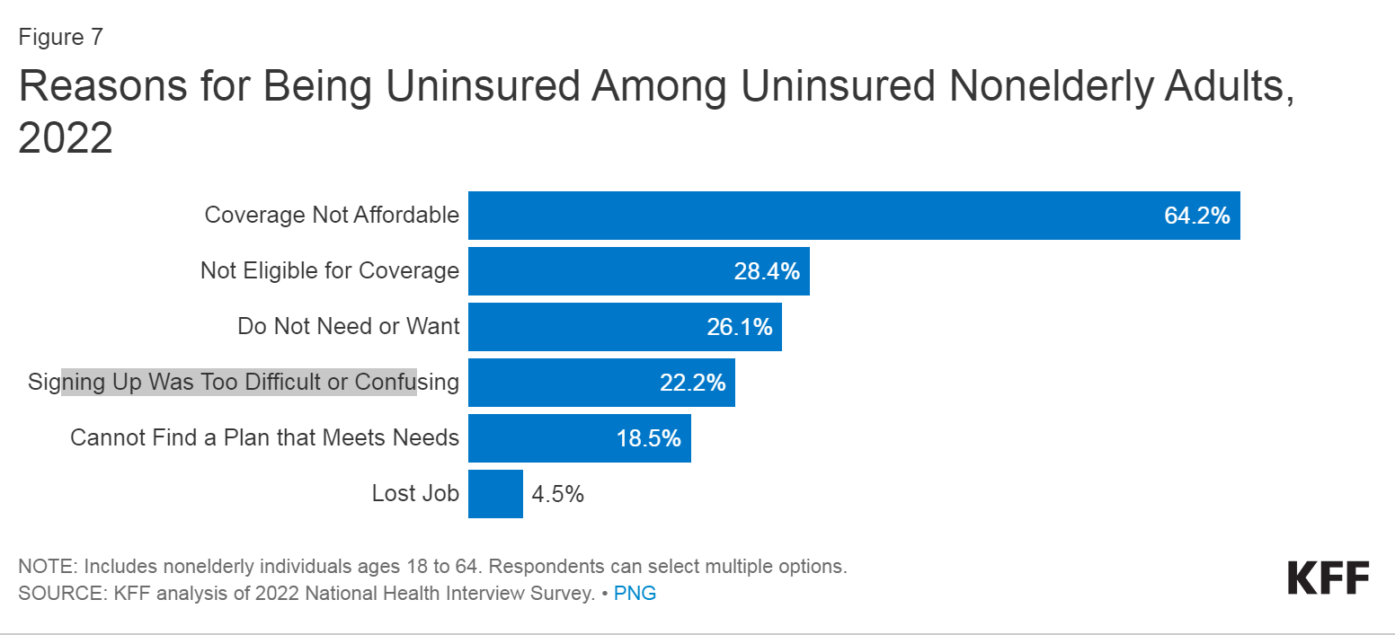

Multiple studies consistently reveal that uninsured individuals are less likely than those with insurance to receive preventive care and services for major health conditions and chronic diseases. Despite an overall decline in healthcare service utilization during the pandemic, uninsured adults were more likely to attribute their delay or avoidance of care in 2021 to cost barriers rather than COVID-19-related concerns. In 2022, almost half (47.4%) of nonelderly uninsured adults reported not having seen a doctor or healthcare professional in the past 12 months, in contrast to 16.6% with private insurance and 14.0% with public coverage. A significant factor contributing to the lack of access to care among uninsured individuals is the absence of a regular healthcare facility, as cited by many (43.1%) (Figure 9). However, cost is also a crucial factor, with over one in five (22.0%) nonelderly uninsured adults stating that they had forgotten needed care in the past year due to cost, compared to 4.7% of adults with private coverage and 7.4% of those with public coverage.

Many uninsured individuals do not adhere to the prescribed treatments recommended by their healthcare providers due to the financial burden of care. In 2022, uninsured nonelderly adults were more than twice as likely as adults with private coverage to report delaying or not obtaining a necessary prescription drug due to cost (12.3% vs. 5.4%). While insured and uninsured individuals with injuries or newly diagnosed chronic conditions receive similar plans for follow-up care, those without health coverage are less likely to receive all the recommended services.

Due to the lack of health coverage, individuals are more prone to hospitalization for avoidable health problems and experience declines in overall health. When hospitalized, uninsured individuals receive fewer diagnostic and therapeutic services and face higher mortality rates than their insured counterparts. Research indicates that acquiring health insurance significantly improves healthcare access and mitigates the adverse effects of previous uninsurance. An analysis of the effects of the ACA Medicaid expansion reveals positive outcomes in terms of care access, service utilization, care affordability, and financial security among the low-income population. Medicaid expansion is correlated with increased early-stage cancer diagnosis rates, reduced cardiovascular mortality, and higher odds of tobacco cessation.

Individuals lacking health insurance often grapple with exorbitant medical expenses when seeking care, swiftly accumulating medical debt, given their typically low or moderate incomes and limited savings. Notably, those without insurance for an entire calendar year cover nearly 40% of their healthcare expenses out-of-pocket, with hospitals often charging them higher rates than those paid by private health insurers or public programs. This financial strain is evident in the heightened uncertainty of uninsured nonelderly adults, as 85% express difficulties affording healthcare costs, in stark contrast to the 47% reported by their insured counterparts. The inability to afford medical bills translates into healthcare-related debt for over 62% of uninsured adults, surpassing the 44% reported by insured adults. This debt burden leads to adverse consequences, including depleting savings, struggling with living expenses, and resorting to borrowing money. While certain hospitals are mandated to provide charity care, its impact remains limited, constituting a minor share of operating expenses. Research underscores that acquiring health coverage not only improves the affordability of care but also enhances financial security, particularly among the low-income population, as demonstrated by reduced challenges in paying medical bills and decreased medical debt in states that expanded Medicaid under the Affordable Care Act.



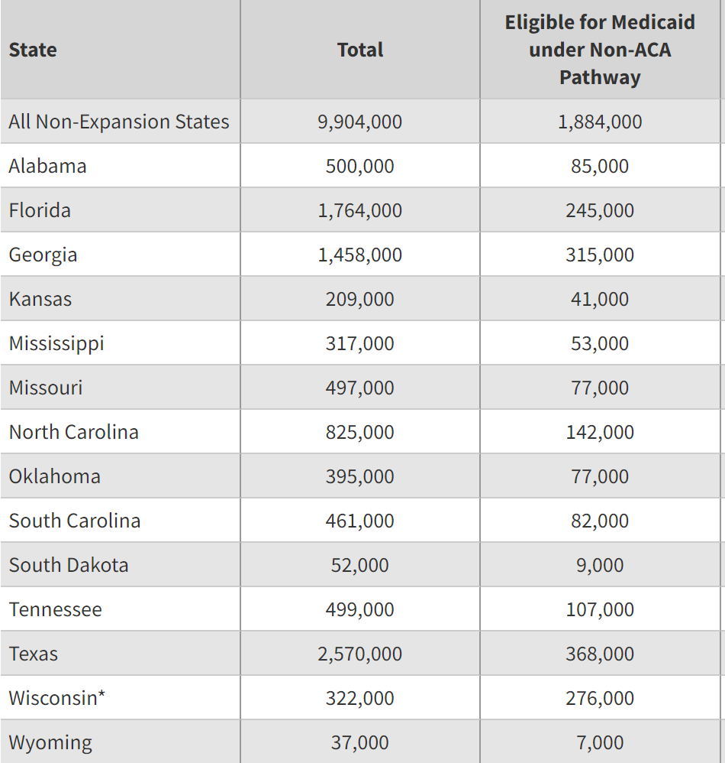

For example In 2021 there were 1,8 Millions of people who were eligible for medicaid even without the expansion but did not sign up for it.

We would examine the reason and what could possibly be the influence of it.

* Age factor: The majority of the uninsured people are beyond 18 years( 80-92%) old so we assume that they should be financially literate people who would be familiar with the opportunities provided by the state. Age factor by itself does not really give us any specific indicators.

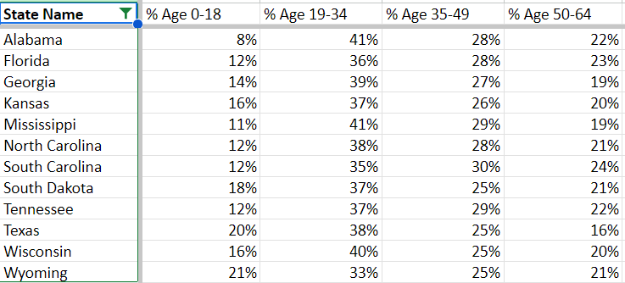

* Ethnicity factor: Among these non-expansion states the majority of the uninsured population is Hispanic, White and Black. With the ethnicity factor by itself we can not assume anything at this point.

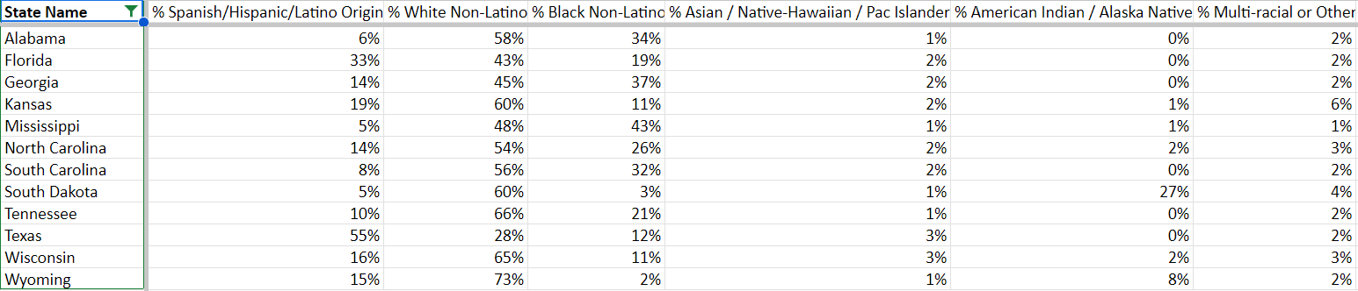

* Education factor: The majority of the uninsured population has a HIgh School Diploma or less than a High School Diploma and only a small percentage is College Grad (8%-16%) which could possibly indicate the level of illiteracy of finances or eligibility.

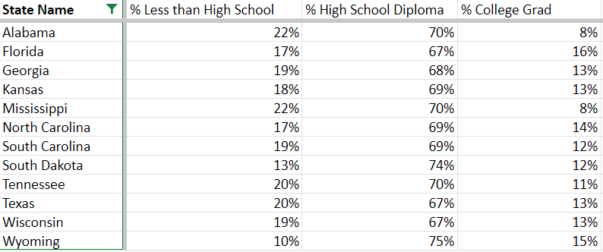

* Language barrier: Definitely not a language barrier among the majority of the uninsured population (81%-98%).

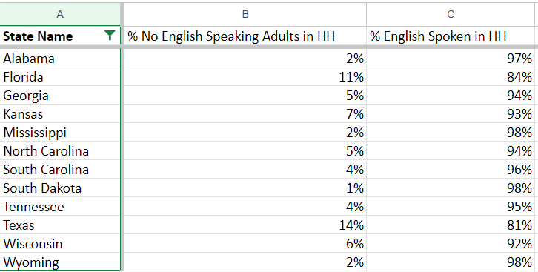

* Industry: High uninsured percentages are noticeable in certain industries, particularly the Entertainment Industry, where percentages reach as high as 18%. This trend may be attributed to the nature of employment within the entertainment sector, which often includes freelancers, part-time workers, or individuals without employer-sponsored health insurance.

Conversely, the Agriculture and Military/Public industries consistently display lower percentages of uninsured individuals across states. This may be influenced by factors such as access to employer-sponsored health insurance or specific health coverage programs for military personnel.

In the Trade Industry, there are varied percentages of uninsured individuals, indicating differences in health coverage within this sector. Similar variations are observed in the Info/Finance and Education/Health industries, where higher percentages may suggest challenges in obtaining health coverage for certain roles.

The Manufacturing Industry, with percentages ranging from 4% to 8%, demonstrates some variability. Factors influencing these percentages may include the prevalence of employer-sponsored health plans within the manufacturing sector.

Geographic patterns are evident as differences in uninsured percentages may reflect regional variations in healthcare policies, economic conditions, and access to healthcare services.

State-specific considerations play a crucial role, with factors such as the presence of Medicaid expansion, state healthcare policies, and the overall economic landscape impacting uninsured rates within different industries.

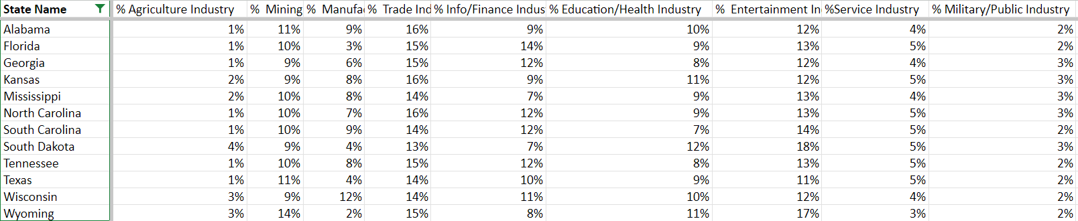

Interesting finding: In the Trade Industry, we observe a range of uninsured percentages, reflecting disparities in health coverage within this sector. Similarly, variations exist in the Info/Finance and Education/Health industries. While we might anticipate a higher level of insurance literacy in these industries, the presence of relatively higher uninsured percentages suggests that certain roles within these sectors may still face challenges in obtaining adequate health coverage or financial assistance.

* Rural areas: The states are ranked from 1 until 51 based on people living in rural areas i.e rural population.

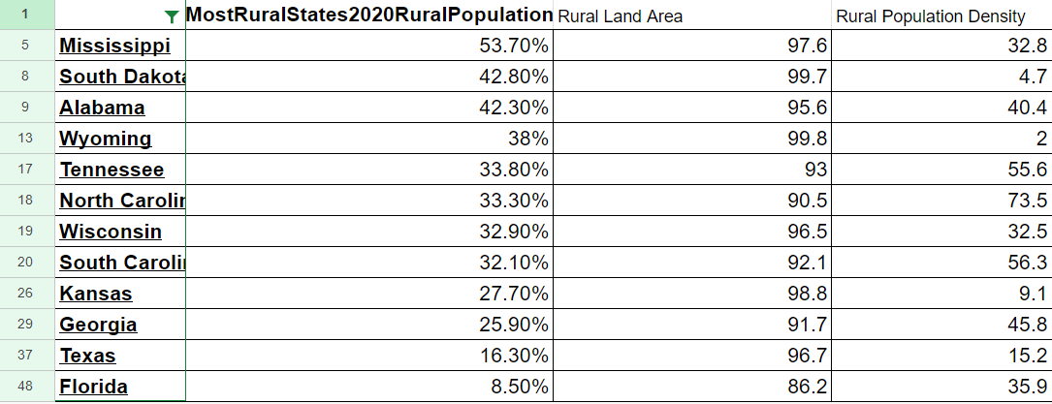

[https://worldpopulationreview.com/state-rankings/most-rural-states]

Analysis:

Alabama:

* 1. Uninsured Rate: 11%
  2. Rural Population: 42.3%
  3. Rural Area and Density: Considerable
  4. Influencing Factors:
     + Substantial rural population and lower rural population density contribute to a higher uninsured rate.
     + Employment-related healthcare gaps from jobs in the Trade Industry.
     + Challenges in healthcare literacy due to the prevalence of individuals with less than a High School Diploma.

Florida:

* 1. Uninsured Rate: 16%
  2. Rural Population: 8.5%
  3. Rural Area and Density: Lower
  4. Influencing Factors:
     + Diverse population contributes to the higher uninsured rate.
     + Lower rural population and density may impact healthcare accessibility.
     + Percentages in the Education/Health Industry could also play a role.
     + Florida's unique demographic makeup may contribute to challenges in healthcare understanding.

Georgia:

* 1. Uninsured Rate: 15%
  2. Rural Population: 25.9%
  3. Rural Area and Density: Considerable
  4. Influencing Factors:
     + Considerable rural population and moderate rural population density lead to a notable uninsured rate.
     + Influence of the Entertainment Industry contributes to employment-related gaps in coverage.
     + Georgia's education factor may impact healthcare literacy.

Kansas:

* 1. Uninsured Rate: 10%
  2. Rural Population: 27.7%
  3. Rural Area and Density: Significant
  4. Influencing Factors:
     + Significant rural population and lower rural population density contribute to a lower uninsured rate.
     + Presence of the Manufacturing industry and a higher percentage of individuals with less than a High School Diploma could contribute to more accessible healthcare.
     + The education factor in Kansas may play a role in healthcare literacy.

Mississippi:

* 1. Uninsured Rate: 16%
  2. Rural Population: 53.7%
  3. Rural Area and Density: Considerable
  4. Influencing Factors:
     + Large rural population, lower rural population density, and challenges in accessing healthcare contribute to the highest uninsured rate.
     + Presence of the Entertainment Industry and economic disparities play a significant role.
     + Mississippi's education factor may affect healthcare understanding.

North Carolina:

* 1. Uninsured Rate: 12%
  2. Rural Population: 33.3%
  3. Rural Area and Density: Significant
  4. Influencing Factors:
     + Diverse economy, substantial rural population, higher rural population density, and a higher percentage of individuals with less than a High School Diploma contribute to the moderate uninsured rate.
     + Presence of the Manufacturing and Education/Health industries may lead to variations in coverage.
     + Education factor in North Carolina may impact healthcare literacy.

South Carolina:

* 1. Uninsured Rate: 12%
  2. Rural Population: 32.1%
  3. Rural Area and Density: Significant
  4. Influencing Factors:
     + Significant rural population impacted by the Entertainment and Service industries.
     + Economic factors, access challenges, and a higher percentage of individuals with less than a High School Diploma contribute.
     + Education factor in South Carolina may affect healthcare literacy.

South Dakota:

* 1. Uninsured Rate: 11%
  2. Rural Population: 42.8%
  3. Rural Area and Density: High
  4. Influencing Factors:
     + High rural population, lower rural population density, and challenges in the Entertainment Industry contribute to the moderate uninsured rate.
     + Economic factors and a higher percentage of individuals with less than a High School Diploma play a role.
     + Education factor in South Dakota may impact healthcare literacy.

Tennessee:

* 1. Uninsured Rate: 11%
  2. Rural Population: 33.8%
  3. Rural Area and Density: Significant
  4. Influencing Factors:
     + Significant rural population, higher rural population density, and percentages in the Manufacturing and Education/Health industries contribute to the moderate uninsured rate.
     + Economic disparities, access challenges, and a higher percentage of individuals with less than a High School Diploma play a role.
     + Education factor in Tennessee may impact healthcare literacy.

Texas:

* 1. Uninsured Rate: 19%
  2. Rural Population: 16.3%
  3. Rural Area and Density: Lower
  4. Influencing Factors:
     + Highest uninsured rate, possibly due to a lower rural population and density.
     + Challenges from the Trade and Service industries.
     + Significant proportion with less than a High School Diploma contributes to the challenges in healthcare coverage.
     + Education factor in Texas may affect healthcare literacy.

Wisconsin:

* 1. Uninsured Rate: 6%
  2. Rural Population: 32.9%
  3. Rural Area and Density: Significant
  4. Influencing Factors:
     + Lowest uninsured rate influenced by a substantial rural population, moderate rural population density, percentages in the Manufacturing industry, and a higher percentage of College Graduates.
     + Successful Medicaid outreach likely contributes to better healthcare coverage.
     + Education factor in Wisconsin may impact healthcare literacy positively.

Wyoming:

* 1. Uninsured Rate: 14%
  2. Rural Population: 38%
  3. Rural Area and Density: Lower
  4. Influencing Factors:
     + Moderate uninsured rate influenced by a moderate rural population, lower rural population density, challenges in the Trade Industry, and a higher percentage of individuals with less than a High School Diploma.
     + Economic factors and access to healthcare services contribute to this rate.
     + Education factor in Wyoming may play a role in healthcare literacy.

Based on the provided information, the states facing the highest challenges in accessing healthcare facilities due to factors such as a higher uninsured rate, substantial rural population, lower rural population density, and potential barriers in healthcare literacy are the following:

Mississippi:

* + - Large rural population and lower rural population density.
    - Challenges in accessing healthcare services.
    - Presence of the Entertainment Industry contributing to potential employment-related gaps.
    - Economic disparities play a significant role.

Texas:

* + - Highest uninsured rate among the states.
    - Lower rural population and density.
    - Challenges from the Trade and Service industries.
    - A significant proportion with less than a High School Diploma, contributing to healthcare coverage challenges.

Georgia:

* + - Considerable rural population and moderate rural population density.
    - Challenges in healthcare access.
    - Influence of the Entertainment Industry contributing to employment-related gaps.
    - Potential impact on healthcare literacy due to educational factors.

**Top three influencing factors:**

1. **Provider Availability:** 
   1. Moderate Rural Population Density (e.g., Georgia):
      1. *Characteristics:* Regions with moderate rural population density often have a balanced distribution of residents across geographic areas.
      2. *Healthcare Infrastructure:* While there may be some healthcare infrastructure, it is not as extensive as in urban areas, leading to challenges in meeting the healthcare needs of the local population.
      3. *Travel Distances:* Residents may experience moderate travel distances to access healthcare services, with healthcare facilities more evenly distributed compared to areas with lower rural population density.
   2. Lower Rural Population and Density (e.g., Texas):
      1. *Characteristics:* Areas with lower rural population and density have fewer residents scattered across larger geographic spaces.
      2. *Healthcare Facilities:* The number of hospitals, clinics, and healthcare professionals is limited, resulting in fewer healthcare facilities available.
      3. *Increased Travel Distances:* Residents in these areas often face longer travel distances to reach healthcare providers, making it more challenging to access timely medical services.
   3. Large Rural Population with Lower Rural Population Density (e.g., Mississippi):
      1. *Characteristics:* Regions with a large rural population and lower rural population density have a significant number of residents spread across expansive areas.
      2. *Healthcare Challenges:* Inherent challenges arise due to the increased geographical distances between residents and potential scarcity of medical facilities.
      3. *Access Hurdles:* The combination of a large rural population and lower rural population density intensifies the barriers to healthcare access. Residents may encounter greater difficulties in reaching healthcare providers promptly.
2. **A significant proportion with less than a High School Diploma, contributing to healthcare coverage challenges:** The significant proportion of the population with less than a High School Diploma in Texas may correlate with lower health literacy levels. Limited understanding of healthcare information can hinder individuals from navigating the healthcare system effectively and making informed decisions about their well-being.
3. **Presence of the Entertainment Industry, Trade and Service Industries:** These Industries often rely on irregular employment structures, such as freelance or part-time work, leading to inconsistent access to employer-sponsored healthcare benefits. This can result in gaps in coverage and higher uninsured rates. Jobs in the Trade and Service industries may be associated with lower income levels. Lower-income individuals may face challenges in affording health insurance coverage or medical expenses, contributing to higher uninsured rates. These industries may not always provide comprehensive employer-sponsored health insurance, leaving employees to seek coverage through other means. In the absence of affordable options, individuals may remain uninsured.

Potential solutions

***Provider availability***

**Provider availability + Low Patient Volume in Rural Healthcare**

Non-Financial Barriers to Care in rural areas persist despite improvements in insurance coverage. Public hospitals, community clinics, health centers, and local providers catering to underserved communities play a crucial role in providing a healthcare safety net for uninsured individuals. However, these safety net providers face limitations in resources and service capacity, and not all uninsured individuals have geographical access to such providers. High uninsured rates contribute to rural hospital closures and present greater financial challenges for rural hospitals, placing individuals in rural areas at a heightened disadvantage in accessing care. Research indicates that Medicaid expansion is associated with reductions in uncompensated care costs and improved financial performance for rural hospitals and other healthcare providers.

Provider availability stands out as a significant challenge, especially for physicians, with rural areas experiencing ongoing shortages in various specialties and primary care. Some rural regions, affected by the overdose crisis, face additional hurdles due to a lack of behavioral health specialists, hindering treatment for substance use disorders. The shortage of healthcare professionals is evident in the ratio of providers per 10,000 persons, as highlighted in Table 4. To combat these geographic imbalances, the U.S. Department of Health and Human Services (HHS) designated Health Professional Shortage Areas (HPSAs), directing resources to address provider shortages. Primary care HPSAs, crucial for programs like the National Health Service Corps and Nurse Loan Repayment, are predominantly located in rural areas, as illustrated in Figure 6. This underscores the need for targeted efforts to enhance healthcare accessibility in underserved regions.

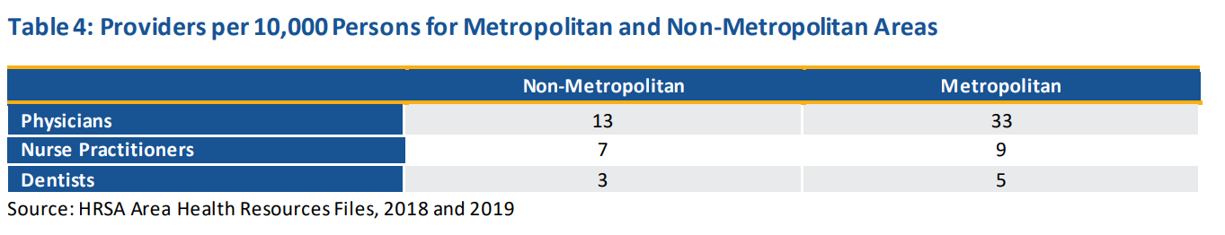

[<https://www.kff.org/uninsured/issue-brief/key-facts-about-the-uninsured-population/>]

[<https://www.kff.org/racial-equity-and-health-policy/issue-brief/health-coverage-by-race-and-ethnicity/#:~:text=Nonelderly%20AIAN%20and%20Hispanic%20people%20had%20the%20highest,than%20the%20rate%20for%20their%20White%20counterparts%20%286.6%25%29>.]

**Trends Affecting Rural Hospital Financial Sustainability**

Analysis for Rural Hospital Closures Threaten Access

From 2010 to 2021, a total of 136 rural hospitals shut down, as reported by the UNC Cecil G. Sheps Center. The year 2020 saw the highest number of closures in the past decade, with nineteen hospitals ceasing operations.

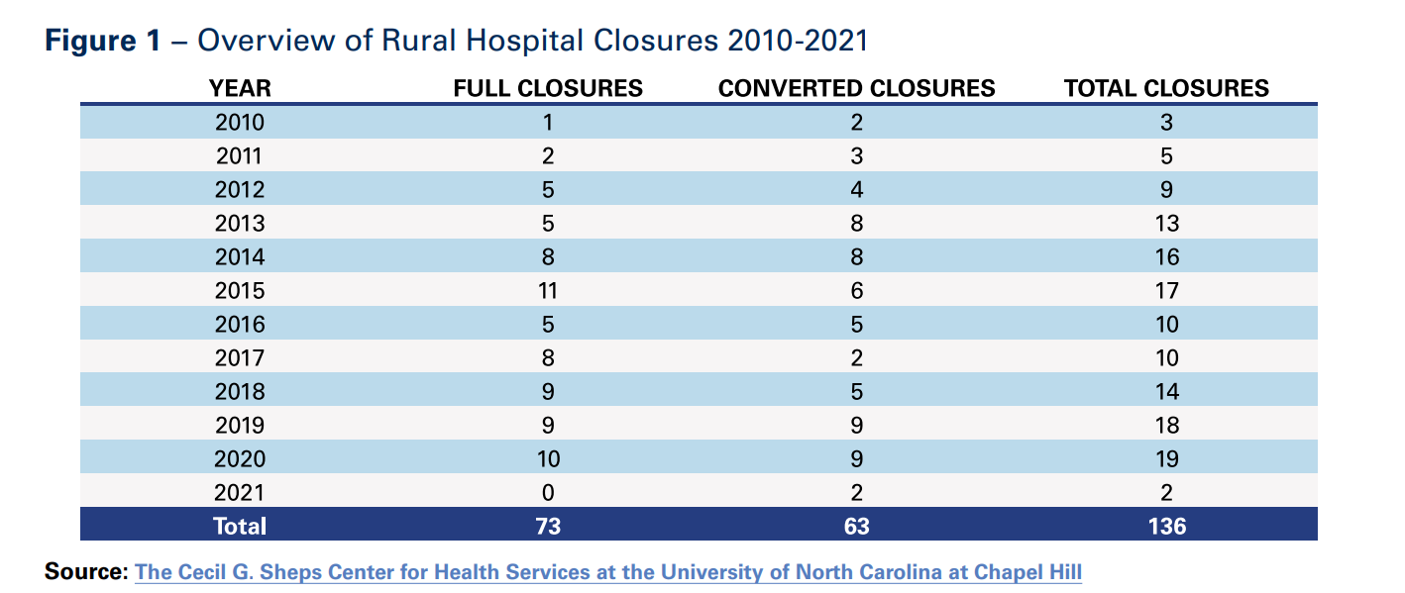

• The majority (74%) of these rural closures occurred in states without Medicaid expansion or where expansion had been in place for less than a year.

• Rural hospitals grapple with significant staffing shortages, with only 10% of physicians in the United States practicing in rural areas, despite these areas accounting for 14% of the population. Additionally, nearly 70% of primary care Health Professional Shortage Areas (HPSAs) are located in rural or partially rural regions.

• An analysis by the American Hospital Association (AHA) of UNC Sheps Center data from 2010 to 2020 indicates that slightly more than half of the closed hospitals were independent.

• Despite ongoing challenges, various pathways exist for ensuring the financial sustainability of rural hospitals.

In 2020, rural hospitals supported one in every 12 rural jobs in the U.S. as well as $220 billion in economic activity in rural communities.

1.Patient Volume and Health

Rural areas experience lower population densities, resulting in rural hospitals facing challenges associated with maintaining fixed-operating costs due to lower patient volumes. The COVID-19 pandemic has exacerbated this issue, leading to more volatile patient volumes and acuity. Lower patient volumes also hinder participation in performance measurement and quality improvement activities, making it challenging for rural hospitals to identify areas of success or improvement.

Furthermore, rural hospitals may struggle to obtain statistically reliable results for some performance measures, limiting their participation in innovative payment models and alternative revenue streams. In addition to lower patient volumes, rural hospitals often serve older, sicker, and poorer populations compared to the national average. A significant percentage of rural patients are uninsured, leading to delayed care-seeking due to cost, contributing to sicker and more costly patients.

Geographic isolation and limited transportation access in rural areas exacerbate delays in care-seeking, placing additional strain on rural health systems. Overall, the challenging patient mix and lower volumes in rural areas make it difficult for these health systems to provide care with the varied and intense resources needed, distinguishing them from other regions.

* Overcoming Low Reimbursement

Rural hospitals heavily rely on government payers, with Medicare constituting nearly half of their revenue. However, both Medicare and Medicaid reimburse less than the cost of services, resulting in significant underpayments. In 2020, rural hospitals incurred $5.8 billion in Medicare underpayments, $1.2 billion in Medicaid underpayments, and provided $4.6 billion in uncompensated care. Medicare underpayments grew by almost 40% from 2016 to 2020. The expiration of relief programs, such as the Medicare-dependent Hospital (MDH) and enhanced Low-volume Adjustment (LVA) program, scheduled for September 30, 2022, poses financial challenges, especially for one in five rural closures in 2020 that were MDHs.

In the commercial insurance market, rural hospitals often face below-average rates or exclusion from plan networks. This lack of negotiation power can lead to unfavorable terms, impacting patient access. Exclusion from certain plan networks due to unfair insurer tactics hampers patient access in rural areas, where long distances are already a factor. Additionally, affordable coverage remains a challenge, with lack of health insurance resulting in high uncompensated care costs for hospitals. Medicaid expansion has proven crucial for rural hospital viability, with 74% of closures occurring in states without or with less than a year of Medicaid expansion. Research by the American Hospital Association indicates that Medicaid expansion is associated with improved hospital financial performance and a lower likelihood of closure, particularly in areas with high uninsured rates before expansion.

* Managing Staffing Shortages

Rural hospitals grapple with significant staffing shortages, with only 10% of physicians practicing in rural areas despite these areas accounting for 20% of the population. Nearly 70% of primary care Health Professional Shortage Areas (HPSAs) are situated in rural or partially rural regions. This shortage of primary care services adversely impacts rural populations, leading to lower health outcomes compared to more densely populated areas. Additionally, behavioral health and substance abuse professional shortages are prominent, with 65% of rural counties lacking psychiatrists, 47% without psychologists, and 81% lacking psychiatric nurse practitioners.

The COVID-19 pandemic has exacerbated existing staffing challenges, with nearly one-third of hospitals anticipating critical staffing shortages during the January 2022 omicron surge. To address these shortages, hospitals have resorted to expensive contract labor firms, resulting in a more than doubling of average pay for hospital contract nurses. This has increased labor expenses by over 50% on a per adjusted discharge basis compared to pre-pandemic levels, posing a significant financial burden, especially for rural hospitals already facing negative operating margins.

Recruitment and retention of health professionals in rural areas have been persistent challenges, intensified by acute workforce shortages and rising labor expenses due to the pandemic. Rural hospitals are exploring novel approaches and federal programs, such as the National Health Service Corps and the Rural Public Health Workforce Training Network Program, to incentivize clinicians and expand public health capacity. Continued support from state and federal governments is crucial to address these challenges in recruiting and retaining healthcare professionals in rural areas.

**Opportunities:**

Rural hospitals received COVID-19 relief funds from the CARES Act and the American Rescue Plan Act, providing critical support and temporarily slowing rural closures. However, as these funds deplete, rural hospitals may face financial challenges. Only two rural hospitals closed in 2021, thanks to relief, but without additional support and halted payment cuts, more closures are anticipated.

The Centers for Medicare & Medicaid Services (CMS) expanded telehealth services during the pandemic, benefiting rural hospitals. Still, these waivers may expire without congressional action, endangering progress in increasing patient access.

To address challenges, rural hospitals can implement new care models, such as the Community Health Access and Rural Transformation (CHART) value-based payment model and the Rural Emergency Hospital designation under Medicare. Regulatory burdens hinder rural hospitals, and addressing outdated regulations can protect community access to healthcare.

Partnerships, collaborations, mergers, and affiliations can be effective for rural hospitals to preserve access to care. Despite claims that consolidation drives closures, data show that system affiliation is not a significant factor in rural hospital closures. Integrations can enhance quality of care, provide resources, and facilitate partnerships with larger employers, offering rural hospitals the ability to obtain affordable capital.

[<https://www.aha.org/system/files/media/file/2022/09/rural-hospital-closures-threaten-access-report.pdf>]

1. Ensure Fair and Adequate Reimbursement:

* Update reimbursement rates across payers to cover the cost of care in rural areas.
* Reverse Rural Health Clinic (RHC) payment cuts to maintain access to primary care.
* Extend ambulance add-on payments to safeguard emergency medical care access.
* Provide flexibility for Critical Access Hospitals (CAHs) through regulatory adjustments.
* Support the Save Rural Hospitals Act to establish a wage index floor for hospitals.

2. Support Telehealth Coverage:

* Permanently eliminate restrictions on originating sites and geographic locations.
* Remove in-person visit requirements for behavioral telehealth.
* Extend reimbursement parity based on the place of service.
* Continue payment and coverage for audio-only telehealth services.
* Expand eligible provider types and remove unnecessary licensure barriers.
* Establish DEA Special Registration Process for Telemedicine for controlled substance administration.
* Promote cross-agency collaboration on digital infrastructure and literacy initiatives.

3.Boosting and Incentivising Workforce:

3.1 Graduate Medical Education:

* Urges Congress to pass the Resident Physician Shortage Reduction Act of 2023 (S. 1302).
* Aims to increase the number of Medicare-funded residency slots, addressing shortages, particularly in rural areas.

3.2 Conrad State 30 Program:

* Urges Congress to pass the Conrad State 30 and Physician Access Reauthorization Act (S. 665).
* Seeks an extension of the Conrad State 30 J-1 visa waiver program, benefiting physicians agreeing to serve in federally-designated underserved areas.

3.3 Loan Repayment Programs:

* Urges Congress to pass the Restoring America’s Health Care Workforce and Readiness Act (S. 862).
* Aims to significantly expand National Health Service Corps funding, providing incentives for clinicians to practice in underserved areas, including rural communities.
* Supports the Rural America Health Corps Act (S. 940) to establish a dedicated program targeting rural workforce shortages through focused loan repayment initiatives.

3.4. Boost Nursing Education:

* Urges Congress to invest $1 billion in supporting nursing education.
* Calls for resources to enhance student and faculty populations, modernize infrastructure, and foster partnerships and research at schools of nursing.
* Expresses support for expanding the National Nurse Corps.

3.5. Health Care Workers Protection:

* Urges Congress to enact federal protections for healthcare workers, addressing violence and intimidation.
* Advocates for hospital grant funding to support violence prevention training programs.
* Encourages coordination with state and local law enforcement to enhance the safety of healthcare workers.

[https://www.aha.org/system/files/media/file/2023/05/aha-statement-to-senate-finance-committee-subcommittee-on-health-on-improving-rural-health-care-access-5-17-2023.pdf]

**National Health Service Corps**

The National Health Service Corps (NHSC) is a program in the United States that aims to improve access to healthcare services in underserved areas. It is part of the U.S. Department of Health and Human Services (HHS) and operates under the Health Resources and Services Administration (HRSA).

The NHSC was established in 1972 and has since been working to address the shortage of healthcare professionals in rural, urban, and tribal communities. The program provides scholarships and loan repayment assistance to healthcare providers in exchange for their commitment to work in areas with limited access to healthcare services.

Key components of the NHSC include:

* Scholarships: The NHSC Scholarship Program provides financial support to individuals pursuing primary care professions, such as physicians, nurse practitioners, and dentists. In return, recipients commit to serving in NHSC-approved sites in underserved areas upon completion of their training.
* Loan Repayment: The NHSC Loan Repayment Program offers loan repayment assistance to healthcare professionals who agree to work in designated Health Professional Shortage Areas (HPSAs) for a specified period. The program helps to alleviate the financial burden of student loans for those committed to serving in underserved communities.
* Workforce Placement: NHSC works to connect healthcare professionals with communities in need. It supports the placement of providers in areas facing shortages, improving access to care for vulnerable populations.
* Primary Care Training and Technical Assistance: NHSC provides training and technical assistance to healthcare professionals to enhance their skills in delivering primary care services, with a focus on meeting the needs of underserved populations.

Income-Share Agreement (ISA) in Healthcare:

Let's consider a healthcare professional named Aleksandra who is a participant in the NHSC program and has opted for an Income-Share Agreement to manage her student loan repayment.

* Agreed Percentage and Duration:
  + Aleksandra agrees to repay 10% of her annual income for a period of 7 years as part of the ISA.
* Initial Income and Repayment:
  + Upon completing her medical training, Aleksandra joins an NHSC-approved site in a rural community. Her starting salary is $80,000 per year.
  + In the first year, Aleksandra's ISA repayment obligation would be $8,000 (10% of $80,000).
* Threshold Adjustments:
  + The ISA includes income thresholds that trigger adjustments to the repayment percentage.
  + If Aleksandra's income falls below $60,000 due to unforeseen circumstances (e.g., taking a sabbatical or working part-time for family reasons), the repayment percentage automatically decreases to 5% until her income surpasses the threshold again.
* Career Advancement and Increased Income:
  + As Aleksandra gains experience and advances in her career, her income increases to $100,000 per year after the third year of service.
  + With the increased income, Aleksandra's repayment obligation rises to $10,000 (10% of $100,000).
* Risk-sharing Mechanism:
  + The ISA includes a risk-sharing mechanism that considers broader economic factors impacting the healthcare industry.
  + In the event of an economic downturn affecting healthcare salaries nationwide, the ISA contract allows for a temporary reduction in the repayment percentage for all participants until economic conditions improve.
* Completion of Agreement:
  + After completing 7 years of service and fulfilling the terms of the ISA, Aleksandra successfully repays a total of $70,000 under the agreement.

Advantages of the ISA Scenario:

* Income Alignment: Aleksandra's repayments are directly tied to her income, making it more manageable during lower-earning periods.
* Flexibility: The ISA provides flexibility with threshold adjustments, allowing Aleksandra to adapt to changing life circumstances without incurring financial hardship.
* Risk-sharing: The risk-sharing mechanism acknowledges external factors, ensuring a collaborative approach to loan repayment that considers broader economic conditions.

Disadvantages of the ISA Scenario:

Income-Share Agreements (ISAs) are an alternative to traditional student loans, with their roots traced back to Milton Friedman's 1955 essay. Unlike loans, ISAs tie repayments to a student's post-graduation income, making them more aligned with investment principles. Purdue University's "Back a Boiler" program and coding bootcamps like Bloom Institute of Technology offer ISAs, each with unique terms. While ISAs avoid interest and have fixed repayment periods, they lack federal regulation, raising concerns about consumer protection.

Advantages of ISAs include no interest accrual and set repayment periods, but their unregulated nature poses risks. Critics, such as the Student Borrower Protection Center, argue that ISA providers may engage in harmful practices like aggressive collections and potential discrimination based on field of study. A recent study highlighted racial disparities in ISAs, revealing higher costs for students from historically Black colleges and universities (HBCUs) and other minority-serving institutions (MSIs).

Students are advised to carefully assess their options, considering total payback amounts and comparing ISAs with traditional student loans. The suitability of ISAs depends on individual circumstances, and potential risks and benefits should be weighed before opting for this financing method.

However, ISAs, unlike traditional student loans, are not widely accessible. They are predominantly available through four-year colleges, universities, coding bootcamps, other vocational schools, and private lenders.

Purdue University's "Back a Boiler" program is a prominent example of an ISA, determining its income-share rate based on the student's field of study. ISAs associated with higher-paying majors, like chemical engineering, generally feature lower rates and shorter terms compared to those linked to lower-paying majors.

Coding academies, which are career schools specializing in computer programming, have also embraced ISAs for financing. These academies, often lacking accreditation, are ineligible for federal financial aid. For instance, Bloom Institute of Technology (formerly Lambda School) allows graduates to postpone payments until their earnings reach $50,000.

Bloom Institute of Technology. "Our Income Share Agreement."

Private lenders also provide ISAs, and one such example is Stride Funding, an ISA financier. Stride Funding offers students funding of up to $25,000 per school year, which is directly disbursed to their college. The rates are determined by factors such as the student's major, the educational institution they attend, and the anticipated time of earning a paycheck.

**Promising startups addressing the barrier in HealthCare in Rural Areas**

1. Main Street Health <https://mainstreetruralhealth.com/> (USA)

Rural America encounters distinctive healthcare obstacles, evident in data indicating reduced access to both primary care and specialist providers. Furthermore, numerous rural hospitals have been compelled to shut down due to financially unsustainable conditions.

Despite the widespread adoption of value-based care in many urban and suburban regions, rural areas exhibit lower participation rates in value-based care compared to their urban and suburban counterparts.

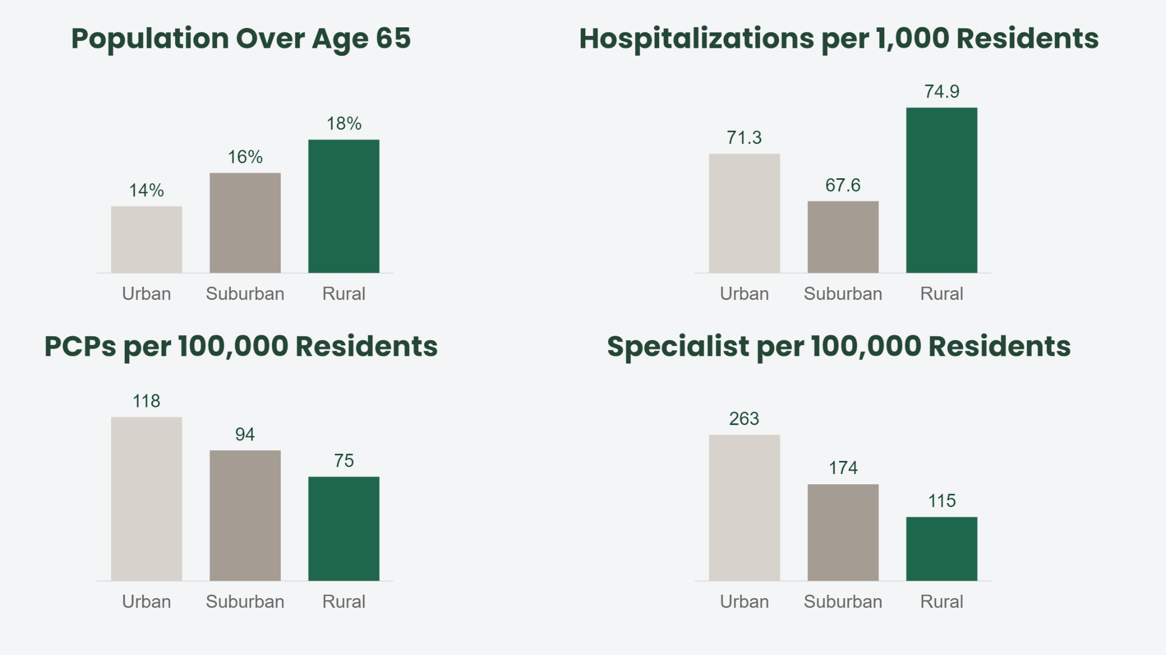

Main Street Rural Health is an organization that partners with various healthcare providers in rural areas to support the transition to value-based care. They collaborate with different types of providers, including small independent private practices, large group private practices, rural health clinics, critical access hospitals, community health centers, and health systems.

Main Street coordinates care for Medicare patients through the Medicare Shared Savings Program, as well as for Medicare Advantage patients.

The partnership involves providing resources such as staff, technology, and opportunities to help these clinics succeed in a value-based delivery model. They specifically mention their local Health Navigators who act as an extra set of hands in the clinic, helping patients navigate care and reducing the burden on clinic staff at no cost to the clinic. They also offer behind-the-scenes data tools to ensure providers have accurate information at the point of care, without the need to learn a new technology system. Main Street provides rural clinics with easy-to-understand recurring payments to reinvest in their practice, patients, and communities.

Main Street Health recently disclosed a $315 million funding round, backed by a company valuation of $2.1 billion, signaling intentions to expand its services into 26 states.

The goal is to help insurance companies spend less on their patients and improve care by stepping in to implement preventative care to avoid more complex diagnoses down the line. Provided it meets clinical quality requirements, Main Street Health is paid by a piece of the shared savings, and from that, it pays clinics a flat fee per month.

During the spring of 2021, EastWood Clinic, a primary care facility located in Paris, Tennessee, experienced a cold call from Main Street Health based in Nashville. The outreach from Main Street Health aimed at exploring potential partnerships in delivering care to rural Medicare patients.

In discussing the challenges faced by smaller clinics in realizing shared savings, it becomes evident that these establishments often lack the necessary human resources and capacity. This situation is described metaphorically as leaving money on the table, a commonly used euphemism. - Josh Roberts, administrator at EastWood Clinic in Paris, Tennessee

From the perspective of Dr. Roberts, the navigators serve as an additional support system for physicians, undertaking tasks that are challenging for nurses and time-consuming for doctors. While Henry County Medical Center caters to many local patient needs, residents often travel to Jackson or Nashville for specialized services. Dr. Roberts expresses a desire for telehealth options to connect rural patients with specialists in larger cities, potentially offering rapid feedback without necessitating a visit to another city for management.

[https://mainstreetruralhealth.com/about-us/]

[<https://www.nashvillepost.com/business/health_care/how-main-street-health-operates-in-rural-clinics/article_2e45e1de-6c74-11ee-81a0-db7c8cd2946a.html>]

1. Homeward Health (USA)

Telemedicine, particularly virtual medical appointments, is on the rise, providing a safer way for physicians and patients to interact amid the COVID-19 pandemic. This approach not only minimizes exposure risks but also improves healthcare access for those residing far from medical facilities.

Homeward Health, a startup founded by former Livongo executives, is employing a hybrid model of in-person and telehealth services to cater to rural communities. Their strategy involves mobile clinics and virtual patient monitoring to simplify healthcare and address infrastructure challenges in rural America. Partnering with Rite Aid, Homeward aims to offer on-site primary care services at up to 700 Rite Aid locations, making healthcare more convenient for rural residents. The company plans to prioritize specialty care, particularly focusing on heart disease, aiming to bridge the treatment gap between rural and urban patients. The use of technology allows for early diagnosis and prevention, resembling an old-school approach of traveling doctors making house calls. Homeward envisions transforming the rural healthcare model to alleviate the workload and burnout experienced by healthcare workers in these areas.

The company revealed in 2022 that it secured $50 million in Series B funding, a mere four months after concluding its $20 million Series A round. ARCH Venture Partners and Human Capital jointly led the new funding round, with involvement from General Catalyst. Additionally, the company disclosed a partnership with Priority Health, a health insurance provider based in Grand Rapids, Michigan. This collaboration aims to offer services to as many as 30,000 Medicare Advantage beneficiaries over the next three years.

Homeward's Care Navigators act as guides, helping individuals comprehend the intricate details of their health insurance benefits. With expertise in deciphering insurance policies, these navigators empower healthcare consumers by providing clarity on covered services and ensuring a full understanding of available benefits.

Locating doctors who align with your insurance can be a daunting task. Homeward's Care Navigators step in to assist in this crucial aspect, facilitating the search for in-network doctors who not only accept your insurance but also match your specific healthcare needs and preferences. It's about ensuring a seamless connection between patients and healthcare providers.

Homeward goes beyond traditional healthcare boundaries by addressing factors crucial to maintaining independence. Care Navigators establish links to local support services, including transportation, meal services, and additional caregiving assistance. This holistic approach ensures individuals have the necessary resources to sustain their independence and well-being.

Homeward's commitment to comprehensive care extends to healthcare coordination. Care Navigators take charge, scheduling appointments on behalf of individuals and facilitating the seamless sharing of medical records between healthcare providers. This ensures a cohesive and integrated healthcare experience.

1. Hi.health (Austria)

In the dynamic landscape of healthcare, hi.health stands out by redefining the claims process through the integration of modern payment solutions. At the core of this transformation is a comprehensive payment card system that not only streamlines reimbursements but also ensures an unparalleled user experience. Here's how hi.health is reshaping the healthcare financial landscape.

Austrian insurtech startup hi.health has successfully secured €6 million in funding from investors such as SpeedInvest, Calm/Storm, Haymarker Ventures, Fin VC, Nina Capital, and others.

Established in 2019, hi.health has developed an application enabling users to effortlessly claim reimbursements for their medical expenses. The process involves users capturing an image of their invoice using the app, following which hi.health handles the submission of invoices to the respective insurers for payment. Noteworthy insurance partners collaborating with hi.health include Allianz Private Krankenversicherung, ARAG, AZA, Ergo Direkt, and HUK-Coburg.

Operating primarily in Germany, the startup extends its services to health service companies through an online checkout solution, hi.direct. This innovative product incorporates a reimbursement feature, enabling customers to make payments for health services or products and directly submit associated costs to their private health insurers during the checkout process.

Since its inception, hi.health has facilitated reimbursements exceeding €50 million, showcasing the impactful success of its user-friendly reimbursement platform.

Modern Payment Solutions for Effortless Claims Processing:

hi.health's solution is designed to eliminate friction in the claims process while implementing effective cost controls. The innovative payment card comes in both tangible and digital formats, providing members with flexibility. Activation of the card grants users global access to healthcare facilities, with payments facilitated seamlessly through insurer funds. The ecosystem also handles any financial gaps, such as co-pays or deductibles, ensuring a hassle-free and financially manageable experience.

Direct Payments and Collaborative Partnerships:

Empowering merchants through direct reimbursement, hi.health collaborates with a diverse range of partners, including online and retail pharmacies, as well as software providers for healthcare professionals. Currently operational in Germany, hi.health is set to expand its services to additional markets, broadening its impact on the healthcare payment landscape.

What hi.health Offers:

* 10x Better User Experience:
  + A payment card in partnership with Visa, providing real-time coverage and swift reimbursements.
  + Transforms the claiming process into a cashless, seamless, and user-friendly experience for insured members.
* Revamped Claims Handling:
  + Intelligent and secure payment card mechanism automating a significant portion of the claims management process.
  + Achieves a remarkable 45-50% time saving in claim processing compared to traditional methods, streamlining operations.
* Reducing Fraud:
  + Direct linkage of each claim to a specific transaction minimizes the potential for fraudulent submissions.
  + Robust anti-fraud algorithms and verification solutions enhance security, ensuring a safer experience for all parties.
* Easy & Seamless Integration:
  + Built with ease of integration in mind, hi.health's payment card system seamlessly merges with an insurer's existing infrastructure.
  + Dedicated technical support ensures swift and efficient setup, minimizing disruption and facilitating the delivery of enhanced services.

1. Walnut(USA)

Walnut employs a "buy now, pay later" framework, a model made popular by companies like Affirm and Klarna, but with a distinct emphasis on healthcare payments. Instead of requiring patients to make a lump-sum payment using their credit cards, Walnut collaborates with healthcare providers to extend the payment period.

The operational model of Walnut unfolds as follows:

Extended Payment Terms: Patients can choose to settle their healthcare bills through manageable $100 monthly increments over a 30-month duration. This approach offers a more gradual and flexible payment structure, easing the burden of managing healthcare expenses.

Data-Driven Underwriting: Walnut utilizes sophisticated underwriting models that transcend conventional credit scoring. Rather than relying solely on credit scores, deemed outdated, Walnut scrutinizes thousands of data points from diverse sources. This includes details about side hustle income and spending habits on essentials like groceries and bills, creating a holistic financial profile for each individual.

Provider Negotiations: Walnut takes a proactive stance in negotiating with healthcare providers. For example, if a provider's collection rate for out-of-pocket expenses stands at 50%, Walnut proposes a mutually beneficial arrangement. They request a 40% discount from the provider and, in return, guarantee upfront cash. This setup enables the provider to receive 60% of the collection rate without exposure to the risks associated with delayed or unpaid payments.

Risk Management: Walnut assumes the financial risks tied to patient payments. By providing upfront cash to providers, even at a discounted rate, Walnut helps mitigate the impact of non-payment or delayed payments. This proves particularly valuable for healthcare providers grappling with challenges related to collecting the full amount owed, often due to factors such as bankruptcies or defaults on payments.

Steady Cash Flow for Providers: While the ideal scenario would involve providers receiving the full 100% of owed payments, the healthcare industry faces the reality that a substantial number of bills go unpaid. The average collections rate for hospital out-of-pocket expenses is less than 20%. Walnut steps in to offer a more dependable upfront cash flow to providers, covering 60% of the overall bills. This not only provides financial security but also ensures predictability in cash flow for healthcare providers.

In essence, Walnut's inventive approach not only benefits patients by introducing a more flexible payment structure but also supports healthcare providers by ensuring a more dependable and timely cash flow, ultimately contributing to the sustainability of the healthcare ecosystem.

1. ProCredEx (USA)

ProCredEx stands out as a trailblazer, setting a new standard by seamlessly integrating collaborative networks, blockchain reliability, a powerful compliance engine, and immediate actionable solutions. This article explores how ProCredEx is transforming the credentialing and compliance landscape, breaking down historical barriers and ushering in a new era of efficiency and reliability.

### 1. Collaborative Networks: Connecting Compliance Ecosystems

ProCredEx is at the forefront of collaborative networks, serving as a centralized hub that connects every element within the compliance ecosystem. Through a secure and trusted network, data sharing becomes a seamless process, breaking down silos and fostering a community-driven compliance network.

### 2. Blockchain Reliability: Ensuring Trustworthy Data Management

Leveraging the power of distributed ledger technology, ProCredEx ensures the reliability of data by capturing its provenance, rendering it immutable, and establishing a traceable chain-of-custody. This not only enhances the integrity of compliance records but also eliminates repetitive tasks, setting a new standard for secure and efficient data management.

### 3. Compliance Engine: Automating and Showcasing Compliance

ProCredEx introduces a robust compliance engine that automatically confirms adherence to relevant standards tailored to each organization. The platform goes beyond mere confirmation, allowing organizations to showcase the quality of their compliance programs through network-wide electronic auditing and reporting. This automated approach simplifies compliance processes and provides real-time insights.

### 4. Immediately Actionable Solutions: Breaking Down Barriers

ProCredEx takes pride in offering solutions that create immediate value, addressing diverse requirements, data structures, and operational models. Historical barriers to credentialing and compliance are transformed into strategic assets, allowing organizations to navigate compliance challenges with unprecedented efficiency.

### Conclusion: Redefining Credentialing and Compliance Dynamics

ProCredEx's innovative approach redefines the dynamics of credentialing and compliance. By integrating collaborative networks, blockchain reliability, a powerful compliance engine, and immediate actionable solutions, ProCredEx propels organizations into a new era where efficiency, security, and reliability become the benchmarks of excellence. As the platform continues to shape the future of credentialing and compliance, it stands as a beacon for organizations seeking to elevate their standards and embrace a transformative approach to regulatory adherence.

**Potential fintech solution**

**Leveraging Fintech (Aleksandra’s opinion)**

What kind of solution would address 1. Patients awareness (non-elderly) for eligibility and financial assistance + 2. Medicaid Providers incentives to work in Rural hospitals + overcoming low reimbursement for hospitals in rural areas?

* Autoenrollment support system for eligibility
  + Financial income of the household
  + Number of family members
  + Static costs
  + Passive costs
  + Is it eligible for something?
  + How to invest in a health insurance plan from what is left from the income costs?
* Redirect for educational purposes to Camper Health (USA)
* Incentivize health workers in rural areas ft Lilian Care (Germany)
* Claim support reimbursement with Hi.Health (Austria)

### **Healthcare Ecosystem Prototype with Real-World Companies and Clear Input-Output Relationships**

### ***Integrated Flow Breakdown***

### **Step 1: Camper Health (Patient Journey Begins)**

* **Flow**: The patient first contacts **Camper Health** to begin their healthcare journey.
* **Purpose**: **Camper Health** assesses the patient’s financial eligibility based on their income and other factors to determine if they qualify for subsidized care.
* **Example**: A low-income patient approaches **Camper Health**, and they assess the patient’s eligibility for financial assistance (e.g., for telehealth services or in-person care).

### **Step 2: Camper Health → Homeward Health (Eligibility Sharing for Telehealth Services)**

* **Flow**: Once **Camper Health** determines the patient's eligibility, it sends **Eligibility Data** to **Homeward Health**.
* **Purpose**: **Homeward Health** uses this data to determine if the patient qualifies for subsidized telehealth services, facilitating access to care.
* **Example**: A patient is found to qualify for telehealth services based on their eligibility data from **Camper Health**, so **Homeward Health** arranges the necessary care.

### **Step 3: Homeward Health → Main Street Health (Visit Data Sharing for Care Coordination)**

* **Flow**: After the telehealth consultation, **Homeward Health** shares **Visit Data** (such as treatment details and follow-up instructions) with **Main Street Health**.
* **Purpose**: **Main Street Health** coordinates care and ensures the patient follows up on any necessary in-person visits or specialists.
* **Example**: The patient may need to visit a local clinic for a follow-up after their telehealth session. **Main Street Health** facilitates this by sending the visit data to the clinic.

### **Step 4: Main Street Health → ProCredEx (Care Summary and Credentialing Data Sharing)**

* **Flow**: **Main Street Health** sends **Care Summaries** (e.g., updates on treatment, progress, and future care needs) and provider credentialing information to **ProCredEx**.
* **Purpose**: **ProCredEx** verifies that the care data is compliant with healthcare standards and updates provider credentialing if necessary.
* **Example**: **ProCredEx** verifies that a rural clinic is compliant with regulations and ensures the provider’s credentials are up to date for continued service.

### **Step 5: ProCredEx → Lilian Care (Credential Data for Provider Incentives)**

* **Flow**: **ProCredEx** shares **Credential Data** with **Lilian Care**.
* **Purpose**: **Lilian Care** evaluates the data to determine if healthcare providers working in rural or underserved areas are eligible for incentives or bonuses.
* **Example**: A rural provider who is compliant and meets performance metrics receives an incentive, ensuring retention and support for healthcare providers in underserved regions.

### **Step 6: Lilian Care → ProCredEx (Incentive Data Feedback for Compliance Reporting)**

* **Flow**: **Lilian Care** shares **Incentive Data** back with **ProCredEx**.
* **Purpose**: **ProCredEx** updates its compliance and credentialing records based on the incentives given to healthcare providers.
* **Example**: **ProCredEx** tracks that a rural provider received an incentive, linking this data to the provider’s compliance and performance, which helps strengthen compliance reporting.

### **Step 7: ProCredEx → Hi.Health (Claims Processing Data for Validation)**

* **Flow**: **ProCredEx** sends **Claims Processing Data** to **Hi.Health** for validation.
* **Purpose**: **Hi.Health** checks the claims for accuracy and ensures that they align with the treatment plan and all necessary compliance standards.
* **Example**: **Hi.Health** validates a claim for a telehealth visit, ensuring the service provided matches the patient’s documented care and that the claim is compliant.

### **Step 8: Hi.Health → Walnut (Payment Plan Status & Reimbursement Data)**

* **Flow**: **Hi.Health** sends **Payment Plan Status** and **Reimbursement Data** to **Walnut**.
* **Purpose**: **Walnut** uses this data to confirm if the patient is eligible for payment plans and to process any reimbursements based on the approved claims.
* **Example**: **Hi.Health** confirms the patient's payment plan status and sends the information to **Walnut**, which processes the reimbursement and ensures the clinic is paid correctly.

### **Step 9: Walnut → Camper Health (Communication of Financial Assistance Status)**

* **Flow**: **Walnut** shares updates about **Payment History** and **Financial Assistance** with **Camper Health**.
* **Purpose**: **Camper Health** uses this information to reassess the patient’s financial situation and adjust their eligibility for financial assistance if needed.
* **Example**: If a patient misses a payment, **Camper Health** may reassess their eligibility for continued financial assistance or offer alternative options based on their current financial status.

### **Summary of Workflow Starting with Camper Health (and Including Lilian Care and Hi.Health):**

1. **Camper Health** initiates the patient journey by assessing **financial eligibility**.
2. **Camper Health** shares **Eligibility Data** with **Homeward Health** to arrange **telehealth services**.
3. **Homeward Health** sends **Visit Data** to **Main Street Health** for **care coordination**.
4. **Main Street Health** sends **Care Summaries** to **ProCredEx** for **credentialing verification** and compliance tracking.
5. **ProCredEx** sends **Credential Data** to **Lilian Care** to evaluate provider **incentives**.
6. **Lilian Care** sends **Incentive Data** back to **ProCredEx** to update **compliance records**.
7. **ProCredEx** sends **Claims Processing Data** to **Hi.Health** for **validation**.
8. **Hi.Health** sends **Payment Plan Status & Reimbursement Data** to **Walnut** for processing and reimbursement management.
9. **Walnut** sends updates about **Payment History** and **Financial Assistance** to **Camper Health**.

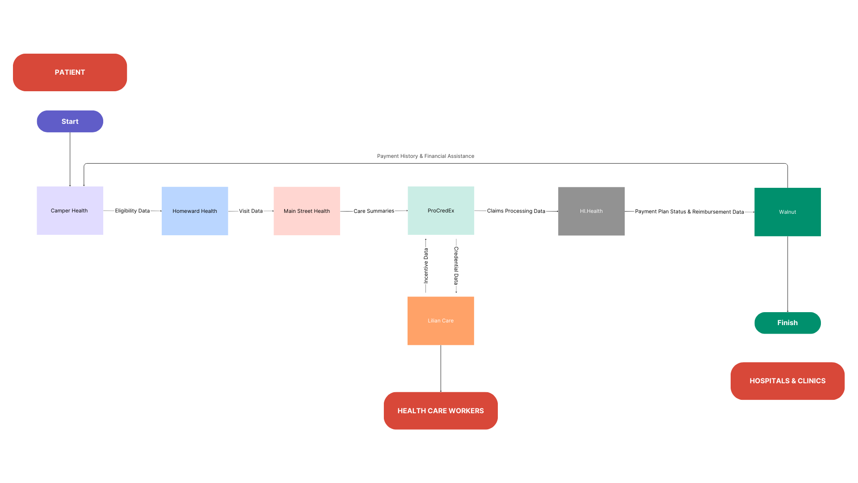

What kind of solution would address 1. Patients awareness (non-elderly) for eligibility and financial assistance + 2. Medicaid Providers incentives to work in Rural hospitals + overcoming low reimbursement for hospitals in rural areas?

This integrated system of existing solutions if they work together as one ecosystem.

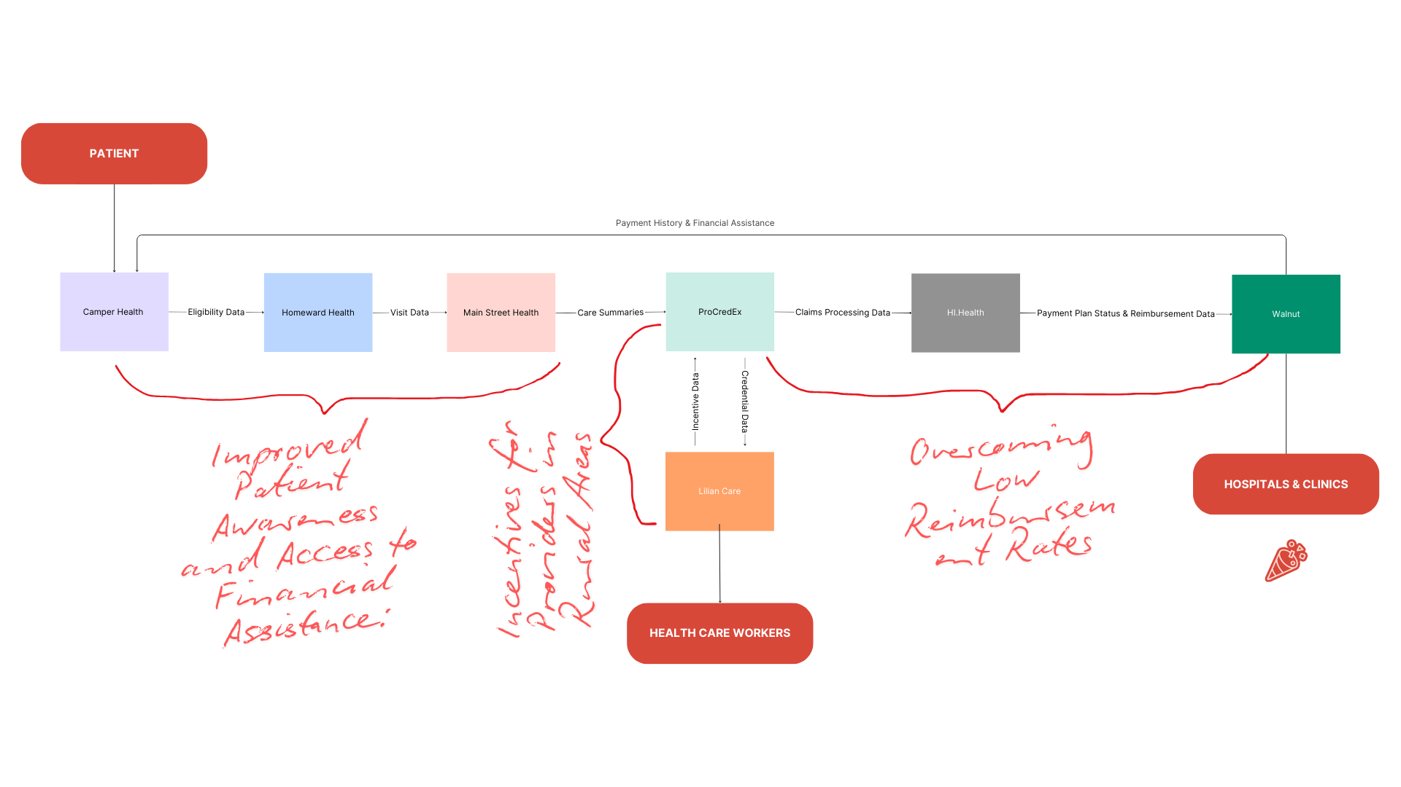

This system addresses gaps identified in the health care:

### **Problem 1: Patients’ Awareness (Non-Elderly) for Eligibility and Financial Assistance**

#### **Gap Addressed: Lack of awareness among non-elderly patients about their eligibility for financial assistance, particularly in accessing healthcare services, including telehealth.**

#### **Solution:**

* **Camper Health → Homeward Health → Main Street Health**: This part of the system directly addresses the issue of financial eligibility and streamlines access to care based on financial assistance.
  + **Camper Health** determines a patient’s eligibility for subsidized care, such as Medicare or other assistance, and shares this data with **Homeward Health**.
  + **Homeward Health**, in turn, uses this data to ensure that patients are aware of their qualification for telehealth and in-person services at little or no upfront cost. By leveraging digital platforms, **Homeward Health** ensures that even younger, non-elderly patients are aware of and can access services without needing complex navigation through government or insurance systems.
  + **Main Street Health’s** role as a navigator ensures that patients understand their financial eligibility and how it ties into their care journey, ensuring continuous engagement with the patient.

#### **How the Integrated System Solves the Problem:**

* **Proactive awareness**: The system helps inform patients about their eligibility early in the care process (through **Camper Health**).
* **Accessible care**: Non-elderly patients, especially those in rural or underserved areas, can easily access telehealth services once eligibility is confirmed by **Homeward Health**, ensuring affordable care.
* **Clear guidance and coordination**: **Main Street Health** acts as a bridge to help patients navigate the process, ensuring they understand how their financial assistance fits into their care plan.

### **Problem 2: Medicaid Providers' Incentives to Work in Rural Hospitals**

#### **Gap Addressed: Incentives for healthcare providers to work in rural or underserved areas, where there is a shortage of medical professionals due to low reimbursement rates and other factors.**

#### **Solution:**

* **ProCredEx → Lilian Care → ProCredEx**: This flow addresses the issue of incentivizing healthcare providers to work in rural areas.
  + **ProCredEx** shares **credentialing data** with **Lilian Care**, which evaluates healthcare providers' performance in rural areas and determines eligibility for **incentives or bonuses**.
  + **Lilian Care**, focusing on providers working in underserved areas, provides financial and retention incentives (such as bonuses) based on their compliance and credentialing status, which are verified by **ProCredEx**.
  + **ProCredEx** closes the loop by ensuring the incentive data is recorded and aligned with compliance and provider performance metrics.

#### **How the Integrated System Solves the Problem:**

* **Provider incentives**: **Lilian Care** ensures that rural providers receive performance-based incentives, encouraging them to stay in underserved areas.
* **Retention of skilled workers**: These incentives directly address the shortage of providers in rural hospitals by offering bonuses and other rewards for meeting key performance and compliance metrics.
* **Easier monitoring**: **ProCredEx** ensures that compliance and incentive data is transparent, making it easier for hospitals to track and retain qualified providers.

### **Problem 3: Overcoming Low Reimbursement for Hospitals in Rural Areas**

#### **Gap Addressed: Low reimbursement rates for hospitals in rural areas, making it financially difficult for them to sustain operations and provide adequate care.**

#### **Solution:**

* **ProCredEx → Walnut → Hi.Health → Camper Health**: This flow addresses the low reimbursement rates by ensuring that care is properly validated, compliant, and reimbursed.
  + **ProCredEx** ensures that all care data and claims are compliant with healthcare standards. It works with **Walnut**, which ensures that only compliant claims are reimbursed, and payment plans are managed efficiently to help rural hospitals with cash flow.
  + **Hi.Health** validates claims processing, ensuring that **Walnut** has the necessary payment information and reimbursement status to facilitate timely payments to healthcare providers.
  + The communication between **Hi.Health** and **Camper Health** ensures that financial assistance or patient payment plans are reviewed regularly, which can include extending assistance or reassessing a patient’s eligibility, preventing missed payments and supporting rural hospitals.

#### **How the Integrated System Solves the Problem:**

* **Timely reimbursement**: The **ProCredEx → Hi.Health → Walnut**  system ensures that rural hospitals receive reimbursement for the care they provide, reducing the financial strain caused by low reimbursement rates.
* **Streamlined claims and payment processing**: With **Hi.Health** validating claims and **Walnut** handling payment plans, hospitals can better manage cash flow and ensure they receive fair compensation for services provided.
* **Financial assistance coordination**: **Camper Health** ensures that patients' financial needs are continuously evaluated, allowing rural hospitals to adjust care pricing or offer financial assistance to patients who are unable to pay, thus maintaining patient volume.

### **Summary of Problems Solved by the Integrated System**

1. **Improved Patient Awareness and Access to Financial Assistance**:
   * **Camper Health**, **Homeward Health**, and **Main Street Health** work together to ensure non-elderly patients are aware of their eligibility for financial assistance and can easily access telehealth and in-person services. The integration reduces confusion and barriers to care for patients in rural areas.
2. **Incentives for Providers in Rural Areas**:
   * **ProCredEx** and **Lilian Care** ensure that healthcare providers working in rural areas receive performance-based incentives. These incentives help retain skilled workers and ensure that providers in underserved areas remain motivated and adequately supported.
3. **Overcoming Low Reimbursement Rates**:
   * **ProCredEx**, **Walnut**, and **Hi.Health** form a comprehensive financial ecosystem that ensures accurate claims processing and timely reimbursements for rural hospitals. This helps alleviate the financial burden caused by low reimbursement rates and improves cash flow for rural healthcare providers.

By integrating these solutions into a cohesive system, **patients** gain improved access to financial assistance, **providers** are incentivized to work in rural areas, and **rural hospitals** benefit from more predictable and timely reimbursement, creating a healthier and more sustainable rural healthcare ecosystem.

### **Three Different Patient Scenarios**

We'll provide three patient inputs with different eligibility, medical conditions, and financial statuses to demonstrate varied outcomes in the journey:

1. **Scenario 1**: **Low-income family, Medicaid and CHIP eligible**.
2. **Scenario 2**: **Mid-income individual, eligible for marketplace coverage**.
3. **Scenario 3**: **Senior individual with disability, eligible for Medicaid and Medicare**.

### **Scenario 2:** **Low-income family(single mother with 5y old) in Rural Area, Medicaid and CHIP eligible**.

### 

**Patient Detail**

* + **Income**: $18,000
  + **Family Size**: 2 (single parent and 5-year-old child)
  + **Ages**: [30, 5]
  + **State**: Texas
  + **Citizenship**: U.S. citizen
  + **Residency**: State resident
  + **Medical Necessity**: No (no immediate urgent care needed)
  + **Disability**: [False, False] (neither the parent nor the child has a disability)
  + **Expenses**: Passive expenses: $500, Active expenses: $1000

### **Eligibility Breakdown:**

#### **1. Medicaid Eligibility (Texas):**

* **Medicaid** eligibility in Texas for a family of 2 (parent and child) is based on income, with the cutoff being **138% of the Federal Poverty Level (FPL)** for the **expanded Medicaid** program.
* The **FPL for 2024** for a family of 2 is **$20,600**.
* **138% of the FPL** for a family of 2 is: 20,600×1.38=28,42820,600 \times 1.38 = 28,42820,600×1.38=28,428
* Since this family's income of **$18,000** is **below 138% of FPL**, they are **eligible for Medicaid** under the **Texas Medicaid program**.

#### **2. CHIP Eligibility (Texas):**

* **CHIP** in Texas covers children in households with incomes up to **200% of the FPL**.
* For a family of 2, **200% of the FPL** is: 20,600×2=41,20020,600 \times 2 = 41,20020,600×2=41,200
* With a household income of **$18,000**, the child is **eligible for CHIP** because the family’s income qualifies under the **200% of FPL** threshold for children.

#### **3. Marketplace Eligibility:**

* The **Marketplace** is available to families with incomes between **100% and 400% of the FPL**.
* For a family of 2:
  + **100% of FPL**: $20,600
  + **400% of FPL**: $82,400
* With an income of **$18,000**, this family is **not eligible for the Marketplace** because their income is below **100% of the FPL**. They are **not eligible** for Marketplace coverage, but **they do qualify for Medicaid**.

#### **4. Medicare Eligibility:**

* **Medicare** is available for people aged 65 or older or those with certain disabilities. Since the family is young and does not have any disabilities, they are **not eligible for Medicare**.

### **Outcome Based on Real Eligibility:**

1. **Medicaid**: The family is **eligible for Medicaid** because their income is below **138% of FPL**.
2. **CHIP**: The child (5-year-old) is **eligible for CHIP** because the family’s income is below **200% of the FPL** for children’s healthcare.
3. **Marketplace**: The family is **not eligible for the Marketplace** because their income is below **100% of the FPL**, but **Medicaid** coverage is available.
4. **Medicare**: The family is **not eligible for Medicare** because neither individual meets the age or disability requirements.

### **Process Payments and Medical Necessity:**

* **Medical Necessity**: Since there is **no medical necessity** (no urgent care needed), the services provided would be routine check-ups and general care.
* The **payment plan** may involve **no upfront payment** or **low cost-sharing**, as Medicaid typically covers `routine care fully for eligible individuals.

### **Generated Expected Outcome for Scenario 1:**

#### **Eligibility Summary:**

* **Medicaid**: Eligible for Medicaid (income below 138% of FPL).
* **CHIP**: Eligible for CHIP for the child (income below 200% of FPL).
* **Marketplace**: Not eligible for Marketplace, as income is below 100% of FPL.
* **Medicare**: Not eligible for Medicare (not age 65 or disabled).

#### **Advice Based on Eligibility:**

1. You are eligible for **Medicaid** and should apply for Medicaid to cover your healthcare needs.
2. Your child qualifies for **CHIP** and should be enrolled in the program for their healthcare coverage.
3. Since you are **not eligible for Marketplace coverage**, Medicaid is the best option for your healthcare needs.

#### **Visit Outcome:**

* Routine check-up provided. No immediate concerns or medical necessity for urgent care.

#### **Care Coordination:**

* Routine care with a scheduled follow-up for any potential needs.

#### **Claims Status:**

* Routine services covered by Medicaid. No out-of-pocket costs required.

#### **Payment Plan:**

* Medicaid covers the full cost of the visit. No out-of-pocket payment required for routine care.

#### **Provider Incentives:**

* **Rural provider** (for the parent) may receive:
  + **Bonus for working in a rural area** and providing primary care.

#### **Credential Updates:**

* **Provider 1** (rural provider): Compliant - No action required.

### **Final Outcome for the Scenario:**

This **low-income family** is eligible for both **Medicaid** and **CHIP**, which will cover their healthcare needs. The parent and child do **not have to pay** for routine care due to the Medicaid and CHIP programs. No **Marketplace coverage** is needed since the family is eligible for Medicaid. The **child qualifies for CHIP**, ensuring that they are covered for healthcare needs. The family will not incur any out-of-pocket expenses for their care, as Medicaid fully covers their routine healthcare needs. The provider in the rural area may also receive an incentive for providing care to underserved populations.

**Input in Python:**

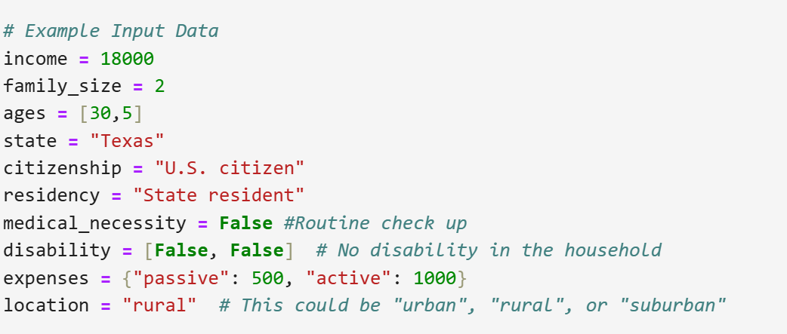

**Actual Output:**

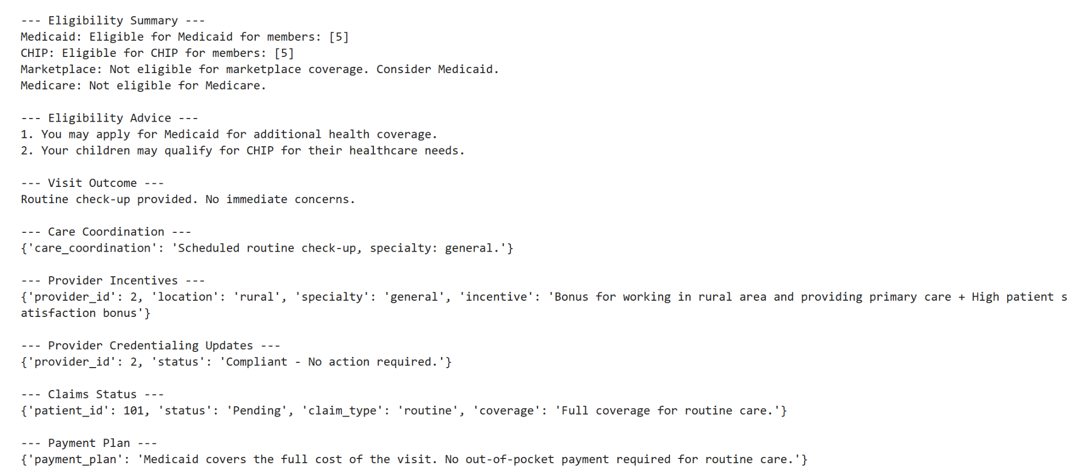

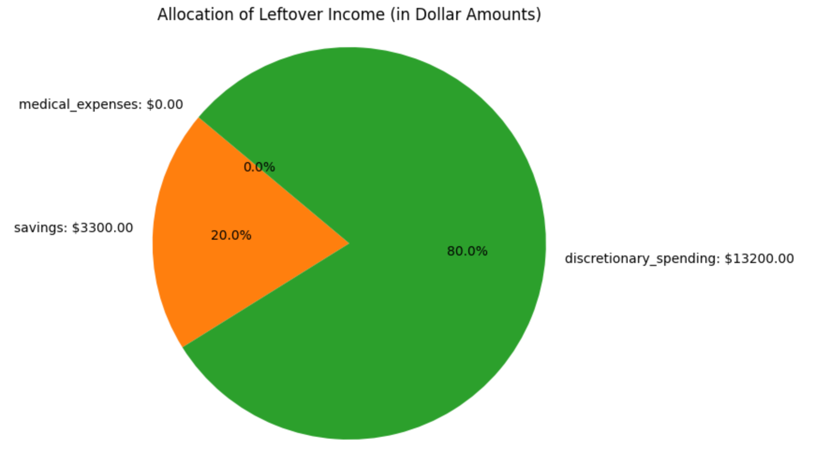

### **Scenario 2: Middle-Income Family in Suburban Area, No Medicaid Eligibility but Marketplace Subsidies Available**

**Patient Details:**

* **Income**: $45,000
* **Family Size**: 4 (Two adults, one 16-year-old child, and one 5-year-old child)
* **Ages**: [40, 38, 16, 5]
* **State**: California
* **Citizenship**: U.S. citizen
* **Residency**: State resident
* **Medical Necessity**: Yes for one adult (assuming this refers to the adult needing urgent care)
* **Disability**: [False, True, False, False] (only the second adult has a disability)
* **Expenses**: Passive expenses: $1200, Active expenses: $2000

#### **Execution and Outcomes:**

### **Eligibility Breakdown:**

#### **1. Medicaid Eligibility:**

* **California Medicaid** eligibility generally covers individuals and families with incomes up to **138% of the Federal Poverty Level (FPL)**. For 2024, the FPL for a family of 4 is **$28,200**.
* **138% of FPL** for a family of 4: 28,200×1.38=38,91628,200 \times 1.38 = 38,91628,200×1.38=38,916
* With an income of **$45,000**, this family does not meet the Medicaid eligibility threshold (they earn more than **138% of FPL**). Therefore, they are **not eligible for Medicaid**.

#### **2. CHIP Eligibility:**

* CHIP in California has a cutoff for children that is generally **up to 250% of the FPL**.
* For a family of 4, **250% of the FPL** is: 28,200×2.5=70,50028,200 \times 2.5 = 70,50028,200×2.5=70,500
* Since the children in this family (16-year-old and 5-year-old) fall under the CHIP eligibility, they **may be eligible for CHIP** because their household income is well below the CHIP eligibility threshold for children.

#### **3. Marketplace Eligibility:**

* The **Marketplace** is available to individuals whose income is between **100% and 400% of FPL**.
* For a family of 4:
  + **100% of FPL**: $28,200
  + **400% of FPL**: $112,800
* This family’s income of **$45,000** is **well within the Marketplace income range** for a family of 4 (between $28,200 and $112,800), so they are **eligible for the Marketplace**. Furthermore, they **may qualify for premium tax credits** (subsidies) to help with the cost of insurance.

#### **4. Medicare Eligibility:**

* **Medicare** eligibility is typically for individuals **aged 65 or older** or those with specific disabilities. Since no one in this family is 65 or older or meets the disability requirements for Medicare, they are **not eligible for Medicare**.

### **Outcome Based on Real Eligibility:**

1. **Medicaid**: The family is **not eligible for Medicaid** because their income exceeds the **138% FPL** threshold.
2. **CHIP**: The children (16-year-old and 5-year-old) are likely **eligible for CHIP** because they are under 19 and their family income qualifies under the **250% FPL** threshold.
3. **Marketplace**: The family is **eligible for Marketplace coverage**, and since their income qualifies, they may be eligible for **premium tax credits** to reduce the cost of their health insurance.
4. **Medicare**: The family is **not eligible for Medicare** because no one is 65 or older and the other adult does not qualify for Medicare based on disability (disability requires being on Social Security Disability Insurance for 24 months).

### **Process Payments and Medical Necessity:**

* **Medical Necessity**: The adult with medical necessity will require **urgent care**, meaning they will need immediate attention.
* Based on this, the **payment plan** may involve **full upfront payment** for urgent services, as urgent care is typically more expensive than routine services.

### **Generated Expected Outcome for Scenario 2:**

#### **Eligibility Summary:**

* **Medicaid: Not eligible for Medicaid.**
* **CHIP: Eligible for CHIP for children (16-year-old and 5-year-old).**
* **Marketplace: Eligible for marketplace coverage with potential premium tax credits for adults.**
* **Medicare: Not eligible for Medicare.**

#### **Advice Based on Eligibility:**

1. **Your children may qualify for CHIP for their healthcare needs.**
2. **Consider enrolling in a Marketplace plan to lower your healthcare costs with premium tax credits.**

#### **Visit Outcome:**

* **Urgent care provided. Follow-up with primary care scheduled.**

#### **Care Coordination:**

* **Emergency care scheduled at a local hospital.**

#### **Claims Status:**

* **Emergency services may be partially covered. Additional charges apply for urgent care.**

#### **Payment Plan:**

* **Full upfront payment required for urgent services.**

#### **Provider Incentives:**

* **Suburban provider (for the adult needing care) may receive:**
  + **Standard incentive for suburban providers + High patient satisfaction bonus.**

#### **Credential Updates:**

* **Provider 2 (suburban provider): Non-compliant - Credential review pending.**

### **Final Outcome for the Scenario:**

**This family is eligible for Marketplace coverage with potential subsidies, which will help lower the cost of health insurance. They will need to pay upfront for the urgent care services due to the immediate medical necessity, and follow-up care will be scheduled. Their children are eligible for CHIP, ensuring their healthcare needs are covered through a different program. The overall costs will be managed by the family’s income level and the available insurance options.**

**Input:**

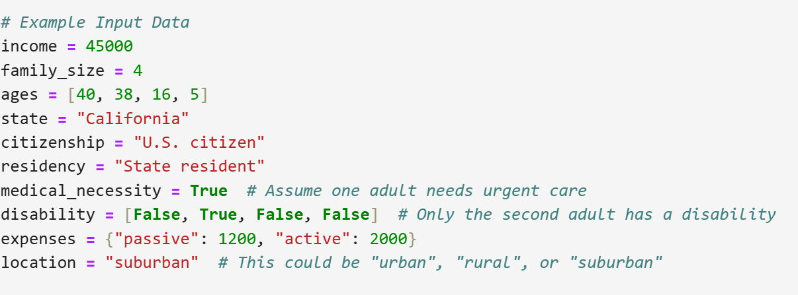

**Actual Output:**

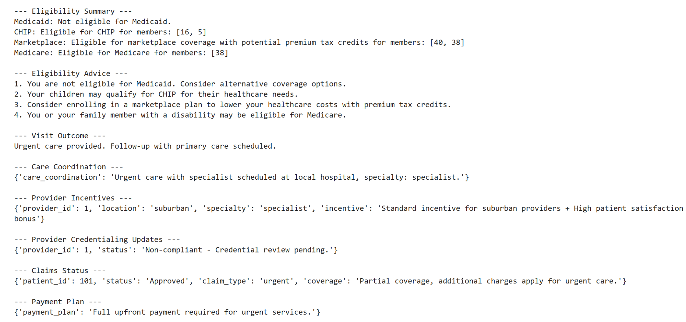

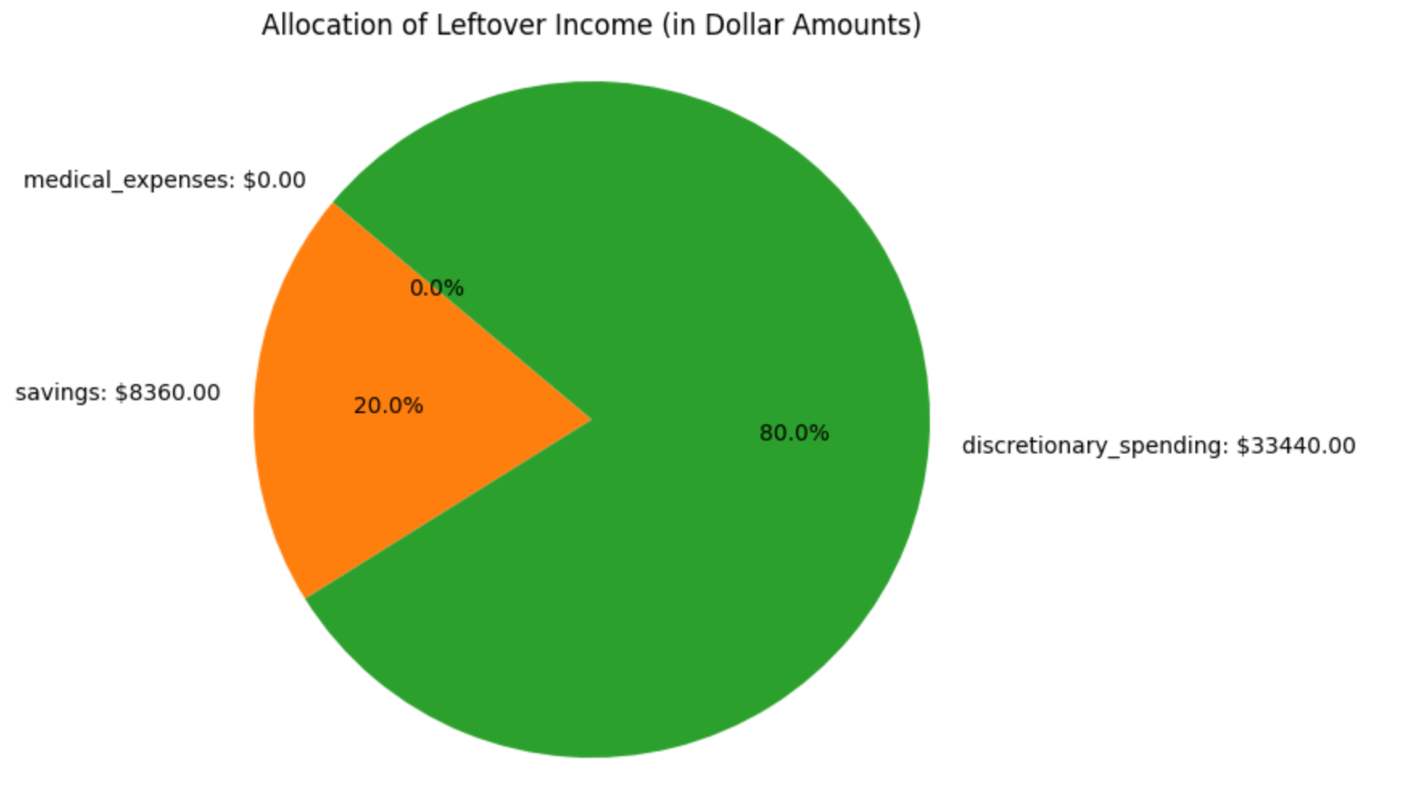

### **Scenario 3: High-Income Elderly Couple with Medicare Eligibility and Routine check up in urban area**

**Patient Details:**

* Income: $70,000
* Family size: 2 (two elderly adults)
* Ages: [70, 68]
* State: California
* Citizenship: U.S. citizen
* Residency: State resident
* Medical necessity: No
* Disability: [False, False]
* Expenses: {"passive": 2000, "active": 1500}

### **Eligibility Breakdown:**

#### **1. Medicaid Eligibility:**

* **Eligibility Check**:  
  California Medicaid (Medi-Cal) typically covers individuals and families with incomes up to **138% of the Federal Poverty Level (FPL)**. For a family of 2 in 2024, the **FPL** is **$19,720**, and **138%** of this is approximately **$27,235**.
* **Result**: **Not eligible for Medicaid**The couple’s income of **$70,000** is above the threshold of **$27,235**, so they **do not qualify** for Medicaid.

#### **2. CHIP Eligibility:**

* **Eligibility Check**:  
  CHIP provides healthcare coverage for children in families with incomes up to **250% of the FPL**. Since this household has no children, **CHIP eligibility does not apply**.
* **Result**: **Not eligible for CHIP**As there are no children in this family, CHIP does not apply to their situation.

#### **3. Marketplace Eligibility:**

* **Eligibility Check**:  
  The **Marketplace** is available for individuals and families who do not qualify for Medicaid or other government programs, and whose incomes fall between **100% and 400%** of the FPL. However, **since both adults are eligible for Medicare**, they **are not eligible** for Marketplace coverage.
* **Result**: **Not eligible for Marketplace**Since they qualify for **Medicare** due to their ages, they **cannot** enroll in a Marketplace plan.

#### **4. Medicare Eligibility:**

* **Eligibility Check**:  
  Medicare is available to individuals aged **65 and older**, and both individuals in this scenario are eligible. They would typically be enrolled in **Medicare Part A (hospital insurance)** and **Medicare Part B (medical insurance)**.
* **Result**: **Eligible for Medicare**Both individuals are **eligible for Medicare** and should have access to healthcare coverage under Medicare Part A and Part B.

### **Outcome Based on Real Eligibility:**

* **Medicaid**: The couple is **not eligible** for Medicaid due to their income exceeding the 138% FPL threshold.
* **CHIP**: The family is **not eligible** for CHIP, as they have no children.
* **Marketplace**: The couple is **not eligible** for Marketplace coverage because they are eligible for **Medicare**.
* **Medicare**: Both adults are **eligible** for Medicare, providing them with comprehensive healthcare coverage.

### **Process Payments and Medical Necessity:**

* **Medical Necessity**:  
  Since the couple has **no medical necessity** (only routine check-ups), their medical expenses will generally be lower than those for urgent or emergency care.
  + **Medicare Part B** typically covers preventive care, including routine check-ups and screenings, so these visits should be covered under their Medicare plan.

### **Generated Expected Outcome for Scenario:**

#### **Eligibility Summary:**

* **Medicaid**: Not eligible for Medicaid.
* **CHIP**: Not applicable (no children in the household).
* **Marketplace**: Not eligible for Marketplace coverage (eligible for Medicare).
* **Medicare**: Eligible for Medicare (due to age).

#### **Advice Based on Eligibility:**

1. **Medicare**:  
   The couple should ensure that they are **enrolled in Medicare Part A and Part B** if they are not already. These will cover their hospital services (Part A) and medical care (Part B), including routine doctor visits and preventive care.
2. **No Marketplace**:  
   Since they are **eligible for Medicare**, they **cannot** enroll in a Marketplace plan. Their primary health insurance should be **Medicare**.
3. **No Medicaid or CHIP**:  
   The couple does not qualify for **Medicaid** or **CHIP**, as their income exceeds the eligibility thresholds and they do not have children in the household.

#### **Visit Outcome:**

* **Routine check-up provided**:  
  Routine check-ups will be covered under **Medicare Part B** if they are enrolled, or the couple could explore **Medicare Advantage (Part C)** for additional benefits.

#### **Care Coordination:**

* **Routine Care**:  
  The couple’s primary care provider will coordinate their routine check-ups under **Medicare**. No urgent or emergency care is needed at this time.

#### **Claims Status:**

* **Routine Care Coverage**:  
  If enrolled in **Medicare Part B**, routine care visits should be covered, with the possibility of a **co-payment** or **deductible** depending on the provider and the specifics of their Medicare coverage.

#### **Payment Plan:**

* **Medicare**:  
  The couple may have to pay a **deductible** and **co-insurance** for services under **Medicare Part B**. If they are enrolled in **Medicare Advantage (Part C)**, they may have additional benefits that reduce out-of-pocket costs for routine visits.

#### **Provider Incentives:**

* **Incentives for Providers**:  
  Providers of routine check-ups may receive **incentives** for delivering high-quality care to Medicare beneficiaries, including bonuses for patient satisfaction or care quality measures.

#### **Credential Updates:**

* **Provider Review**:  
  The providers who are seeing the couple for routine care may be subject to **credentialing reviews** to ensure they meet Medicare standards for care delivery.

### **Final Outcome for the Scenario:**

This couple is eligible for **Medicare** and should rely on this coverage for their healthcare needs. Since they **cannot** access Marketplace plans due to their eligibility for Medicare, their health insurance should be primarily **Medicare Part A and Part B**. They will likely have some out-of-pocket costs for routine check-ups, such as co-pays or deductibles, unless they opt for **Medicare Advantage**. Given that they are **not eligible for Medicaid or CHIP**, Medicare is their primary source of health coverage.

Input Data:

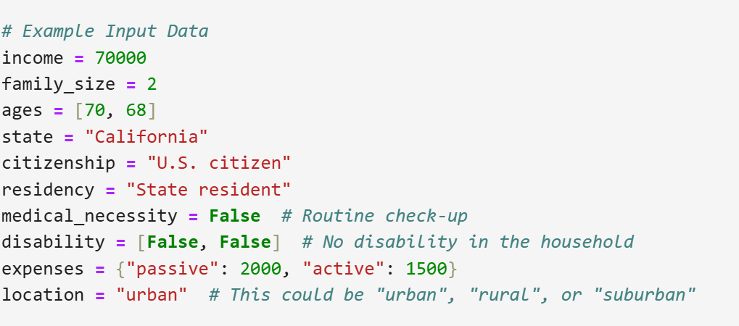

Actual Output:

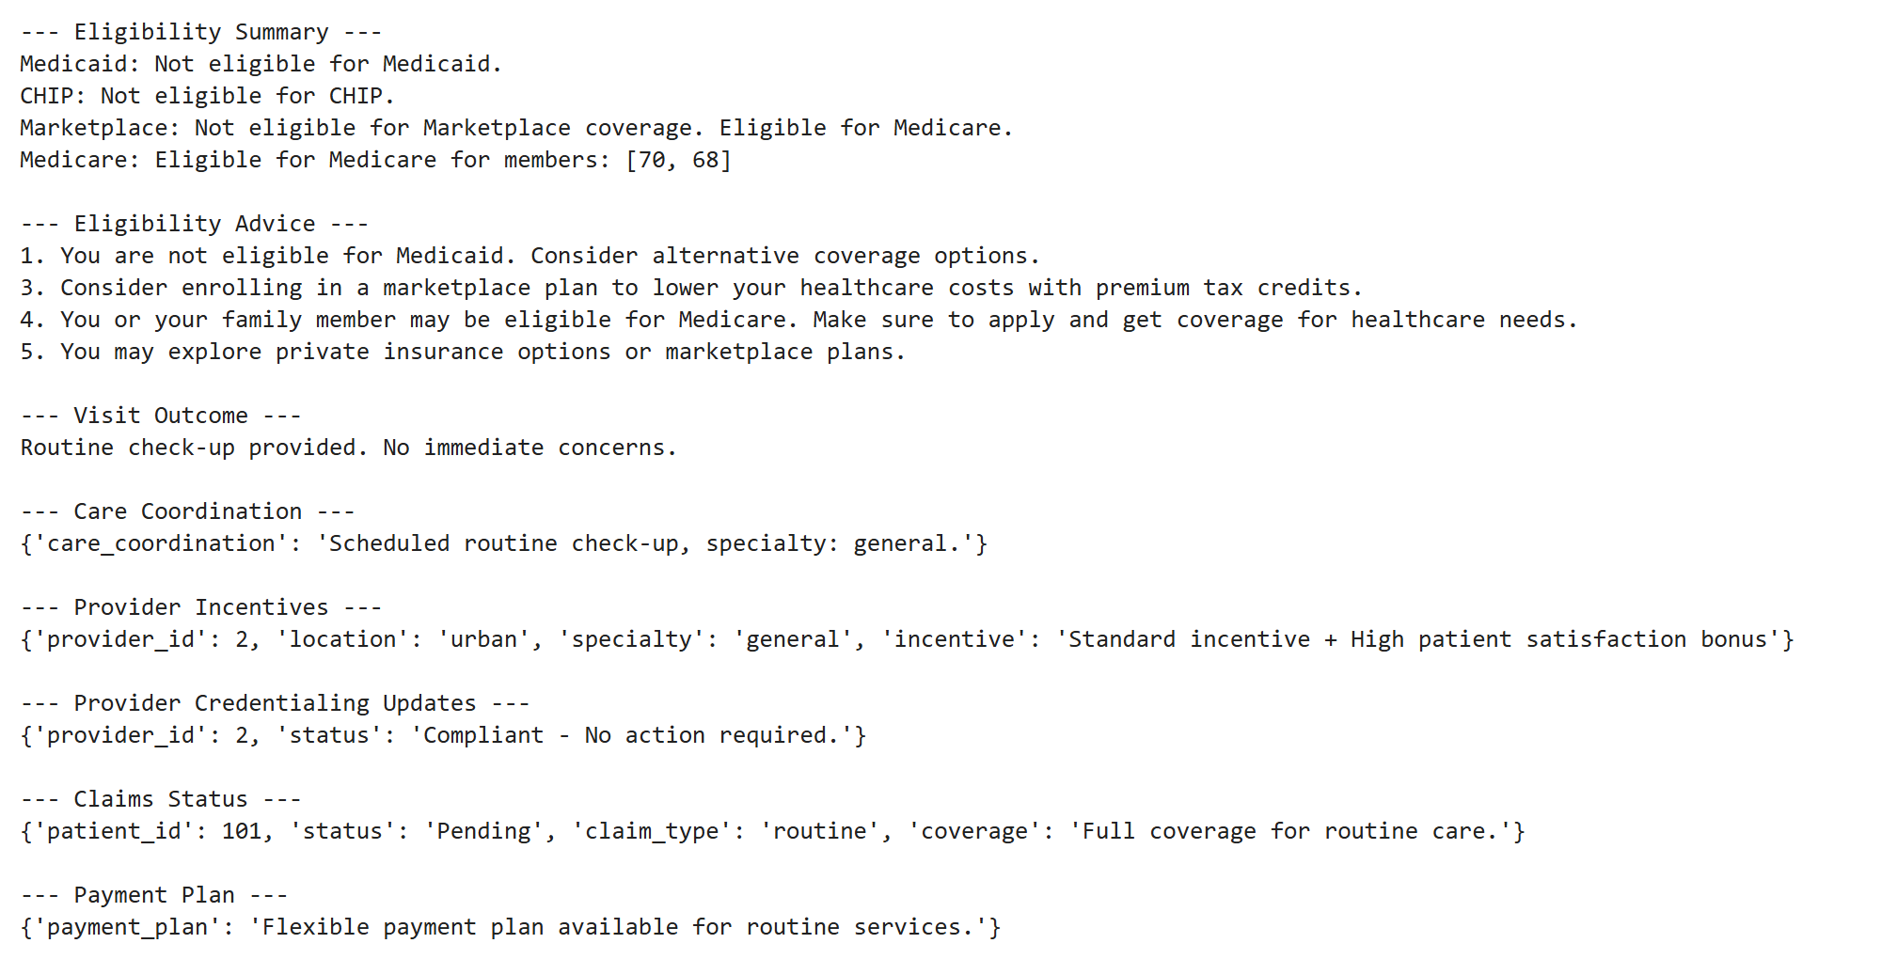

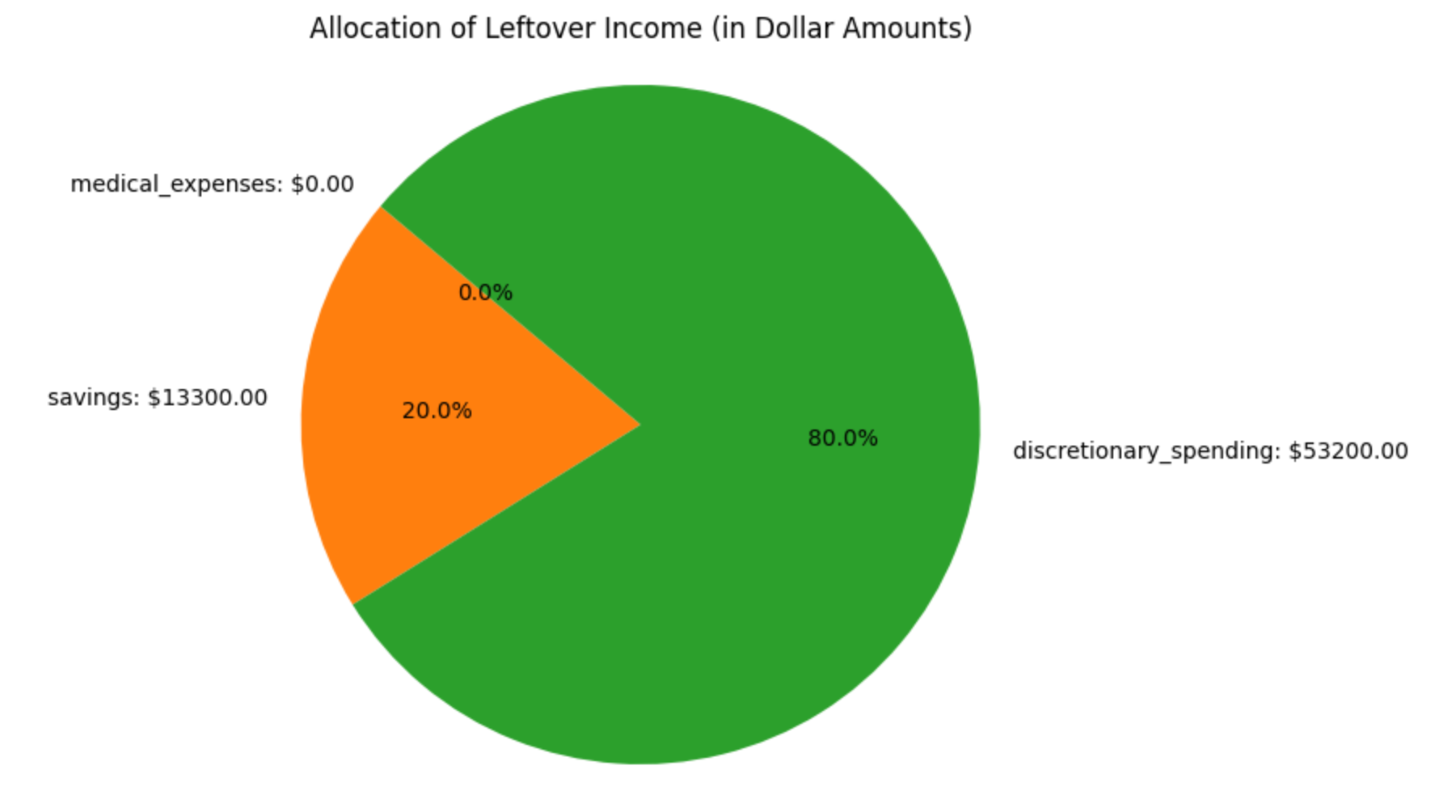

Summary:

What is better with such system compared to the existing processes?

What are the potential challenges in this kind of collaborative environment?